

**République Algérienne Démocratique et Populaire**

**Ministère de l’enseignement supérieur et de la recherche scientifique**

**Université des sciences et de la technologie**

**HOUARI BOUMEDIENE**



**Memory**

Presented with a view to obtaining the master's degree

In chemistry

***Specialty: analytical chemistry***

***Theme***

Presented by:

**Miss. Zeghbib Ania**

**Miss. Abderrahmani Sara**

Publicly supported on 07/07/2025, before the examination jury made up of:

|  |  |  |  |
| --- | --- | --- | --- |
| Name | First name | Grade |  |
| Foudil Cherif | Yazid | Teacherat the USTHB | President |
| Issaadi | HalimaMeriem | MCA at the USTHB | Examiner |
| Benkaci-Ali | Farid | Teacherat the USTHB | Supervisory |
| Rahmoune | Nawel | Mcbat the USTHB | Representative of the incubator |
| #error# | Flida | PCH officials -Saidal | Socio-economic representative |

**Thanks**

*Above all, we thank Allah, the all-powerful and the merciful, for granting us the health, the will and the patience necessary to carry out our master's training and to cross, with faith and determination, each stage of this route.*

*We send our sincere gratitude to our promoter,****Pr. Benkaci-Ali Farid****, for its attentive supervision, its scientific rigor and its enlightened advice, which greatly enriched this work.*

*We warmly thank the members of the jury,****Mr.* *Foudil Cherif Yazid and Mrs. Issaadi* *Meriem****, for the time devoted to the evaluation of this thesis as well as for their precious comments.*

*We also express our profound recognition to the structures teams where we have had the opportunity to carry out our internships, in particular****Saidal Research and Development Center (CRD)****And****the École normale supérieure (ENS)****, as well as****Pr. SadallahMohcene****, for their welcome, their technical support and their benevolent collaboration.Your contribution has been essential to the accomplishment of this research, and we are infinitely grateful to you.*

*We would also like to warmly thank****Doctoral student Rezzig Khaled****And****Doctoral student Chabane Chaouch Aziza****who helped us in this work.*

*We are also grateful to the technicians and staff of these institutions, the support of which has greatly facilitated the realization of our practical work.*

*To our family, a real pillar of our journey, we send all our gratitude for their unconditional love, their unwavering support and their constant encouragement, which carried us throughout this adventure.*

*Finally, we thank everyone, close or distant, who, directly or indirectly, have contributed to the success of this work.May everyone find the sincere expression of our deep gratitude here.*

**Dedication**

*By the grace of Allah, the Almighty, which lights up our paths, strengthens our hearts and guides our steps ...*

*I dedicate this memory to those who walked by my side with love, patience and confidence.*

*To my mother****HADJI SADIA****, my pillar, my light in dark days, my refuge in storms.No line will never be enough to express the immensity of my gratitude for your unconditional love,your sacrificesand your prayers that brought meso far.*

*To my father****Zeghbib Said****, for his quiet strength, his right advice and his constant support, often discreet but always present.Your look full of pride was an invaluable source of courage for me.*

*To my sister****Katia****and my brother****Hakim****, who, each in their own way, offered me affection, inspiration and strength.You are an essential part of my balance.*

*HAS****Malek****, for his kindness, his attentive presence and his discreet but sincere support.Thank you for your kindness in our family daily life.*

***To my little angel Urabah****, whose smile illuminates our hearts.Your presence is a source of sweetness and inspiration in my life.*

*To my precious friend****Rahma Hammoudi****, for your sincere friendship, your faithful presence, your listening without judgment and your contagious energy.Thank you for being thereat each stage, without ever failing.*

*To my friends, those who offered me moments of joy, comfort, sharing and sometimes simple silences that do good.* *Thank you for making this path a softer adventure.A very special thought of****Massi****, for his sincere friendship, his comforting words and his constant presence, even at a distance.*

*To all my family, close or distant, young and old, for their love, their encouragement, their prayers and their warm, even silent presence.*

*To my pair****Sara****, more than a teammate: an accomplice at all times for four years.Together, we built much more than a project - we shared a real life course.Thank you for your patience, your confidence and your constant commitment.*

*And finally, to****Pr. Benkaci-Ali Farid****, for the confidence granted, quality supervision, and the advice that has enriched this thesis and guided our work with requirement and benevolence.*

*This memory is a tribute to all these expensive souls.To you, I owe what I have become today.* ***Ania***

**Dedication**

*Above all I thank****ALLAH****, the very high to give me strength, the flying and the patience to follow my studies, carry out and purchase this modest work.*

*From the deep of my heart that I dedicate this work:*

*To my father****Mouhend Larbi,****You are my landmark, my courage, my example.You have always brought me with your gestures, your look, your love and your confidence.Even when I was on the verge of letting go, you found the words to get up.I'm so proud to be your daughter.*

*To my mother****Nora****, my life, my joy, you have always been there for me, in my tops as in my stockings.You brought me, supported, loved more than I could never thank you.I grew up with your love, your patience, your attention.And today, if I got there, it’s thanks to you.Thank you for always being proud of me.I love you with all my heart.*

*To my sister,****Salwa****, you have always been there, sweet, present, ready to listen to me without judging.Thank you for being this little corner of peace when everything was too heavy.*

*To my brothers,****Yahia and Smail****, you are my discreet strength, my bearings.Thank you for being my pillars.*

*To my grandfather****Yahia****, may God offer you his peace and welcome him in his vast paradise.Your memory is a tender light that never goes out in me.*

*To my uncle****Djafer****, you were more than an uncle.Thank you for each gesture, each word, each presence.Thank you for your precious help, for your outstretched hand, your real support, your presence that I will never forget.*

*To all my family,****My grandparents, my uncles, my aunts, my cousins, cousins****#error#*.*Thank you to each of you for love, encouragement.Even by far, I felt you near me.*

*To my dear friends:****Kenza, Amina, Sarra, Yasmine, Fedwa, Achewak, Rahma, Sabrina****And****Houda****, which have put light in the dark days, laughs in long nights,Thank you for your sincerity, your warm words, your loyalty without conditions.Without you, this course would not have had the same flavor.*

*To my pair****Ania****, thank you for being there in all the tops as in all the stockings.Your seriousness, your patience, your good humor made this path more beautiful.Thank you for this beautiful complicity, you are one of the most beautiful memories of this work.*

*To my supervisor, sir****Benkaci Ali Farid,****Thank you for your availability, your patience and your precious advice.*

*To all of you, this thesis is not just a work of end -of -studies.It is a reflection of my path, and an offering of gratitude.*

**Sara**

**Summary in French**

Ce mémoire explore la valorisation de la résine de myrrhe (Commiphora spp.) à travers une approche intégrée combinant extraction, analyses chimiques et formulation de produits thérapeutiques. L’extraction a été réalisée par des procédés doux optimisés (HD, HD-MO, Soxhlet) pour préserver les composés bioactifs naturels.

Les techniques chromatographiques (GC-MS et HPLC) ont permis d’identifier et quantifier les principaux constituants responsables des effets pharmacologiques.

Les évaluations biologiques démontrent des activités antimicrobiennes, antioxydantes et anti-inflammatoires, analgésiques significatifs, confirmant le potentiel thérapeutique des produits formulés.

Ces résultats offrent une base solide pour la valorisation industrielle et la commercialisation de produits naturels issus d’une plante médicinale ancestrale. Trois formulations innovantes—un roll-on, un baume et une préparation dermique—ont été développées et testées.

**Mots-clés** : hydro distillation, extraction, micro-ondes, DPPH, Myrrhe ¨Commiphora spp, GC-MS, analgésiques, dermique.

**ملخص بالعربية**

يتناول هذا البحث عملية تثمين **صمغ المُرّ** (Commiphora spp.) من خلال مقاربة علمية شاملة تشمل الاستخلاص، التحليل الكيميائي، وتطوير مستحضرات علاجية.تم تنفيذ الاستخلاص باستخدام ثلاث تقنيات مختلفة: التقطير المائي (HD)، التقطير المائي المدعوم بالموجات الدقيقة (HD-MO)، واستخلاص (Soxhlet)، بهدف استخراج المركبات النشطة دون الإخلال ببنيتها الكيميائية.

أُجريت التحاليل الكيميائية باستخدام الكروماتوغرافيا الغازية المقترنة بمطياف الكتلة (GC-MS) والكروماتوغرافيا السائلة عالية الأداء (HPLC)، مما مكّن من تحديد وتقدير المركبات الرئيسية ذات الفعالية البيولوجية.

أظهرت التقييمات البيولوجية أن المستخلصات تمتلك خصائص مضادة للميكروبات، ومضادة للأكسدة، ومضادة للالتهاب، مُسَكِّن للألم، مما يثبت فعاليتها العلاجية تُوفر هذه النتائج أساسًا علميًا يُعزّز فرص التثمين الصناعي والتسويق التجاري لمشتقات طبيعية من أصل نباتي تقليدي.

وفي هذا السياق، تم تطوير ثلاث صيغ علاجية مبتكرة: مستحضر "رول-أون"، بلسم، وتحضير جلدي، وقد خضعت جميعها للتقييم من حيث الخصائص الفيزيائية والفعالية البيولوجية.

**الكلمات المفتاحية:** صمغ المُرّ، الاستخلاص النباتي، التحليل الكروماتوغرافي (GC-MS وHPLC)، النشاط البيولوجي، الفعالية المسكِّنة للألم، التثمين الصناعي للمشتقات الطبيعية

**ABSTRACT ENGLISH**

This thesis explores the valuation of the Myrrh resin (Commiphora spp.) Through an integrated approach combining extraction, chemical analyzes and formulation of therapeutic products. The extraction was carried out by optimized soft processes (HD, HD-MO, SOXHLET) to preserve natural bioactive compounds.

Chromatographic techniques (GC-MS and HPLC) have made it possible to identify and quantify the main constituents responsible for the pharmacological effects.

Biological assessments demonstrate significant antimicrobial, antioxidant and anti-inflammatory drugs, confirming the therapeutic potential of the formulated products. These results offer a solid basis for industrial valuation and the marketing of natural products from an ancestral medicinal plant. Three innovative formulations-a roll-on, a balm and a dermal preparation-were developed and tested.

**Keywords:**  
Myrrh resin, phytochemical extraction, chromatographic analysis (GC-MS and HPLC), biological activity, analgesic effect, industrial valorization of natural products.

**List of abbreviations**

(G): Gazous State.

(L): Liquid state.

(S): Solid state.

° C: degree Celsius.

µG: Microgram.

µL: Microlitre.

ρ(water):Water density at the temperature taken on the day of the experience.

A: absorbance.

AFNOR: French normalization association.

BC: Cryogenic grinding.

BS: Simple grinding.

C:Commiphora.

C: the dose in (mg/ml).

Cm: centimeter (unit of length equal to 10-2m).

D: Diameter.

DMSO:Dimethylfoxide(Polar organic solvent, used in chemistry and biology).

DPPH: 2.2-Diphenyl-1-Picrylhydrazyl (molecule used to assess antioxidant activity).

ENS: École normale supérieure.

EV#error#

Eve: Extraction by water vapor.

FDA: Food and Drug Administration.

g#error#Gram (mass unit of the international system equal to 10-3kilogram).

GC-MS#error#

GHz: Gigahertz (frequency unit equivalent to 109Hz).

H: The humidity level in (%).

H: time (unit of time equal to 60 minutes).

HD-MO orMWSD#error#

HE: Helium (chemical element, HE symbol).

HE: essential oil.

HPLC orCLHP: High performance liquid phase chromatography (High PerformanceLiquid Chromatography).

HV: vegetable oil.

J.-C:Jesus Christ.

KiRef: Van den Dool of reference.

MHz: Megahertz (frequency unit equivalent to 106Hz).

Min**#error#**Minute (unit of time equal to 60 seconds).

ml: Millilitre.

Mol: mole (unit of quantity of material, equal to 6.022 × 1023elementary entities).

NIST:National Institute of Standards andTechnology(National Institute of Standards and Technology, United States).

N2#error#..

A: yield in (%).

RI: Van den Dool index.

SNC: central nervous system.

TR: retention time.

UV: Ultraviolet (electromagnetic radiation whose wavelength is lower than that of visible light).

Calf: the volume of water in (ml).

W: watt.

Wiley#error#Society spectral databaseWiley(often used in mass chromatography/spectrometry for the identification of compounds).

**List of figures**

**Figure 1:**Diversity of medicinal and aromatic plants used in phytotherapy.

**Figure 2**: Structure of isoprene.

**Figure 3:** Structures of some hydrocarbon sesquiterpenes.

**Figure 4:** Structures of some oxygenated sesquiterpenes.

**Figure 5:** Structures of some aromatic compounds.

**Figure 6**: Extraction diagram by hydrodistillation.

**Figure 7:**Diagram of the hydrodistillation technique assisted by HD-MO microwave.

**Figure 8:**Diagram of the steam training device assisted by microwave.

**Figure 9:**Soxhlet device diagram.

**Figure 10:** Ultrasonic bath.

**Figure 11:** Analysis by gas chromatography coupled with mass spectrometry (GC-MS).

**Figure 12:**planAnalysis by high performance liquid chromatography (CLHP or HPLC).

**Figure 13:**#error#.

**Figure 14:**Commiphora Myrrhe, erased in thenature.

**Figure 15:**Chemical structures of dominant compounds identified in myrrh essential oil.

**Figure** **16:**Vegetable matter.

**Figure** **17:** Classic hydrodistillation mounting (HD) for extraction of myrrh essential oil.

**Figure 18**#error#Hydrodistillation assembly assisted by microwave (HD-MO) for the extraction of essential oil of myrrh resin.

**Figure 19:**Sixhlet experimental assembly used for the extraction of bioactive compounds.

**Figure 20**: DispExperimental osterous of the rotary evaporator(rotary evaporator) used for vacuum concentration of extracts.

**Figure 21:** GC/MS equipment, AG Technologies type: GC 790A, Auto Sampler 7693, SM

5975CInertXL EI/CI MSD.

**Figure 22:**Antimicrobial activity by the discharge method on a nutrition.

**Figure 23:**Photographic steps of albumin extraction from egg whites.

**Figure 24:**The DPPH solution.

**Figure 25:**Diluted solutions of essential oil and extract used for tests.

**Figure 26**::Different dilutionsprepare.

**Figure 27**: UV spectrophotometry spectrophotometry apparatus.

**Figure 28**: Preparation of the extract solution with Tween 20.

**Figure 29:**Weighed with a mouse on an electronic balance.

**Figure 30:**oral cavage of a mouse with flexible probe, in a vertical position.

**Figure 31:**Rest of the mice in their cage after the cavage.

**Figure 32:**Implementation of the mouse in the compression tube.

**Figure 33:**Tail immersion in the double boiler.

**Figure 34:**#error#.

**Figure 35:**Intraperitoneal injection of the acetic acid solution in mice.

**Figure 36:**Mouse placed in individual observation cage after injection of acetic acid.

**Figure 37:**Abdominal twists after acetic acid injection.

**Figure 38:**Variation in the extraction efficiency of the essential oil of myrrh as a function Techniques used with simple grinding.

**Figure 39-A:**Energy consumed according to the techniques used.

**Figure 39-B:**CO2 clearance compared to techniques.

**Figure 40:**Differential yield of the essential oil of myrrh extracted by different extraction methods.

**Figure 41**: Cumulative yield of essential oil from myrrhe extracted by different extraction methods.

**Figure 42-A:**Energy consumed according to the techniques used with optimal time 80%.

**Figure 42-B:**Energy consumed according to the techniques used with optimal time 90%.

**Figure 43-A:**Co clearance2Compared to the techniques used with optimal time 80%.

**Figure 43-B:**Co clearance2Compared to the techniques used with optimal time 90%.

**Figure 44:**Differential and cumulative yield of essential oil from myrrh extracted by HD-MO 800 W with different types of grinding.

**Figure 45:**GC-MS D chromatogram’Hydrodistillation assisted by microwave power 800W BS.

**Figure 46::**Variation of the differential percentage of the majority compounds of the essential oil of myrrh as a function of HD-MO 800W-BS time.

**Figure 47**: Cumulative percentage of majority compounds from the essential oil of myrrh extracted by the HD-MO 800W-BS technique.

**Figure 48:**Fragment spectra of majority compounds identified in the case of HD-MO 800W BS.**HAS**#error# Furanoeudesma-1,3-Diene.**B**#error# Elemène <β->.**C**#error#

**Figure 49::**Variation of the percentage of chemical classes of essential oil as a function of time by the HD-MO 800-BS technique.

**Figure50-has :**Cumulative percentage of chemical classes of essential oil of myrrh extracted by the HD-MO 800-BS technique.

**Figure50-B:**Cumulative percentage of chemical classes of essential oil of myrrh extracted by the HD-MO 800-BS technique.

**Figure 51#error#**Hydrodistillation GC-MS chromatogram assisted by microwave power 800W BC.

**Figure52#error#**Percentage variationMajority compounds of the essential oil of myrrh as a function of HD-MO 800 timeW-Bc.

**Figure 53::**Cumulative percentage of majority compounds from the essential oil of myrrhe extracted by the MO 800 techniqueW-Bc.

**Figure 54::**Variation of the differential percentage of chemical classes of essential oil as a function of time by the HD-MO 800 techniqueW-Bc.

**Figure 55::**Cumulative percentage of chemical classes of myrrh essential oil.

**Figure 56**: HPLC chromatogram of myrrhe extract according to the region and the microwave power studied, region 1: Saudi Arabia HD-MOP = 800 W, Region 2: Pakistan HD-MO P = 800 W, Region 3: Yemen HD-MO P = 800 W, Region 4: Arabia Saudi HD-MO P = 60.

**Figure 57#error#**Inhibition zones of essential oil and myrrh extract against tested microorganisms.

**Figure 58::**graphs representing the % of inhibition of the denaturation of albumin as a function of the concentration of extracts and essential oils.

**Figure 59**: Histogram of IC50 (µg/ml) values ​​of essential oils and extracts from the myrrh obtained by the simple grinding method and diclofenac sodium.

**Figure60::**Antioxidant activity as a function of the concentration of essential oils and extracts from myrrh.

**Figure61**: Histogram of IC50 (µg/ml) values ​​of essential oils and extracts from the myrrh obtained by the simple grinding method.

**Figure 62#error#**Effect of latency treatment in the Tail Flick test in animals.

**Figure 63#error#**Effect of treatment on the reaction latency to the heating plate test in animals.

**Figure 64#error#**Percentages of inhibition of the extract 300 mg/kg on the number of torsions induced by acetic acid.

**Figure 65#error#**Final formulation of the therapeutic Roll-on myrrh.

**Figure 66#error#**Final formulation of therapeutic balm based on myrrh resin.

**Figure 67#error#**Vaseline final formulation based on Myrrhe extract.

**Tables list**

## **Table 1:**Chemical families of HES and their biological properties.

**Table 2:**Main constituents identified in myrrh and their approximate percentages (Ljaljević Grbić, M. 2018).

**Table 3::**THE microbial strains tested as well as their References.

**Table 4:**Operating conditions for the different methods of extraction of essential oils of Commiphora Myrrha.

**Table 5:**Steps intervals of different extraction techniques (BS).

**Table 6:**Optimistic times for different extraction techniques.

**Table 7:**Kinetics of extraction of the essential oil of the myrrh extracted by HD-MO P = 800W BS followed by GC-MS.

**Table 8:**Kinetics of extraction of the essential oil of the myrrh extracted by HD-MO P = 800W BC followed by GC-MS.

**Table 9:**Results of HPLC analysis of phenolic compounds of myrrh resin.

**Table 10:**Results of antimicrobial activities.

**Table 11:**Result of antioxidant activity by DPPH.

**Material table**

Introduction ………………………………………………………………………………………1

Chapter I: bibliographic synthesis

I.1 Medicinal plants ………………………………………………………………………3

I.1.1 Socio-economic and cultural importance………………………………………………3

I.2 Essential oils …………………………………………………………………………4

I.2.1 Definition of essential oils……………………………………………………………4

I.2.2 Composition of essential oils…………………………………………………………4

has.Terpenic compounds: Terpenes andTerpénoids ...…………………………………… 4

b.Aromatic compounds……………………………………………………………………5

c.Composed of various origins…………………………………………………………… 6I.2.3 Location of essential oils ………………………………………………………… 6

I.2.4 Physical properties of essential oils ………………………………………………6

I.2.5 Biological activities of essential oils …………………………………………… 7

I.2.6 Oil extraction proceduresEssential ...…………………………………… 8

I.2.6.1 Hydrodistillation ………………………………………………………………………… 8

I.2.6.2 Extra assisted by microwave……………………………………………………9

I.2.6.3 Extraction by Soxhlet……………………………………………………………… 11

I.2.6.4 Ultrasonic extraction………………………………………………………………… 12

I.2.7 Analysis methods……………………………………………………………….………12

I.2.7.1 UV-visible spectroscopy analysis………………………………………….…… 12

I.2.7.2 Analysis by chromatography coupled with GC-MS mass spectrometry…... ……13

I.2.7.3 Analysis by high performance liquid chromatography………….……… 13

I.3 Hydrols………………………………………………………………………..………15

I.4 Plant extracts………………………………………………...……………………15

Chapter II: the representation of the plant

II.1 Myrrhe resin………………………………………………………..…………… 16

II.1.1 Definition……………………………………………………………………...…………16

II.1.2 Botanical description………………………………………………………………… 16

II.1.3 Harvesting and resin trade……………………..………………………….……… 17

II.1.4 Physico-chemical properties of essential oil of myrrh………………… 17

II.1.5 Chemical composition……… ....... ……………………………………………………… 17

II.1.6 Therapeutic effect of myrrh biomolecules……………………………………….19

* Antioxidant…………………………………………………………………………… ... 20
* Anti-cancer ………………………………………………………………………… ... 20
* Antibacterial and antifungal……………………………………………….…… ... ..20
* Antiparasitic… ………………………………………………………………… ..….20
* Anti-infectious ………………………………………………………………………….20
* Analgesic and anti-inflammatory…………………………………………………………… 21

II.1.7 Other uses……………………………………………………………………….21

II.1.8 Toxicological data of the essential oil of myrrh…………...………….…… 22

Chapter III: Materials and operating conditions

III.1 Material and extraction method………………………………………………………… 23

III.1.1 Classic hydristillation……………………….. ………………………………… 24

III.1.2 Hydrodistillation assisted by microwave…………………………………………..24

III.1.3 Volatile solvent extraction…………………………….………………………… 25

III.2 Operating analysis conditions……………………………………………………..27

III.2.1 Operating conditions for the analysis of essential oils by gaseous phase chromatography coupled with mass spectrometry (GC-MS) ………………………………… 27

III.2.2 Operating conditions of analysis by high performance liquid chromatography (HPLC)…………………………………………………………………………..……………… 29

III.3 activities in vitro……………………………………………………………………………… 30

III.3.1.Antimicrobial…………………………… ... ………………………………………… 30

III.3.2 Anti-inflammatory……………………………………………………………………… 32

III.3.3 Antioxidant…………………………………………………………………………… ... 34

III.4 Activities in vivo…………………………………………………………………………… 37

III.4.1 Assessment of the analgesic activity of myrrhe extract…………………………..37

Chapter IV: Results and discussion

IV.1 Study of the extraction of the volatile fraction………………………………………………..45

IV.1.1 Study of the extraction yield of the essential oil of myrrh………………… 45

IV.1.2 Energy and environmental appearance………………………………………………… 46

IV.1.3 Study of the extraction kinetics of the essential oil of myrrh……………… ... 47

IV.1.4 Studies of extraction kinetics according to time by GC-MS………………..51

IV.1.4.1 HD-MO technique case p = 800W BS……………………………………………… 52

IV.1.4.2 HD-MO technique case p = 800W BC……………………………………………… 62

IV.2 Study of the chemical composition of the polyphenolic fraction by HPLC-DAD HPLC……………………… ……………………………………………………………… ..…..69

IV.3 Study of antimicrobial activity of myrrh resin on bacterial and fungal pathogenic strains………… …………………………………………………………….76

IV.4 Study of anti-inflammatory activity of essential oils and myrrh extracts………………………………… …………………………………………………….77

IV.5 Study of antioxidant activity of essential oils and myrrh extracts by the trapping method at DPPH…………………… …………………………………………… 79

IV.6 Evaluation of the analgesic activity of the ethanolic extract of Myrrhe ………….……81

Chapter V: Formulation

V.1 Roll-on Innovative Myrrh based for applicationTargeted ...…………………..………83

V.2 MYRRHE BALAGE for optimal skin protection and regeneration ………… 84

V.3 Vaseline based on myrrh extract… ……………………………………………………… 85

Conclusion …………………………….………………………………..…………………….87

Reference Bibliographies.

Annexed.

**Introductiongeneral**

For centuries, medicinal plants have been an essential source of natural treatments.They are used to treat and prevent many diseases, thanks to their richness in bioactive compounds which give them various therapeutic properties (Bakkali, F. et al.2008).

Today, these plants are the subject of many scientific research, in order to identify and enhance new active molecules for pharmaceutical, cosmetic or food applications.This richness in natural compounds, such as terpenes, polyphenols or alkaloids, explains their growing interest (Burt, S. 2004).

The myrrh (CommiphoraSPP.) Is one of these medicinal plants widely recognized for its therapeutic effects.Originally from the arid regions of East Africa and the Arabian Peninsula, its resin has been used for centuries in traditional medicine in various cultures for its antiseptic, anti-inflammatory, analgesic and healing properties(Shen, T. et al. 2012).

Its chemical composition is complex and is in the form of essential oil, gum and resin, which gives it many applications in the pharmaceutical and cosmetic fields(Haus, L.O. et al.2005).Despite its ancient use, several aspects linked to the chemical composition and the biological effects of myrrh still remain to be deepened.This is why our work aims to enhance this resin through its extraction, analysis and evaluation of its biological properties, in an innovative framework.

In this study, we have extracted two types of myrrh fractions: the volatile fraction and the phenolic fraction.For the volatile fraction, we used two extraction techniques: hydrodistillation Classic(HD) and hydrodistillation assisted by microwave (HDMO).The essential oils obtained were then analyzed by chromatography in the gas phase coupled with mass spectrometry (GC-MS) in order to identify their main constituents(Adams, R.P. 2007).

Parallel, the phenolic fraction was obtained by extraction to the Soxhlet using ethanol as a solvent, then analyzed by liquid high performance chromatography (HPLC) to determine its composition in phenolic compounds(Singleton, V.L. et al. 1999).

We have evaluated the biological activities of essential oil and the ethanolic extract of myrrh.The tests focused on their antimicrobial, antioxidant and anti-inflammatory effects.In addition, analgesic activity has been evaluated in vivo only on the ethanolic extract(Brand-Williams, W. et al. 1995; Koster, R. et al. 1959)

Following the results obtained and taking into account the demonstrated biological properties of myrrh resin, including its anti-inflammatory, antioxidant and antimicrobial effects, we have designed and proposed simple therapeutic formulations.

These formulations have been developed from an applied valuation perspective, aimed at effectively exploiting the pharmacological potential of myrrh in products for medical or cosmetic use.This approach makes it possible to envisage a transfer of knowledge acquired towards concrete applications, with a particular interest in the development of innovative solutions and accessible in the field of natural health.

**Chapter I**

**Bibliographic synthesis**

**I.1Lmedicinal plants**

According to the 10th edition of the French Pharmacopoeia (Afssaps.2010)), medicinal plants are plant drugs in the sense of European pharmacopoeia, including at least partpossesseddrug properties(Figure 1).

They relate to two origins at the same time.First the spontaneous plants called "wild" or "picking", then second the cultivated plants (Bézanger-Beauquesne, L et al. 1986).

* Spontaneous plants: (or wild, pushes naturally without human intervention),They were the only ones used in the past and still represent today a notable percentage of the Algerian market.Their distribution depends on the soil and especially on the climate.
* Cultivated plants:(Introduced and intentionally maintained by man),These ensure a raw material in sufficient quantity to meet the needs and drugs collected are homogeneous from an appearance and chemical composition point of view.Another advantage, and not the least, all possible confusion by picking is excluded here, which also allows a more timely harvest.



**Figure 1 :** Diversité de plantes médicinales et aromatiques utilisées en phytothérapie

**I.1.1Importance sOcio-economic and cultural**

Most plant species contain substances that can act, at one level or another, on the human and animal organism.They have advantages whose drugs are often without(Iserin,,P.2001).The fundamental reason is that the active ingredients of plants come from biotic processes spread throughout the living world, while synthetic drugs are xenobiotics with very poorly mastered side effects(Bruneton, J.2009).Medicinal plants are therefore important forPharmaceutical research and the development of drugs, acting directly as therapeutic agents, but also as a raw material for the synthesis of drugs or as a model for pharmaceutically active compounds(Decaux, I.2002).

**I.2 essential oils**

**I.2.1Definition of essential oils**

According to(Durville, J-P.1930)), Essences or essential oils, also known as volatile oils, are oily, volatile odorous substances, not very soluble in water, more or less soluble in alcohol and ether, colorless or yellowish, flammable which are easily altered by air. When they are pure and natural, they do not contain any fatty substances: they only consist of volatile aromatic molecules, hence their name of essential oil.The term""oil " underlines the viscous and hydrophobic character of these substances, THEterm" essential "Denotes the main characteristic of the plant through its exhalations.

* Essence: natural secretion developed by the plant organism, contained in various types of producer organs, variable according to the part of the plant considered.
* Essential oil: natural extract of raw materials of vegetable origin, obtained by distillation by water vapor, that is to say that essential oil is distilled essence.(Besombes,,C.2008).

According to the French AFNOR Normalization Association, theHEYsare: "products obtained either from raw materials of vegetable origin, or by steam training, or by mechanical processes from the Citrus epicarpe, or by" dry "distillation.The essential oil is then separated from the aqueous phase by physical processes "(AFNOR, Paris. 2000)).

**I.2.2Composition of essential oils**

Essential oils (HES) are complex mixtures of very varied molecules belonging mainly to two chemical groups compared to their biogenetic origins : terpene compounds (terpenes and their oxygenated derivatives) and aromatic compounds derived fromphenylpropane (Boukhobza, F.and Goetz, P.2014).Certain compounds of various origins (alcohols, aldehydes, ketones, esters, etc.) are generally in the state of trace.All compounds are characterized by low molecular weight(Bakkali, F.et al.2008).

1. **Terpenic compounds: terpenes and terpenoids**

Terpenes are natural hydrocarbons, of structure either cyclic or open chain.Their raw formula is (c5H8) nof which n designates the number of basic patterns called isoprene (or 2-methylbuta-1,3-diene) of Formula C5H8(Figure2).Thus, depending on the value of n, weMeet monoterpenes (n = 2), sesquiterpenes (n = 3), diterpenes (n = 4), etc.(Chagra,,K .2019).THEterpenoids, also known asisoprenoids, are compounds with the structure of terpenes and belonging to different chemical families such as alcohols, aldehydes, ketones, esters and ethers (Benaissa, O. 2011#error# Samate,,A.D. 2002).

**Figure 2** : Structure de l’isoprène

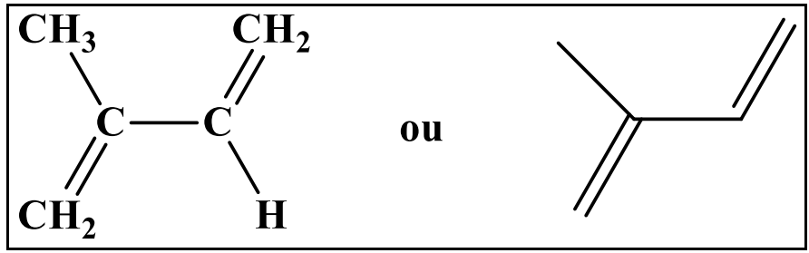

**Figure 3 :** Structures de quelques sesquiterpènes hydrocarbonés

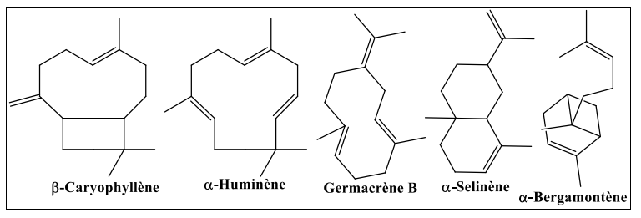

**Figure 4 :** Structures de quelques sesquiterpènes oxygénés

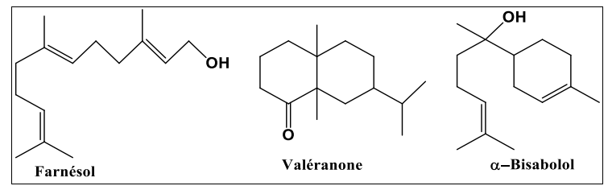

1. **Aromatic compounds**

Unlike terpene derivatives, aromatic compounds(Figure 5)are less frequent inHEYs.Very often, it is allyle and propénylphenol.These aromatic compounds constitute an important whole because they are generally responsible for the characters of essential oils.(Hessas,,T., Simoud,,S. 2018).

**Figure 5 :** Structures de quelques composés aromatiques

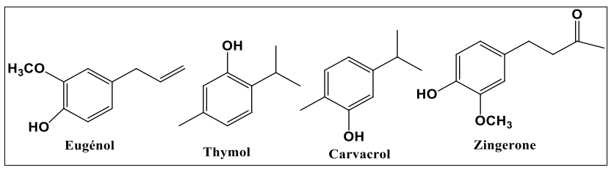

1. **Composed of various origins**

In addition to the mainly terpene and aromatic compounds, essential oils can contain a wide variety of secondary chemicals, such as nitrogen and sulfur compounds, alcohols, fatty acids, coumarins, lactones, as well as aldehydes, ketones, esters and oxids, contributing to their varied biological properties (Bruneton, BrunetonJ.2009).

**I.2.3 Location of essential oils**

THEHEYs can be extracted from all the organs of the plant:

* Dthe flowery tops (lavender, mint,Ylang, chamomile…).
* Dthe roots or rhizomes (vetiver, angelica, ginger ...).
* Dbark (lemon, orange ...).
* Du wood (resin,Cedar, sandalwood, camphor and camphor ...).
* DFruits (pepper ...)and leaves (eucalyptus ...).
* Dthe seeds(Cardamons, coriander, fennel, nutmeg ...). (1))

**I.2.4Physical properties of essential oils**

Essential oils are generally colorless or slightly yellowish liquids, characterized by a strong and specific odor for each plant.They are volatile at room temperature and have a density generally lower than that of water, although there are exceptions.Their boiling point varies according to the nature of the compounds present, but is generally relatively low, which justifies their distillation with water vapor.Insoluble in water, they are however perfectly soluble in organic solvents such as ethanol, ether or vegetable oils.These physical properties not only influence their extraction methods, but also their formulation and stability in therapeutic or cosmetic use (Bruneton,J.2009#error#, N.2005).

**I.2.5Biological activities of essential oils**

Biological activity of HES depends on their compositionchemical Andinteractions between their components(Table 1)(Pibiri, M. C.2006;Lahlou, M.2004).They have several major therapeutic properties.They have antibacterial action thanks to phenols, monoterpenes, aldehydes and ketones that stimulate natural defenses.They also have antifungal properties, protecting against fungi and food microorganisms (Zambonelli, HAS.et al.2011;Manga, T.et al.1999).The HES are antiparasitic by pushing insects and antivirals by slowing down the spread of viruses while strengthening immunity.They have anti-inflammatory, healing and antioxidant effects, thus promoting cellular regeneration.Some HES improve blood circulation, relieve digestive disorders and act as antispasmodic.They also have calming effects, facilitating sleep, and deodorizing, purifying air by eliminating certain odors.

## **Table 1:**Chemical families of HES and their biological properties.

|  |  |
| --- | --- |
| ***Chemical families*** | ***Biological properties*** **(Benayad, N.2008; Belkou, H.et al.2005)** |
| Hydrocarbon monoterpenes | Fungistatic, bacteriostatic, insecticide, nematicide, herbicide, stimulating |
| Hydrocarbon its | Calmant, anti-inflammatory, antiallergic, antibacterial, antifungal |
| Terpenic phenols | Antioxidant, stimulating, tonic, antiseptic, bactericidal, fungicide, antiviral, antiparasitic |
| Monoterpenic alcohols | Anti-inflammatory, antiseptic, bactericidal, fungicide, antiviral, antiallergic, immunostimulant, neurotoxic |
| Sesquiterpenic alcohols | Tonic, stimulating |
| Monoterpenic aldehydes | Antifungal, sporicide, insecticide, antihypertensive, anti-inflammatory |
| Monoterpenic ketones | Calming, antiviral, antifungal, neurotoxic, antiepileptic |

**I.2.6 LEssential oils extraction procedures**

**I.2.6.1Hydrodistillation**

* **Classic hydrodistillation**

Hydrodistillation is the reference technique in the study of volatile compounds of a plant in the field of research(Figure6)).This is the normalized method for extraction ofHEYs from dry spices.



**Figure 6** : Schéma de l'extraction par hydrodistillation

Teisseire, P. J.(1991) indicates that this technique is to immerse the vegetable matter in a water bath, then the whole is brought to a boil under atmospheric pressure.The heat allows the bursting and release of the fragrant molecules contained in vegetable cells.These aromatic molecules form with the Water vapor An azéotropic mixture "Water +HE".The latter is condensed, cooled and recovered in an Essek or Florentine vase.The HE being lighter than water (except a few rare exceptions) it flies over the hydrosol this technique has been applied in numerous works (Lagunez Rivera, L. 2006).

This method is generally used in the event of essential oils whose chemical constituents are thermore -resistant.

The drawbacks of this method are:

* The calcination of plant material, which leads to a modification of the composition and the chemical characteristics of theHEY.
* The non -control of the temperature of the container containing the mixture (water + plant organs).
* Modification of the smell, color and composition of theHEYDuring distillation (ChalchatAndAl,1997).

**I.2.6.2 assisted extractionby microwave**

Microwaves or hyperfrequency are electromagnetic waves which occupy a frequency band of three decades of 300 GHz at 300 MHz.The most used frequency is 2450 MHz, which corresponds to a wavelength in the air of 12.2 cm.

The microwave heating mechanism is based on the fact that polar molecules, such as water, have negative and positive ends: these are dipoles.In the absence of an electric field, the dipoles are randomly oriented.Under the effect of a continuous electric field, the molecules tend to orient themselves in the direction of the electric field.Under the effect of an alternative electric field of frequency F, the dipoles are oriented in the direction of the field on a half-alternation, disorient themselves when the field cancels and reorient in the other direction during the second half alternation: it is the dipolar rotation.Electric energy is converted into kinetic energy by this dipolar rotation.Kinetic energy is then partially transformed into heat.The alignment of dipoles in relation to the electric field is upset by the forces of interaction between molecules (the forces ofLiaison by hydrogen bridge and van der waals bond forces) which can be assimilated to internal friction forces that exist in solid-solid contacts. (Roussy, G., & Pearce, J. A. 1995).

These forces will oppose the free rotation of the molecules and the friction produced, the release of heat is born.

The main drawbacks of microwave assisted extraction are:

* The possible degradation of certain thermosensitive or unsaturated compounds by thermal effect or hydrolysis, which can alter the quality of the extract.
* The loss of certain volatile or fragile constituents during the process.
* The possible presence of residues of organic solvents in the final product, especially when the extraction is carried out with solvents, which complicates their elimination and poses problems of purity and valuation.
* The high investment cost for specialized equipment compared to traditional methods.
* The need for a separation or filtration step to isolate the vegetable matrix of the extraction fluid.
* An industrial development still limited, the technique being mainly used on a laboratory or pilot scale.
* **Assisted hydristillation pAR Microwavee**

Hydrodistillation assisted by microwave (HD-MO), developed by Stashenko andAl.(2004a and 2004b), is an innovative technique that differs from classic hydrodistillation by its heating mode(Figure 7).It uses microwave heating based on a reverse thermal gradient, unlike conventional heating.Under the effect of heatingselective and reduced pressure, the water contained in the vegetable matter comes in boiling, thus facilitating the extraction of volatile compounds.These are then condensed, cooled and decanted.

This method is rapid, economical in energy and water, and makes it possible to obtain an extract without residual solvent (Msweep, B.1994).

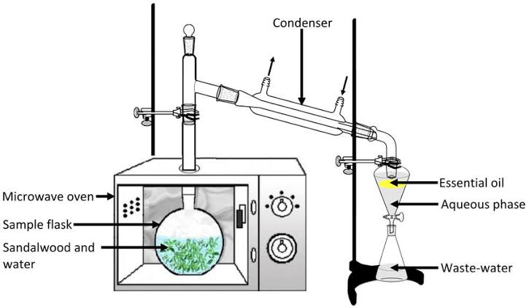

**Figure 7 :** Schéma de la technique d’hydrodistillation assistée par micro-ondes HD-MO

* **Trainingmicrowave steam assisted**

Steam training assisted by microwave (MWSD), developed by Sahraoui andal.(2008), is based on the principle of steam training, with the only difference that the column containing the plant matter is placed in a microwave oven, while the rest of the device remains outside (Figure8).Tested on the extraction of lavender essential oils, this process has reduced the extraction time from 30 to 6 minutes compared to the classic method.

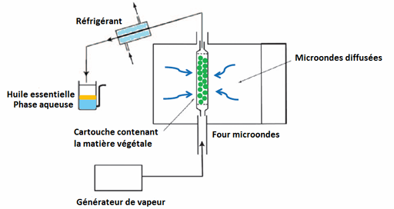

**Figure 8 :** Schéma du dispositif d'entraînement à la vapeur assisté par microondes

The analysis revealed an identical composition of the oils obtained by the two techniques, with a faster opening of the glands containing the essential oil under the effect of microwaves, explaining time saving (SahraouiAndal.2008).It has the advantage of being more effective than hydrodistillation in the limitation of hydrolysis phenomena of essential oil and lies in the lowering of the distillation temperature, which avoids the decomposition of oil obtained obtainede.

**I.2.6.3 Soxhlet extraction**

This technique is for a device called the Soxhlet (Figure 9).It consists in passing a flow descending of fresh solvent.The solvent affecting plant material, remains fresh because it is distilled in the heated tank where it is collected rich in plant matters after extraction.Going up and passing through the refrigerant, the solvent condenses and thus falls on the bed of plant material (Lucchesie, M. E.2005).

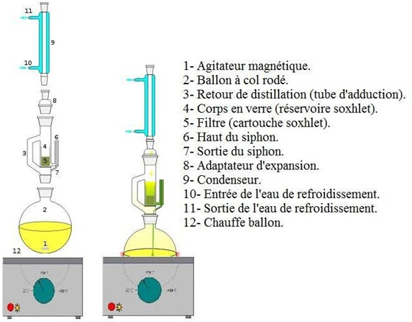

**Figure 9 :** Schéma de l'appareil de Soxhlet

The separation of the extract solvent is made using the apparatus calledthe rotary evaporator.In this device we make a vacuum evaporation using a vacuum pump with a control valve.During evaporation the ball is rotated and plunged into a heated liquid bath.The device has a refrigerant with a condensate balloon.The balloon rotation creates a larger and renewed exchange surface, therefore making it possible to carry out a rapid evaporation.(Penchev, P. I. 2010).

**I.2.6.4 Ultrasonic extraction**

The plant material is immersed in a solvent and subject to the action of ultrasound.The sound waves cause mechanical vibrations in the environment through a succession of expansion and compression phases(Figure10)).Bubbles are thus formed (cavitation phenomenon).In the vicinity of the cell walls, these bubbles are deflated.This produces ultra-rapid micro-games of liquid which cause the destruction of these walls and lead to the release of the molecules sought in the environment.

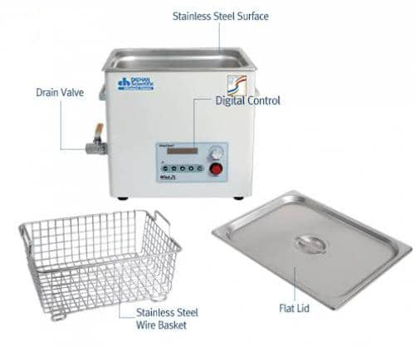

**Figure 10 :** Bain à ultrasons

A solvent elimination step is necessary to recover essential oil.Several research has been carried out on the extraction of essential oils by ultrasound by using laboratory equipment (Chemat, S.et al.2003).

**I.2.7Analysis methods**

**I.2.7.1 analysisbyUV-visible spectroscopy**

The molecular absorption spectroscopy is based on the measurement of the absorbance transmutant has solutions contained in transparent cells with a length of the absorption path equal to the.In general, between the concentration of an absorbent analyst and absorbance, there is a linear relationship which is expressed by the Béer-Lambert equation:

***A = log I0/I = ε. l. C = - log T***

Or : **HAS**: Designates absorbance.

**I0** : Intensity of the incident radius.

**I**: Intensity of the transmitted radius.

**ε**: The absorption coefficient which is a constant for an absorbent species and a given transition (l/mol.cm)(Zerfa, HAS.,Kouchache, K. E. 2015).

**I.2.7.2 Chromatography analysis coupled with GC-MS mass spectrometry**

Gaser phase chromatography coupled with mass spectrometry is today one of the most used techniques in analytical chemistry(Figure 11).The principle of this technique consists in transferring the compounds separated by chromatography to the gas phase by the mobile phase (vector gas) in the mass spectrometer at the level of which, they will be fragmented into variable mass ions whose separation will be according to their mass.The main difficulty encountered during this coupling is due to the big difference in pressure.Indeed, theSM requiresA very low pressure level, while the gas chromatography takes place at a higher pressure level.The identification is then carried out by comparison of the retention indices and mass spectra of individualized constituents with those of the reference products contained in computerized libraries containing several thousand spectra (bendif, H.2017).

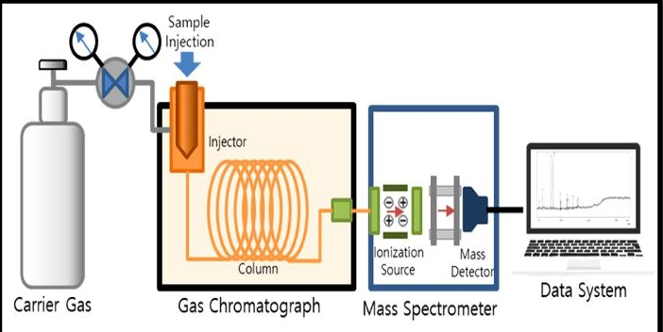

**Figure 11 :** Analyse par chromatographie en phase gazeuse couplée à la spectrométrie de masse (GC-MS)

**I.2.7.3 Analysis byhigh performance liquid phase chromatography**

It is a technique of analytical separation of molecules present in a mixture.Its great precision allows the search for traces.Chromatography in the liquid phase made it possible to carry out analyzes which were not previously possible with the techniques on a thin layer or in the gas phase.This form of chromatography is frequently used in biochemistry and toxicology.

* **Principle**

The compounds to be separated (solutes) are put into solution in a solvent.This mixture is introduced in the liquid mobile phase (eluent).Depending on the nature of the molecules, they interact more or less with the stationary phase in a tube called chromatographic column.

The mobile phase pushed by a high pressure pump, travels the chromatographic system.This is what has been called liquid chromatography under high pressure

(HPLC).

The mixture to be analyzed is injected and then transported through the chromatographic system.

The solution compounds are then distributed according to their affinity between the mobile phase and the stationary phase.

At the outlet of column thanks to an appropriate detector The different solutes are characterized by a peak.All of the recorded peaks are called chromatogram.The detector signal is amplified and recorded, the oven temperature is maintained constant (figure12).

* **Field of application**

HPLC is used in the detection of multiple residues of quinolone antibiotics, sulfonamide, β-lactamine, macrolide, tetracycline ..., in very varied samples such as milk or muscle tissue.

**Figure 12 :** schémaAnalyse par chromatographie liquide à haute performance (CLHP ou HPLC)

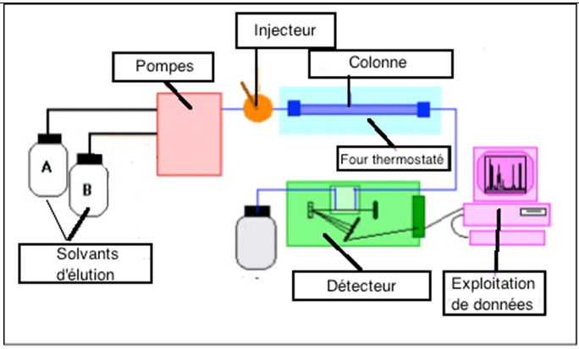

**I.3****THEhydrolas**

Initially treated as a waste of distillation of HEs, hydrosols are today increasingly present on the natural products market.Indeed, a hydrosol is an aqueous distillate recovered after the extraction of the HE byEVE.It can be kept for a year in bottles protected from light, at an ambient temperature not exceeding 15 ° C.

The hydrosols contain the same chemical compounds (hydrophilic active ingredients, a very small amount of HE, trace elements and mucilage) as hesWith different contents(Piochon,M. 2008).All the compounds contained in the hydrosol are necessarily in its HE. Despite their low proportion in active ingredients, they have certain interesting pharmacological and biological activities: antibacterial activities(Sagdiç, Ô.2003)and antifungal(Boyraz, N.AndÔzcan, M. 2005).Theyare frequently used in the composition of certain cosmetic products, such as food aromas or as ingredients in kitchen recipes and in the composition of drinks.

**I.4extractsplants**

Plant extracts are preparations obtained from plant parts (leaves, roots, stems, seeds, etc.) using solvents to extract the bioactive compounds.They represent a precious source of natural substances used in various fields such as pharmacology, cosmetics, food and phytotherapy.Among the most commonly used solvents are ethanol and methanol, due to their polarity and their ability to solve a wide range of polar and semi-polished compounds, including flavonoids, alkaloids, phenols and terpenes (**Sasidharan, S.et al.2011**).

Ethanolic extract is often a privilege for therapeutic or food applications because of its low toxicity and compliance with health standards.Conversely, methanol, although it allows a more complete extraction of certain phenolic compounds thanks to its higher polarite, is toxic to humans and its use is therefore limited to laboratory studies (Azwanida,,N. N.2015).

The choice of solvent therefore directly influences the yield and the chemical composition of the extract obtained.Many works have shown that extraction efficiency also depends on temperature, extraction time, solvent/plant ratio, and the mode of agitation (Bimakret al., 2011;Do et al., 2014).The selection of the optimal solvent is thus based on a compromise between efficiency, selectivity, security and destination of the extract.

**ChapterII**

**The representation ofthereplant**

**II.1Myrrh resin**

**II.1.1Definition**

La myrrhe (figure 13), originaire d’Arabie, est un extrait produit par les tissus sécrétoires présents sur l’écorce des espèces de Commiphora. Commiphora appartient à la famille des Burseraceae qui compte plus de 150 espèces de plantes réparties dans les régions subtropicales et tropicales, en particulier dans le nord-est de l'Afrique, le sud de l'Arabie et l'Inde (Demissew, S. 1993). Les espèces du genre Commiphora sont définies comme de petits arbres ou arbustes ayant des branches épineuses et une écorce qui produit un écoulement gris pâle ou une résine brun rougeâtre.

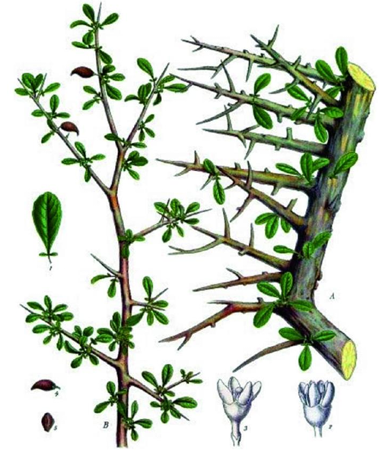

**Figure 13 :** Commiphora myrrhe

**II.1.2Botanical description**

Myrrh trees reach 3 to 10Mabout height (they are smaller in southern Arabia, Ethiopia, India, Somalia, and are characterized by their branches with many thorns (Nomicos, E.Y.H.2007). The majority of species have impared trifoliated oval persistent leaves, very small and unlikely, such as for example inC.myrrh (Tucker, A.O.1986), (Demissew, S.1993).The flowers are also small and white to green in C.myrrh.These dioic flowers have different forms depending on the species, they can be found alone, in panicles, in cymes or in racumes.FruiOvoid ts measure approximately 12-16 mm long, and contain few seeds.Just like in the species of incense, myrrh trees secrete a resin gum when they undergo woundsmechanical, or biotic (Figure 14)).

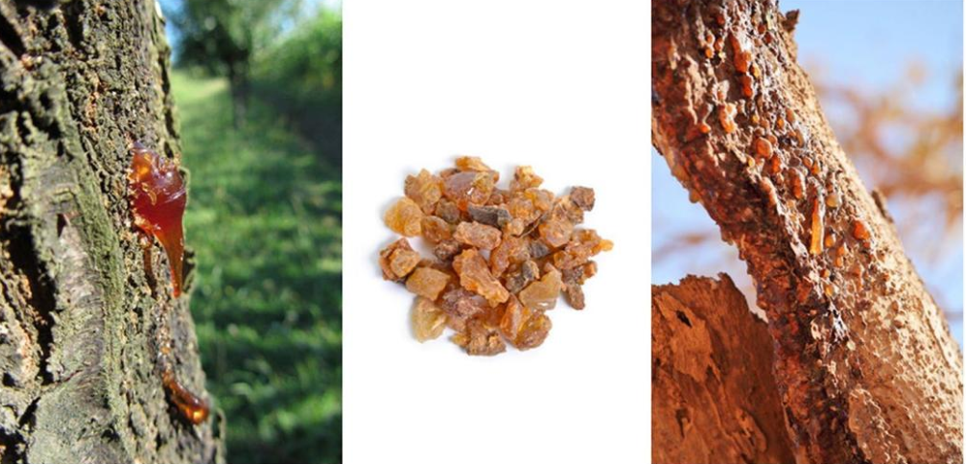

**Figure14#error#**Commiphora Myrrhe, erase in nature

**II.1.3 harvest and traderesin**

In Somalia, there are two periods of "tapping" formyrrhWith around 8 incisions per tree at each period.The rest time is approximately 6 months to 2 years, and if this period is not respected, the tree is exposed to higher risk of death(Lemenih,, M.2004).In the past, the main source of myrrhe marketed was that coming from the speciesC. Erythrea, known asOPOPANAX.Today,myrrhThe most common comes from C. MyrrheVar.Molmol, and its main producers are located in Somalia and Ethiopia and exported nearly 6000 tonnes/year at the end of the 80s(Al-Harrasse, A. et al., 2019).

**II.1.4Physico-chemical propertiesMyrrhe resin essential oil**

* Density at 20 ° C: 0.950-1.040.
* Refraction index at 20 ° C: 1,510-1.535.
* Rotatory power at 20 ° C: -150 ° to -50 °.
* Flash point: 111 ° C.
* Aspect: amber liquid to red or brown amber yellow, slightly viscous.
* Volatility: volatile essential oil, but more viscous than most essential oils.
* Solubility: very soluble in oily oils, alcohol in a high basis**,,**Organic solvents, but not very soluble in water.

**II.1.5 Chemical composition**

Myrrh is an oleo gum resin produced by different species of the genus*Commiphora*.It consists of 3 to 4 % impurities**,,**7 to 17 % of volatile oils, 25 to 40 % soluble alcohol resins, 57 to 61 % soluble gum in water (Massoud et al.2001).

Alcohol soluble resins contain:

* Commiphorical and commiphoric acids,
* Commiférine, Heerabomyrrhols, Heeraboreène (Rao et al. 2001),
* Cinnamaldehyde, cadinène, cumalcool, cuminaldehyde, m-crresol, dipensène, lemonène, pinene, sesquiterpenes, furanosequiterpene, herabolène, terpenes,
* Alcohols, α-camphorane, myrcene, z-guggulsterol, aldehydes I, II, III, guggulsterol.

Water soluble gums mainly contain:

* Galactose, arabinosis, 4-o-methylglucuronic acid, xylose,
* Acid polysaccharides(BissetAndWichtl. 1994),
* Proteins (18-20 %) (Leung, L.1980).

The volatile fraction of myrrh is rich in:

* Furano-sesquiterpénoids (Elemental Structures, Eudesmane,Guaiane, Runcates),
* Aromatic compounds responsible for its characteristic odor(Bruneton, J. 2009),,
* Bioactive constituents such as furanodiene, curzérene and furanoeudesma-1,3-Diene, which contribute to its analgesic properties (Dolara, P.et al.1996).

Of the results foundInTable 2 (Ljaljević Grbić, M.et al.2018):: **""**Oilessential to*myrrh*contains several dominant compounds.Furanoeudesma-1,3-dène is the main constituent, representing 17.65 %of its composition, followed by curzerne at 12.97 %, and β-elemene at 12.70 %.We also find germacrene B at 12.15 %, germacrene D at 9.13 %, German has 5.87 %, and finally linden at 5.34 %.These elements contribute to the aromatic and therapeutic properties of essential oil. **»»** (Figure 15).

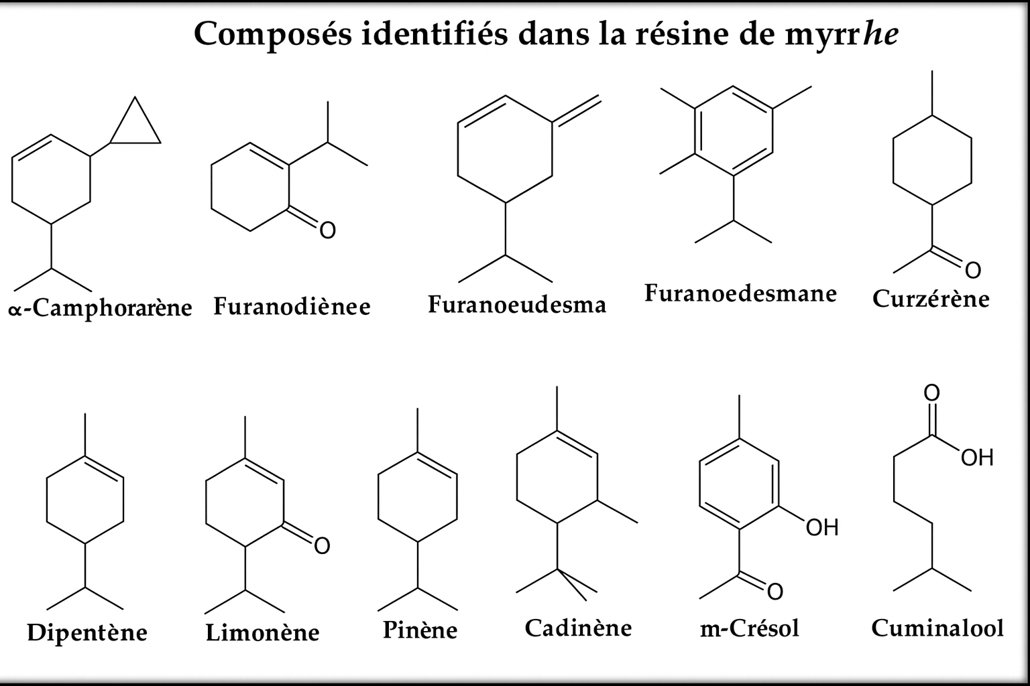

**Figure 15::**Chemical structures of dominant compounds identified in myrrh essential oil

**Table 2:**Main constituents identified in myrrh and their approximate percentages (Ljaljević Grbić, Mr.et al.2018)

|  |  |
| --- | --- |
| ***Compound*** | ***Percentage (%)*** |
| Furanoeudesma-1,3-Diene | 17.65 |
| Curzérene | 12.97 |
| β-Elemène | 12.70 |
| Germacrene B | 12.15 |
| German germacrene | 9.13 |
| German has | 5.87 |
| Linden | 5.34 |

**II.1.6Therapeutic effect of myrrh biomolecules**

One of the most widely recognized and widely used plant products in Saudi Arabia is C. Myrrhe.It was widely used in ancient traditional medicine as a disinfectant and antibacterial agent, as well as to relieve pain (Above, S.et al. 2012).

The plant is commonly seen atJizan, a city in the Kingdom of Saudi Arabia on the Red Sea coast.C. Myrrhe is a resinoleogumaromatic which is exuded of the rod of C. Myrrhe (Alsharif, K. 2020).It is a powerful antibacterial drug used to treat brucellosis, glandular fever, sinusitis, gingivitis, canker sores and parasitic infections (Abdel-Hay, M.et al. 2002#error#Abdul-Ghani, R. A.et al. 2009).In addition, volatile oils of myrrh and their raw extracts have shown a variety of biological actions, including cytotoxic, anesthetic, anti-inflammatory, antiviral and antibacterial properties (Tipton, D.et al. 2003 ; Food, V. N.et al. 2021).

Previous phytochemical studies have indicated that flavonoids, steroids andlignanasare frequently present in plant stems.Frenchtriterpanoidsare the main component isolated from the resins of the Commiphora species (Shen, T.et al. 2012 ; Dekebo, HAS.et al. 2002).It has been documented that many essential oils of Commiphora species contain monoterpenes, oxygenated sesquiterpenes and sesquiterpenic hydrocarbons (Başer, K.et al. 2003 ; Rehman, M. E.et al. 2022).The development of safe and environmentally friendly pesticides and microbial struggle are essential for public health.

In order to detect bioactive ingredients and Allo compounds Chemicals of medicinal plant resins, raw extracts of plants like C. Myrrhe are studied.In this study,The emphasis was placed on the evaluation of the chemical composition of the methanol extract of resin from the eco-espception of the Arabia desert of C. Myrrhe.This evaluation was carried out by gaseous phase chromatography- mass spectrometry, aimed at identifying the biochemical components responsible for its biological activity.By in vitro tests, the study evaluated the Larvicide efficiency of the vegetable resin against the Aedes larvaeEgypt, while examining its antioxidant and cytotoxic properties.

* **Antioxidant**

A 2010 study published in the journal*Food and Chemical Toxicology*revealed that myrrh could protect against liver damage thanks to its strong antioxidant power.Although this study was carried out on rabbits, its use in humans is also possible.

* **Anti-cancer**

Myrrh also has anticancer virtues.A 2011 study has shown that myrrhe could reduce the proliferation or replication of human cancer cells.Researchers have found that myrrh inhibit the growth of eight types of cancer cells, especially gynecological cancers.Although additional research is necessary to determine precisely how to use myrrh in the treatment of cancer, these first research is promising (Siddiqui, M. Z. 2016#error#, S. et al.2011a).

* **Antibacterial and antifungal**

Historically, myrrh was used to treat wounds and prevent infections.It can still be used to treat minor skin irritations such as athlete's foot, ringworm and acne.Its antibacterial and antifungal efficiency has been demonstrated against several pathogens (SahaAndAhmed.2012).A few drops are applied to a clean towel before applying directly to the skin.

* **Antiparasitic**

A myrrh medication has been developed to treat fasciole, a parasite infecting humans worldwide.This parasite is generally transmitted by ingestion of aquatic algae and other plants.The use of myrrh made it possible to alleviate the symptoms of infection and to reduce the number of eggs in the parasite in the stool (El-AshramAnd Suo.2017).

* **Anti-infectious**

The HE of Myrrhe is a remarkable anti-infectious, which gives excellent results in the event of gastric and oto-rhino-laryngo logical infections (Rahman, MM. Et al.2008).In these indications, it can be used by skin, massage on the spine and the soles of the feet three times a day for four days, or orally after being carefully diluted, for example three drops in fifteen drops of vegetable oil (HV) of nigelle.Immunostimulant, it can both fight infectious agents and stimulate the body to defend itself against pathogenic microorganisms.

* **Analgesic and anti-inflammatory**

Sesquiterpenes give the HE of bitter myrrh of very analgesic propertiesinteresting (Su, S.et al.2011B)).Some traditional African medicines have long integrated it as an oral antalgic.It can be applied in local massage in the treatment of rheumatism and muscle disorders, but also in mouthwash to relieve oral problems.

**II.1.7 othersuses**

Myrrh is recognized for its medicinal and therapeutic properties.It was used in China to treat skin problems from the Kaibao era in 973 AD, India in Ayurvedic medicine, and by Romans to treat worms, abdominal pain and dental problems.In Chinese medicine, myrrh (C. Opobalsamum and C. Myrrha) was used to treat oral ulcers, pain, inflammatory diseases, blood disorders and arthritis.Guggul (C. Mukul) has also been used in Ayurvedic medicine for 3000 years before J.-C. to deal with obesity problems (Shen,T.et al.2012).

She hasbeen approved by the FDA (Food and Drug Administration) as an aromating agent and self -seisoning of sure and as a conservation agent in food and drinks (ShalabyAndHamouda.2014).Recently, products derived from myrrh have aroused increasing interest as therapeutic products and food supplements because of their various beneficial properties, in particular antiviral, anti-obesity, anti-cancer, anticancer, anticancer, anticancehepato protectorsand hypoglycaemia (Orabi, S. H.et al.2020) Commiphora Myrrha L. and its derivative products were used to treat infections, inflammatory diseases, obesity.THEfractures andArthritis.ThereMyrrh in traditional oriental medicine has been used to improve wound care, joint pain, gastric dysfunction and burns (Shen, T.et al. 2012).

The He ofMYrrhe is part of the HE groupsspiritual saying, alongside HEsd ’eNcens and Nard de l'Himalaya renowned to raise the mind.It is therefore often used to create an atmosphere conducive to meditation, makes it possible to forget its hassles and anxieties, and to harmonize the nervous system.It reduces all kinds of mental disorders, such as anxiety, fatigue, phobias, depression or overwork.The He ofMYrrhe Béère is also used in palliative care units to allow patients to go calmly.It also has the reputation of being the HE of acceptance of suffering.

**II.1.8Toxicological datas of the essential oil of myrrh**

Despite the beneficial oils of essential oils, they can be more or less toxic, either in situ (irritation, allergic and photo-toxic reaction), or at the level of an organ (Neurotoxicity, hepatotoxicity, nephrotoxicity, etc.).It is necessary to assess the potential danger, which they are likely to representhasA certain level of exposure to avoid any risks.

Myrrh oil being one of the most common uses in topical application, people with sensitive skin should be careful.Myrrh can cause dermatitis, or skin inflammation, in some people.Always test the oil on a small area before applying it all over the skin to ensure the lack of reactionallergic.This discovery was reported in a study published in Contact dermatitis.

* In case of ingestion, myrrh can cause stomach aches and diarrhea.Although generally without gravity, chronic diarrhea can cause dehydration.It is therefore advisable to stop its use in the event of gastrointestinal disorders.
* Pregnant women should avoid taking myrrh because it can increase uterine contractions.
* Another potential side effect of myrrh is cardiac irregularity and the drop in blood pressure, although this is mainly observed in high doses, greater than 2 to 4 grams per day.Anyone with a heart problem should consult a doctor before using myrrh oil.According to a study published in the journal[Phytotherapy Research](http://www.ncbi.nlm.nih.gov/pubmed/18844256)  (Izzo AndErnst,,2009).
* Myrrh can reduce blood sugar;It is therefore not recommended for diabetic people or suffering from other glycemic disorders.Due to her interaction with blood sugar, she is also not recommended for people who have to undergo surgery.It is advisable to stop its use at least two weeks before the intervention (BoneAndMills, 2013).
* Myrrh essential oil is not recommended for people taking anticoagulants such as warfarin because it could interact with this medication.It is also not recommended for people under antidiabetic treatment, due to the risk of drug interaction (Izzo AndErnst, 2009).

**ChapterIII**

**Materials and operating conditions**

The purpose of this work is to extract and enhance the bioactive compounds present in the Myrrhe resin (*C. Myrrhe*) by comparing two methods: HD and HD-MO, aftera simple grinding(Bs) Andcryogenic grinding(Bc) of the raw material.

The study aims to assess the yield and the extraction kinetics of each method, in order to identify the most effective operating conditions.The extracts obtained were then analyzed by GC-MS for volatile compounds and by HPLC for heavy fractions.

Finally, in vitro and in vivo tests were carried out to assess the biological activities of HEs and extracts.

This work contributes to a better understanding of the influence of extraction techniques on the quality and organic activity of myrrh extracts.

* **Vegetable matter**

The plant material used in this study was acquired from a herbalist located in Semmar (Algiers).According to the information provided by the seller, its origin is assigned to Yemen(Figure 16).

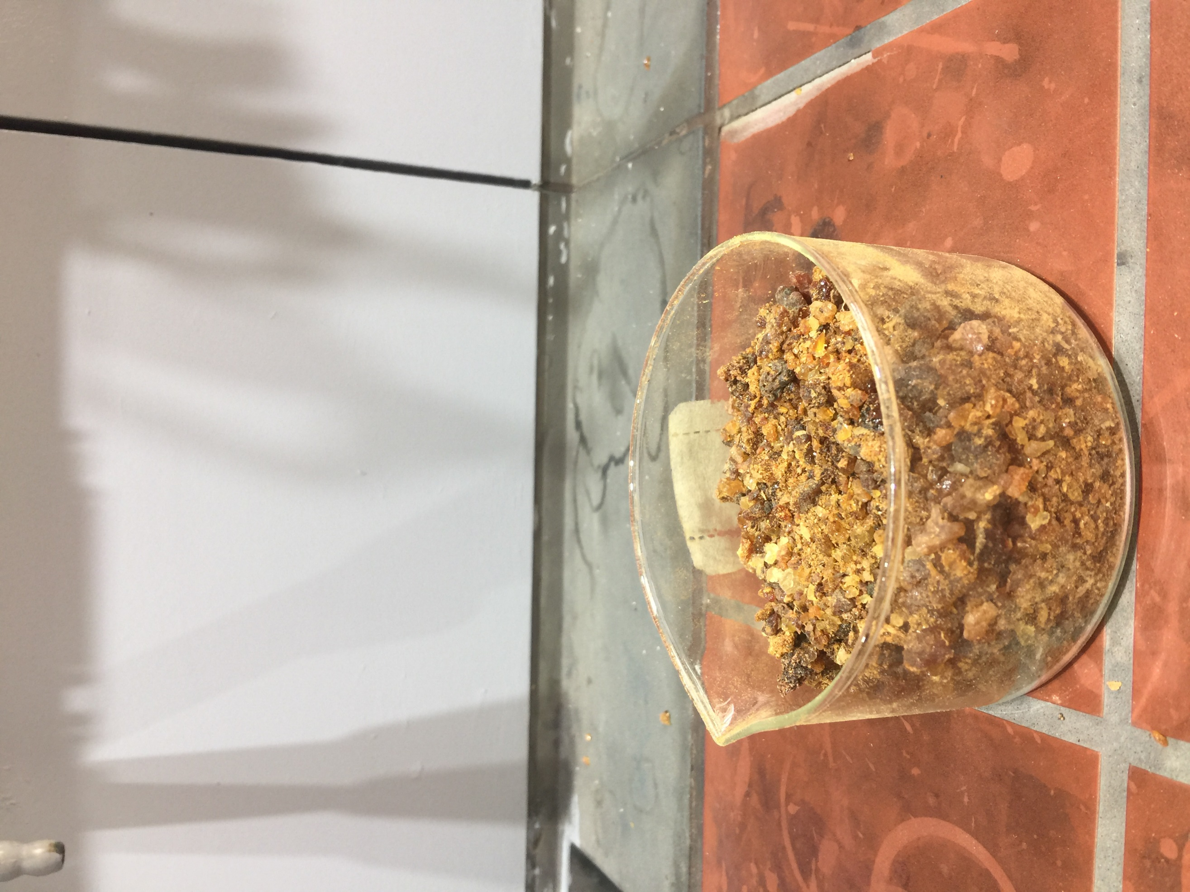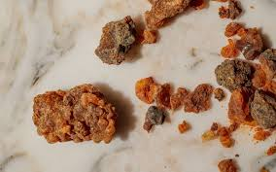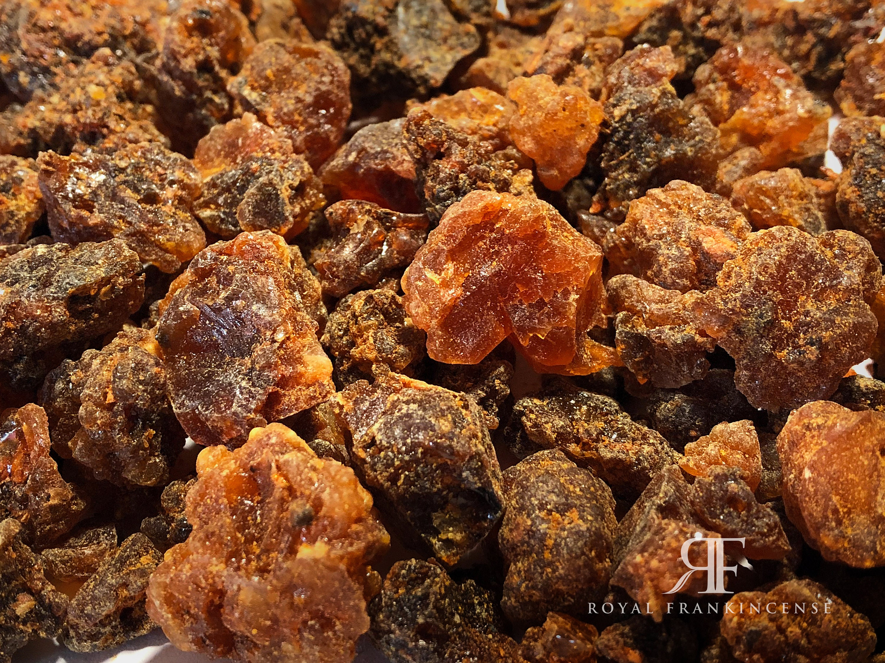

**Figure** **16 :** La matière végétale

**III.1Extraction material and method**

The extraction was carried out at the Master's Laboratory of the Faculty of Chemistry, USTHB.

As part of this experimental work, three extraction methods have been implemented with two types of grinding: simple (BS) and cryogenic (BC) in order to isolate compounds of interest from the Myrrhe resin (Commiphora Myrrha).This is conventional hydrodistillation, hydrodistillation assisted by microwave (Mahd), and extraction by Soxhlet.Each method has been chosen according to the chemical nature of targeted compounds, as well as their volatility, polarity and thermal sensitivity

**III.1.1 Classic hydrodistillation**

* **Principle**

This method consists in heating a heterogeneous mixture of water and resin to the boil to form a heteroazéotrope whose vapors cause volatile compounds.These vapors then condenses in a refrigerant and separate by decantation in an aqueous phase (aromatic water) and an organic phase (essential oil).

* **Procedure**

In a one liter balloon,**150 g crushed myrrhe resin**are introduced, followed by**750 ml of water distilled**, taking care not to fully fill the ball in order to avoid any overflow during boiling.The mixture is then brought to a boil using a bally heater(Figure 17).There**water vapor generated leads to fragrant molecules**released by the resin.These vapors go through a column, then are**condensed in a refrigerant**.The Condensat is collected**drop in a bulb to decant**, where the separation of the phases takes place by difference in density.After distillation,**two phases are formed::**

* **Organic phase**: oily and very fragrant, calledessential oil, containing the majority of volatile compounds.
* **Aqueous phase**: slightly fragrant, calledaromatic water, containing a small amount of fragrant compounds.

L'**essential oil**, being less dense than water, is recovered by**decanation**.

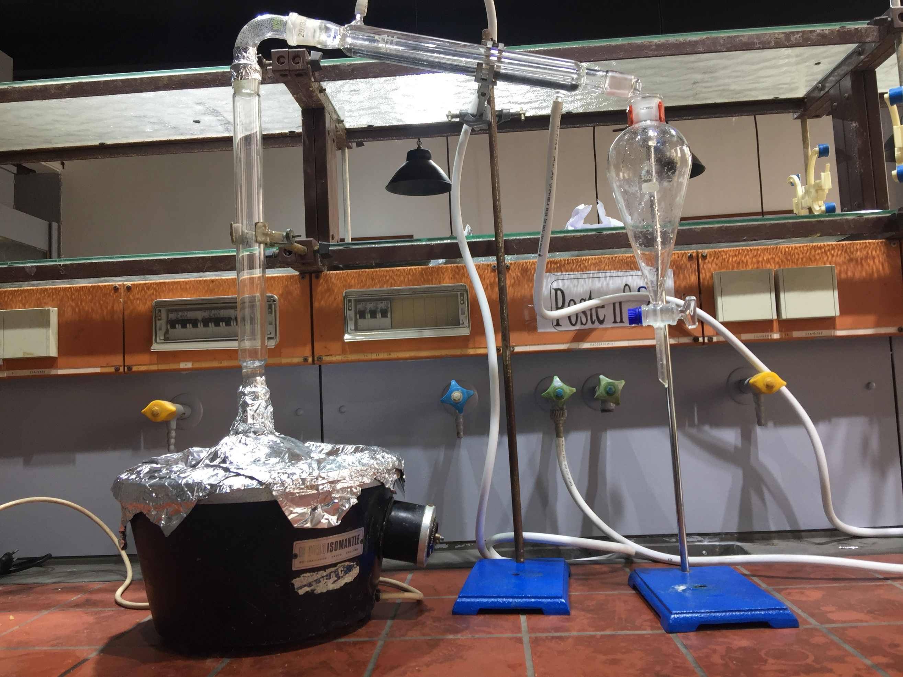

**Figure** **17 :** Montage d’hydrodistillation classique (HD) pour l’extraction de l’huile essentielle de résine de myrrhe

**III.1.2Hydrodistillation assisted by microwave**

* **Principle**

Microwaves are selectively absorbed by the water contained in the resin, causing rapid volumetric heating and the rupture of cell walls.Volatile compounds arethen release more quickly, which significantly reduces the extraction time and energy consumption compared to the conventional technique.

* **Procedure**

A mixture composed of**150 g crushed myrrhe resin** and **750 ml of distilled water**was introduced into a one liter round ball, then placed in a **Modified microwave oven**serving as a heating source.The distillation system includes a**Reflux refrigerant**connected to a**bulb decant(Figure 18).**Microwave heating (600/800 W) has enabled water vaporization and volatile compounds.The condensed vapors were collected drop by drop, allowing the separation of two phases:

* An organic phase (essential oil),
* An aqueous phase (aromatic water).

The essential oil was then recovered by**decanation.**

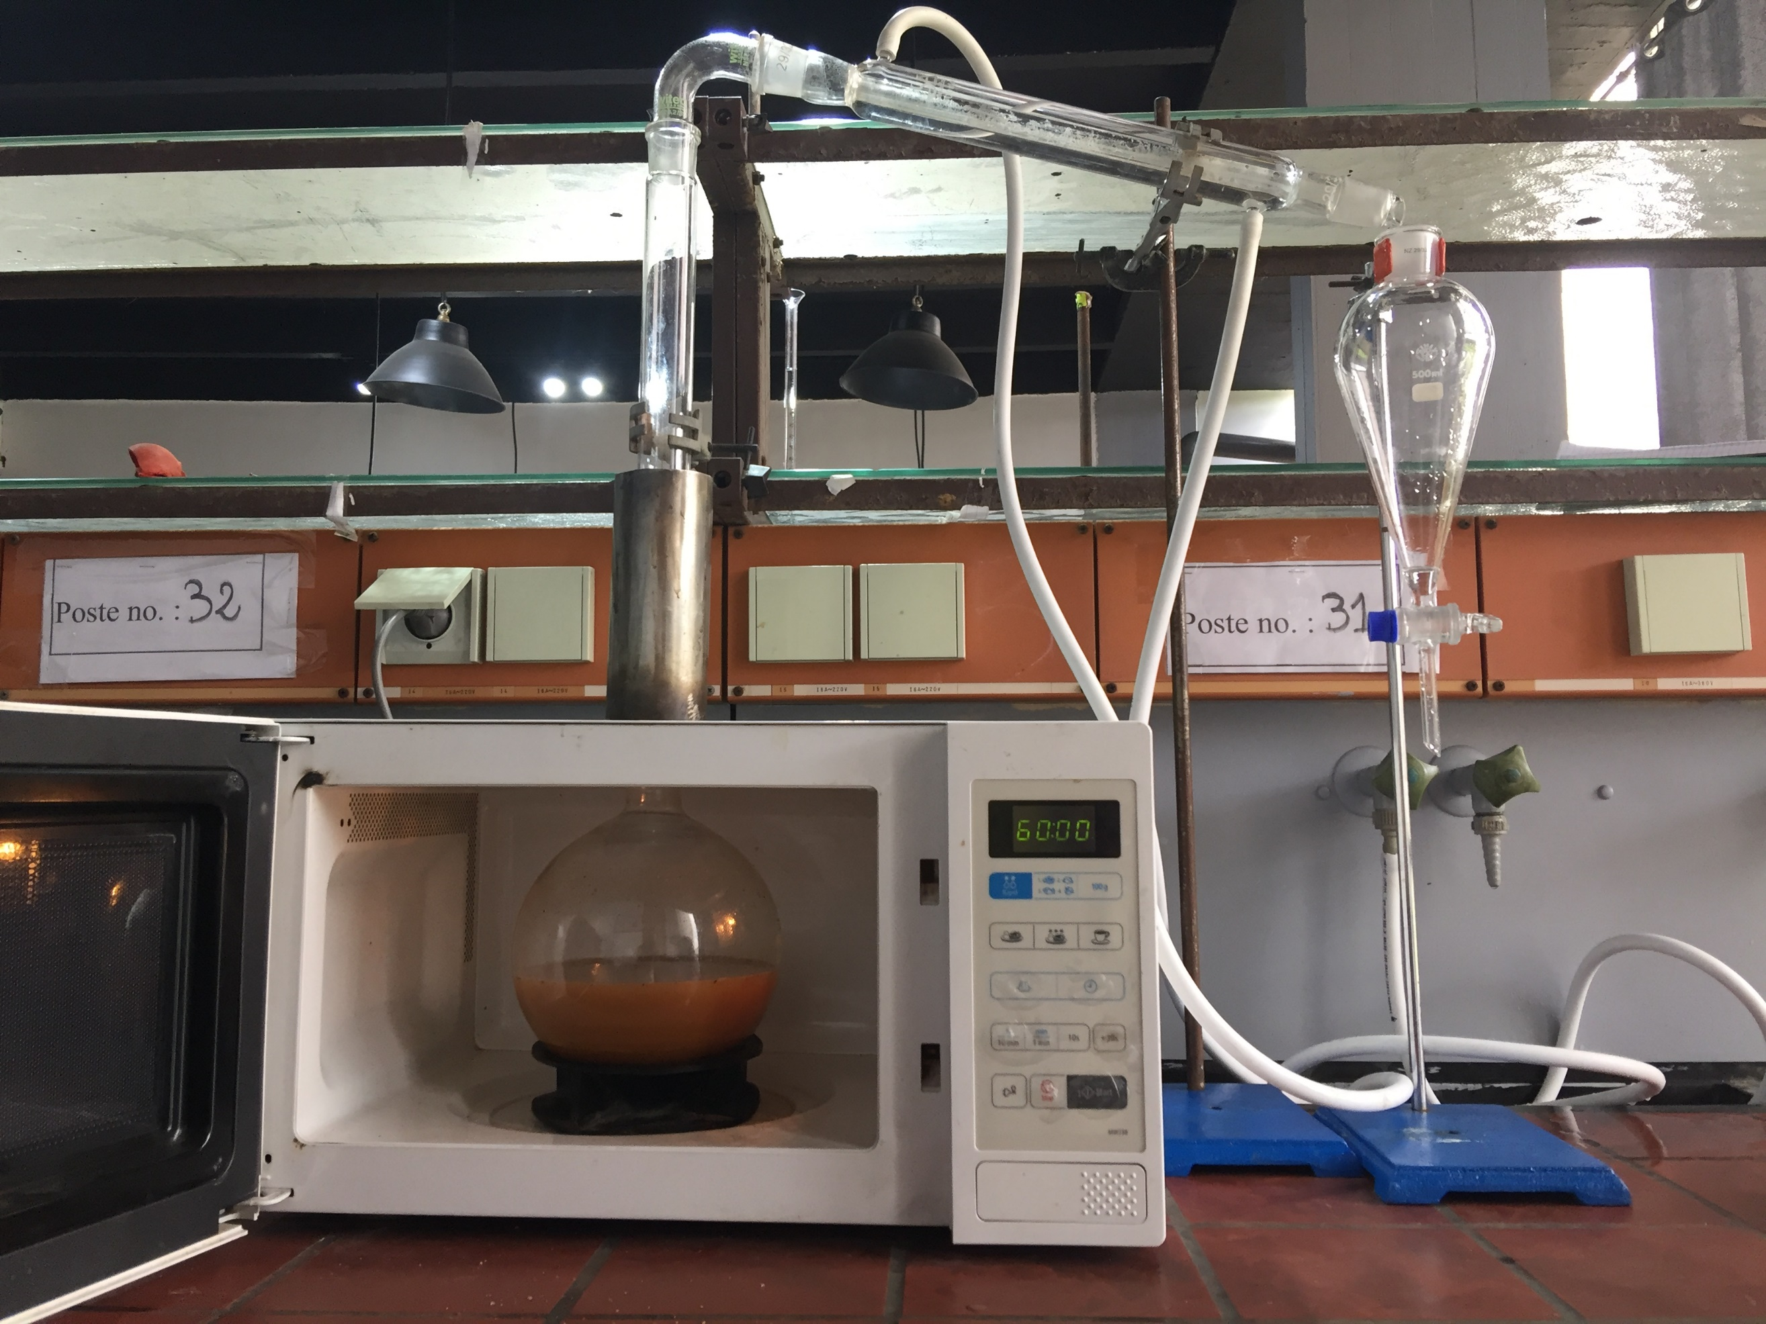

**Figure 18** : Montage d’hydrodistillation assistée par micro-ondes (HD-MO) pour l’extraction de l’huile essentielle de résine de myrrhe

**III.1.3Volatile solvent extraction**

* **Soxhlet extraction**
* **Principle**

Soxhlet extraction is based on a process of**Repeated solid liquid extraction**.THE**Solvent (hexane)**is brought to a boil in a heated balloon, then its vapors**condense in a refrigerant**Located above the cartridge containing the solid sample (crushed vegetable material).

The condensed solvent falls**drop on the sample**, allowing the extraction of lipophilic compounds.When the level of the solvent reaches the siphon, it automatically empties in theDistillation ball, causing the extracted compounds.This**cycle is repeated continuously**, which allows complete extraction without adding fresh solvent to each cycle.

* **Procedure**

Place 150g of myrrhe resin crushed in a cartridge in filter paper (cellulose), closed.Insert this cartridge into the body of the Soxhlet extractor mounted on a 1l round ball containing 250ml of ethanol at 96%.Connect a water refrigerant at the top of the device.

Heat the ball to bring ethanol to a boil (78.37 ° C) (Figure19).Ethanol vapors go up, condense in the refrigerant and fall on the cartridge containing the resin.

The hot solvent percola through the resin, dissolving the lipophilic compounds.Once the extractor's room is filled, the automatic siphon is triggered, returning the enriched solvent (Miscella) to the ball.This cycle is repeated automatically for about 1h30 min, ensuring complete extraction of interest compounds.

After the end of the extraction, let the system cool.Remove the ball containing the Miscella.Eliminate ethanol by vacuum evaporation using a rotary evaporator, thus obtaining the oily extract from the myrrh resin.

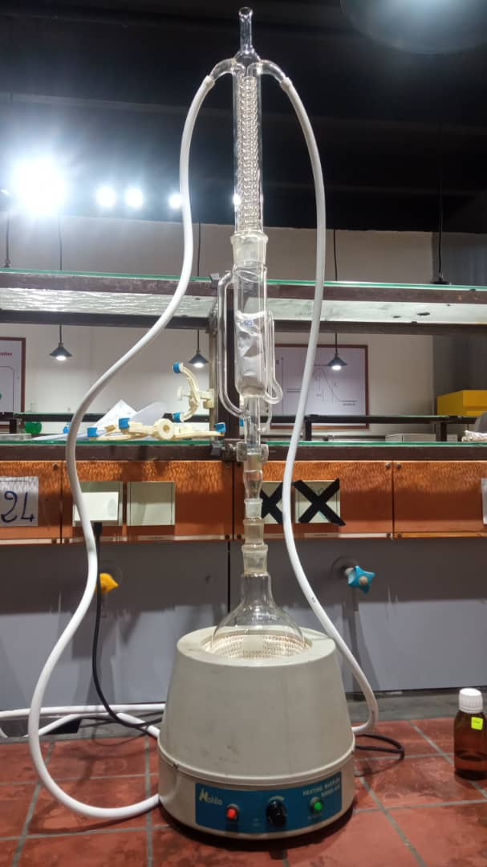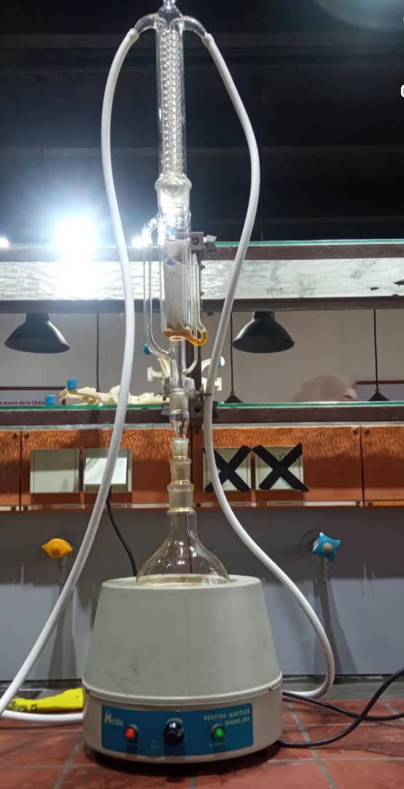

**Figure 19 :** Montage expérimental de Soxhlet utilisé pour l’extraction des composés bioactifs

* **Solvent evaporation**

After extraction, the oil and the solvent mixed (liquid-liquid mixture) in a single phase.To separate them, you must first evaporate the ethanol solvent.For this operation, rotary evaporation orthe rotary evaporatoris used(Figure 20).After this operation, the extract obtained is weighed.

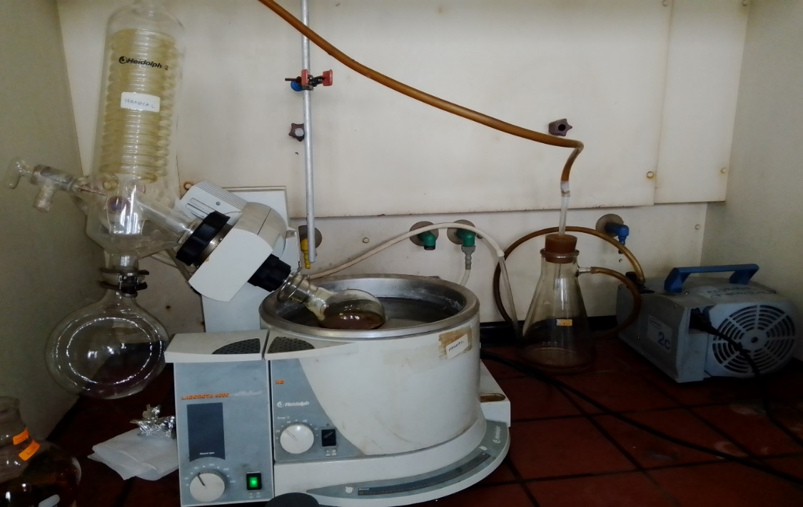

**Figure 20** : Dispositif expérimental de l’évaporateur rotatif (évaporateur rotatif) utilisé pour la concentration sous vide des extraits

After extraction and recovery, the essential oil and the extract obtained by the different extraction methods were stored in sterile glass bottles.These were then placed in the refrigerator at a temperature of 4 ° C, in order to preserve the stability of volatile compounds until they are used for phytochemical analyzes and biological activity tests.

**III.2 Operating analysis conditions**

**III.2.1 Operating conditions of analysis of essential oils by Gaser phase chromatography coupled with mass spectrometry (GC-MS)**

Essential oils are complex mixtures made up of organic compounds with a wide variety of carbon structures and chemical functions.Their analysis generally requires in -depth work of**separation**and d ’**identification**.There**Gaseous phase chromatography coupled with mass spectrometry (GC-MS)**stands out as the most appropriate technique for this type of analysis, due to its sensitivity, high resolution and its ability to identify the compounds present even in the state of traces(Figure 21).

* The analysis was carried out using a gas phase chromatography (GC) coupled with a mass spectrometer (MS), depending on the following parameters:

For gaseous chromatography, an HP-5 ms type hair column(stationary phaseapolar5% - Phenylusand 95% -methodOlysiloxane ))was used, containing an Apolar stationary phase.This column has the following dimensions: 30 meters in length, an internal diameter of 250 µm and a film thickness of 0.25 µm.Helium (Hey) has been used as a vector gas, with a flow rate fixed at 1.5 ml/min.

The sample injection was carried out in Splitless mode, with an injection temperature maintained at 250 ° C.A volume of 25 µl has been injected, corresponding to a solution of essential oil diluted in 1 ml of 99.99 %pure methanol.

The oven temperature program was defined as follows: a first support phase at 250 ° C for 10 minutes, followed by a rise in temperature at a rate of 4 ° C/min until reaching 60 ° C, temperature maintained for 8 minutes.

Regarding mass spectrometry, the analysis was carried out in scanning mode (scan), with ionization by electronic impact at 70EV.The temperature of the ion source has been set at 230 ° C, that of the quadriple at 150 ° C, and the temperature of the auxiliary element at 300 ° C.

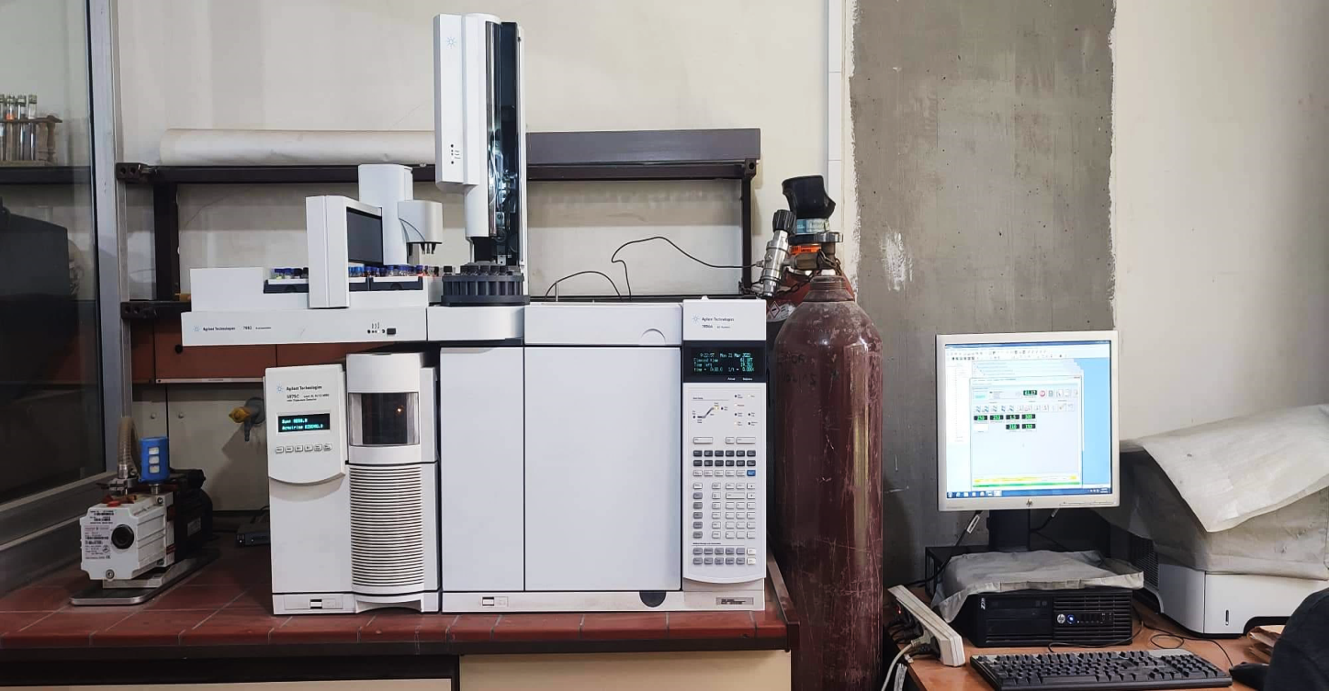

**Figure 21 :** Appareillage GC/MS, type AG Technologies : GC 790A, Auto sampler 7693, SM

5975C Inert XL EI/CI MSD

* **Determination and identification of compounds by GC-MS**

The identification of the compounds present in the essential oil was made from the chromatograms obtained by GC-MS, based mainly onretention indices(RI).These clues were calculated according to the Van den Dool equation andKratz, allowing normalization of the retention time of volatile compounds compared to a series of N-Pauffinic alcanes analyzed under the same conditions.

The equation used is as follows:

$$RI=100n+100×\left(\frac{tri−trn}{tr\left(n+1\right)−trn}\right)$$

With :

* **RI**: Retention index of the unknown compound,
* **n**: Number of n-alcanne carbon atoms elected just before the unknown compound,
* **sorting**​: Retention time of the unknown compound,
* **trn**​: Preceding n-alcan retention time,
* **TR(n+1**)): Retention time of the following n-alcana.

This method allows a more reliable and reproducible comparison of volatile compounds, regardless of minimal variations in chromatographic conditions.The identification of the constituents was then confirmed by two additional approaches:

1. Comparison of experimental retention indices with those postponed in the literature.
2. Analysis of mass spectra, compared to reference libraries (such asNistOrWiley), making it possible to identify the compounds on the basis of their characteristic fragmentation.

All of these data (retention time, retention index, and mass spectrum) allowed a reliable characterization of the main volatile compounds present in the sample analyzed.

**III.2.2Operating conditions of analysis by high performance liquid chromatography (HPLC)**

HPLC is particularly suitable for the analysis of polar and non -volatile compounds present in myrrh resin extracts.Thanks to its high performance in separation and its compatibility with the heat -sensitive compounds, this technique allows fine identification of secondary metabolites, such as flavonoids, phenolic acids and other bioactive compounds.

* The experimental conditions applied during HPLC analysis#error#

The ethanolic extract was dissolved in 15ml of acidified distilled water (pH = 2), then subject to three successive extractions using a mixture of 15ml of ether diethyland ethyl acetate (1:1 v/v).After extraction, the organic phase was recovered and the organic solvents eliminated using a rotary evaporator.The residue was dissolved in a hydro-MEsthanolic (30:70 v/v) before being injected into the HPLC.

SixteenPhenolic stacks were analyzed by HPLC.Diluted samples fromMyrrh resinwere injected into the HPLC.The separation of the phenolic compounds was carried out using an HPLC system agilent series 1260 equipped with a quaternary pump with degaseur associated with an automatic thermostatic sampler.

Control of the instrument and data analysis were carried out using the agilent softwareChemstation.The separation of phenolic compounds was carried out on a column C18In reverse phase (5 µm, 150 mm × 3 mm in internal diameter) Thermostatized at 35 ° C per HPLC equipped with a barrette detector of diodes.The solvent system used was an A gradient (water + 0.1 % formic acid) and B (acetonitrile + 0.1 % formic acid).The solvent flow was 1.5 ml/min.The sample injection volume was 20 µl.The elution gradient was thefollowing :0-5 % B (0-10 min);5-17 % B (10-18 min);17-25 % B (18-33 min);25-100 % B (33-48 min);100-5 % B (48-51 min).TheredetectionAndidentificationPhenolic compounds have beenmadeat 254.4 Nm and 280.4 Nm using a Diode bar detector (DAD);identificationPeaks have been obtained by comparing the retention time and the UV spectra of the chromatogram with those of pure stallions.

* **Determination and identification of HPLC compounds**

High performance liquid chromatography (HPLC) is an analytical technique of choice for the separation, detection and identification of non -volatile and thermosensible compounds present in the myrrh resin.It makes it possible to split the complex mixtures of plant extracts depending on the differences in polarity, molecular size or chemical affinity with the stationary phase of the chromatographic column.The identification of the main bioactive compounds is carried out by comparison of the retention times obtained with those of authentic standards, as well as by spectral analysis via a UV-visible detector, generally adjusted to a wavelength adapted to the functional groups present (280.4NM and 254.4NM).In addition, the data obtained is faced with that of the literature to confirm the nature of the identified compounds.

This method ensures a precise and reliable characterization of the key secondary metabolites of myrrh, thus contributing to a better understanding of its pharmacological properties.

**III.3In vitro activities**

This study was carried out in microbiology and physico-chemical laboratories: Saidal Dar El-Beida production site.It was divided into three parts (antimicrobial, anti-inflammatory and antioxidant).

**III.3.1.Antimicrobial**

Antibacterial and antifungal activity means the capacity of a compound to inhibit or eliminate both bacteria and pathogenic fungi.Myrrh resin (*C. Myrrhe*), widely recognized for its therapeutic virtues, is particularly studied for its antimicrobial properties against bacterial and fungal pathogens.In this context, HES andMyrrh extracts were assessed on different bacterial and fungal strains using standard microbiological methods.

In this study, myrrh extracts have been prepared in the form of solutions to defined concentrations usingDmso, while the essential oil has been used pure, also dissolved in the DMSO for antibacterial and antifungal activity tests.

* **The principle**

The process consists in disseminating discs permeated by the extract to be analyzed on a solid medium, where a test germ has been previously sown(Figure 22).Once the diffusion has been reached, an inhibition zone appears around the discs, indicating the effect of the extract on bacterial growth.The measurement of the diameter of this area makes it possible to assess the sensitivity of the microorganism tested and the intensity of the antimicrobial activity of the sample, using a scale of diameters of the inhibition zones.

**Figure22::**Antimicrobial activity by the discharge method on a nutrition

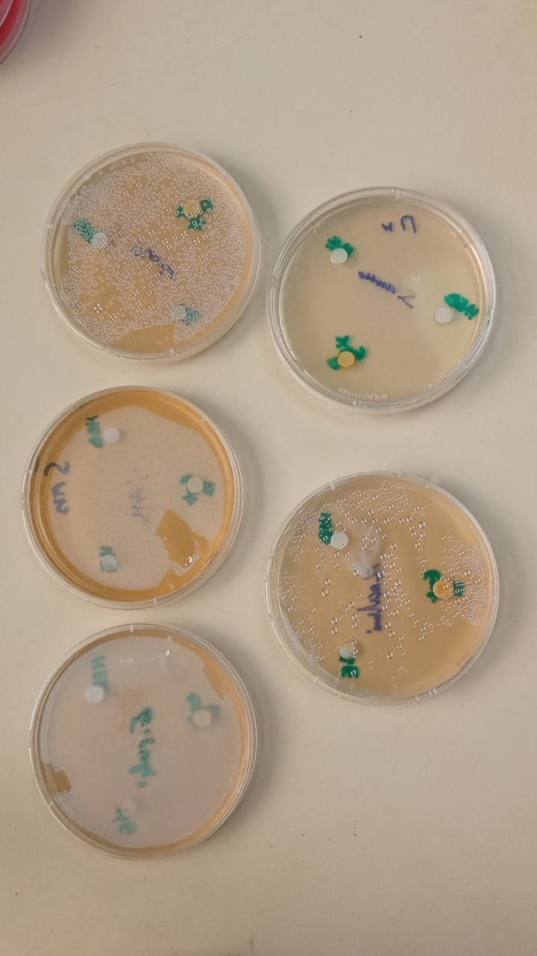

The referenced microbial strains consist of three bacteria and three fungal strains.They come from the unity of Saidal -Dar elBeidaAlgiers(Painting3))*.*

**Painting3 ::**THE microbial strains tested as well as their references

|  |  |  |  |  |  |
| --- | --- | --- | --- | --- | --- |
| **Strain#error#** | | | ATCC | Gram | **Official clsi standards** |
| ***Escherichia coli*** | | | 8739 | - |  |
|  | | |  |  |  |
| ***Staphylococcus aureus*** | | | 6538 | + | Resistant ::#error##error#mm |
|  | | |  |  |
| ***Pseudomonas#error#*** | | | 9027 | - | Sensitive ::#error#mm < D < 14mm    Very Sensitive: 15mm < D <#error#mm |
|  | | |  |  |
| ***Bacillusspizizenii*** | | | 6633 |  | Extremely Sensitive: D>#error#mm |
|  | | |  |  |
| ***Candidates albicans*** | | | 10231 |  |  |
|  | | |  |  |  |
|  |  |  |  |  |  |

* **Procedure**

The evaluation of the extract antimicrobial activity was carried out according to the solid environmental method.This approach first consists of seeding the microbial germ targets on a sterile agar, ensuring a homogeneous distribution of microorganisms.Sterile paper discs, previously impregnated with the extract to be tested, are then placed on the surface of the inoculated medium.

After incubation, the diffuse extract radially around the discs, inhibiting microbial growth if it has an antimicrobial effect.This inhibition is reflected in the appearance of a clear area, free from growth, delimited around each disc.The diameter of this inhibition area, measured in millimeters, quantifies the inhibitory effect of the extract.The more extensive this area, the more significant antimicrobial activity is considered.

* **Comparison with witnesses**

Negative witnesses: a solvent like DMSO is used to ensure that the effect observed comes from the extract and not from the solvent.

**III.3.2Anti-inflammatory**

The assessment of anti-inflammatory activity makes it possible to verify the capacity of an extract to reduce an induced inflammatory reaction.Myrrh resin (C. Myrrhe), traditionally used to relieve pain and inflammation, has been tested in this context using an appropriate biological model.This approach aims to explore its effectiveness in comparison with a standard anti-inflammatory.

* **The principle**

Inflammation is often associated with the denaturation of proteins.This test assesses the ability of an extract to prevent the denaturation of serum albumin, simulating an anti-inflammatory response.An inhibition of this denaturation reflects a protective effect comparable to that of an anti-inflammatory.

* **Experimental protocol**

1. Preparation of oil and myrrh extract: in vials, dilue:

* Oil:M **HEY**= 0.15g Vethanol = 10ml
* The extract: M**Extract**= 0.15g Vethanol= 10ml

1. Extraction of albumin from egg whites(Figure 23)#error#

* Preparation of the solution: separate the 6 egg whites and place them in a clean container, then add a purified volume of water equivalent to the volume of egg whites.
* Agitation: Shake the solution obtained (egg whites + purified water) for 15 minutes at room temperature to properly mix the two components.
* Adding vinegar: Add 2 to 3 drops of white vinegar for each 100 ml of solution (egg whites + purified water).Vinegar promotes albumin coagulation.
* Centrifugation: centrifugal the solution to 3700 rpm for 15 minutes to separate the different phases (sediment and liquid phase).
* Washing the sediment: Recover the sediment (which contains albumin) and washing it with distilled water to eliminate the remaining impurities.
* Recovery of albumin: After washing, recover the sediment which contains albumin.The latter can be used for other applications.

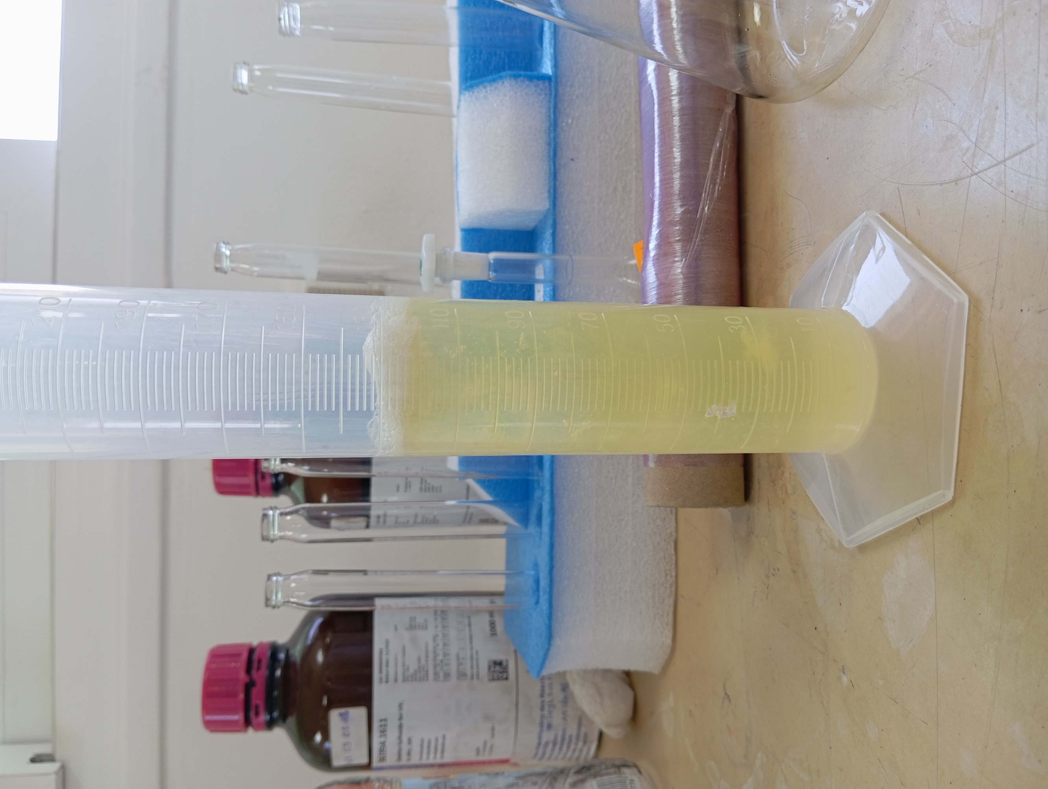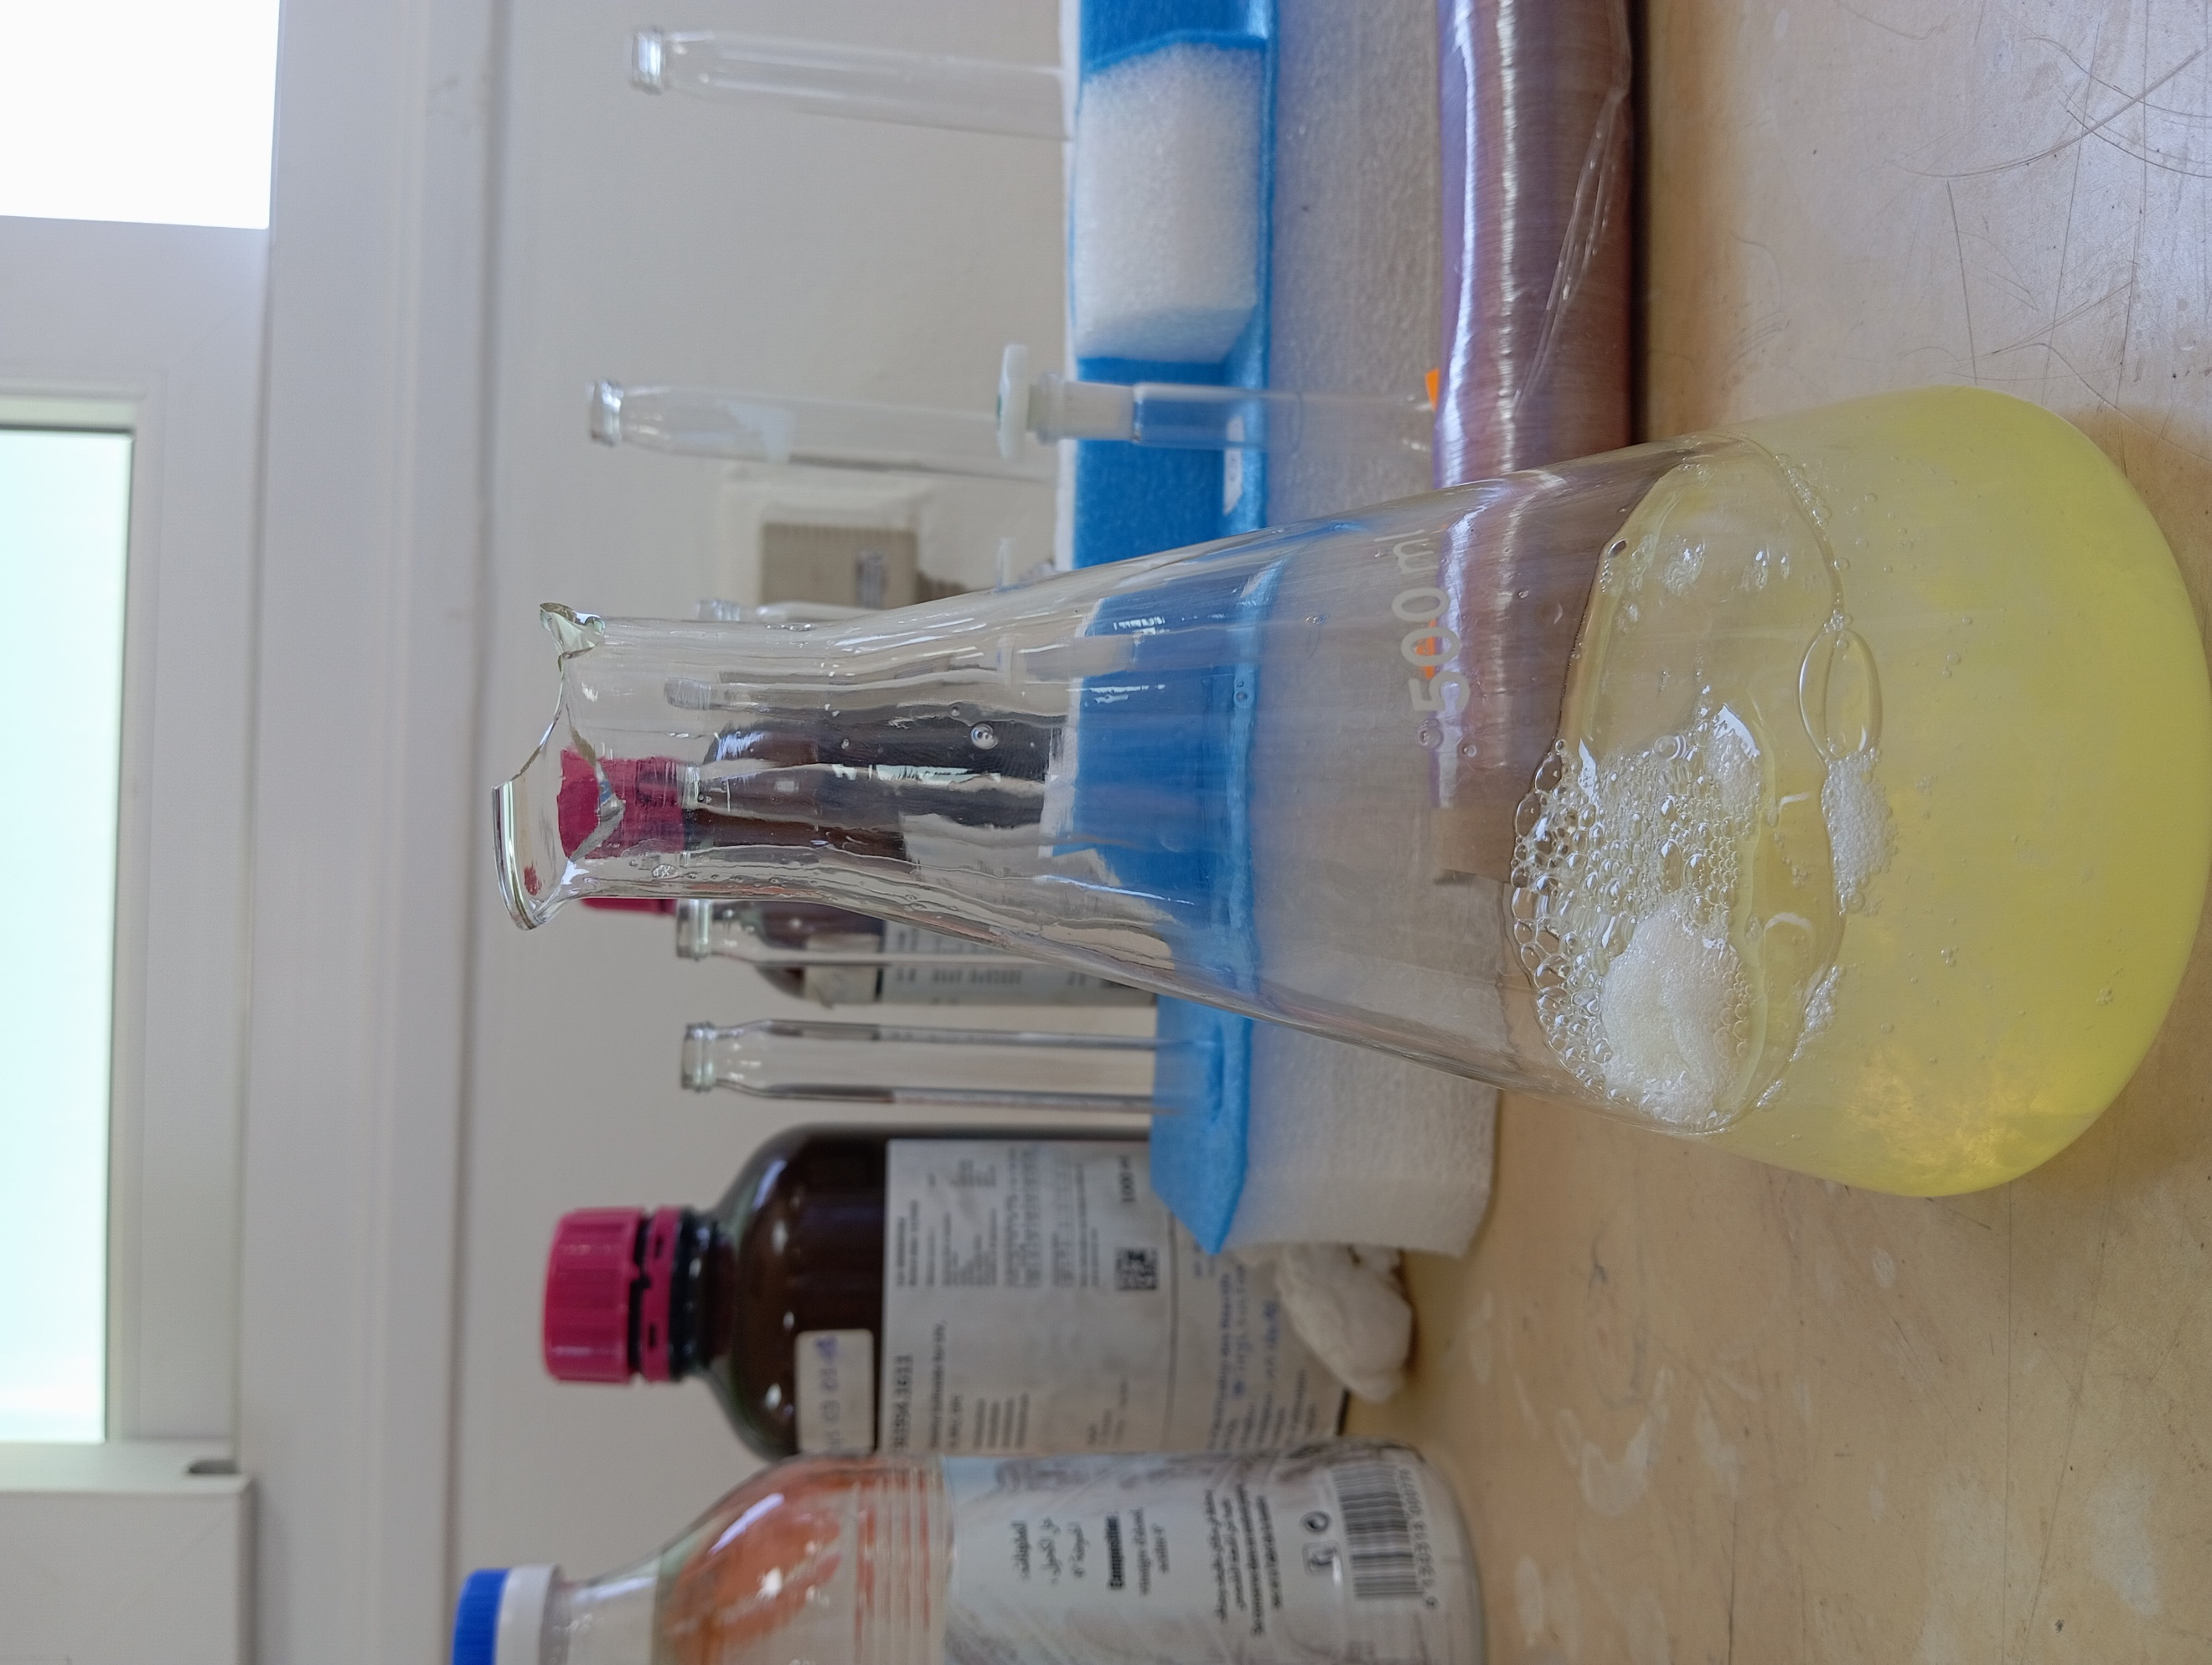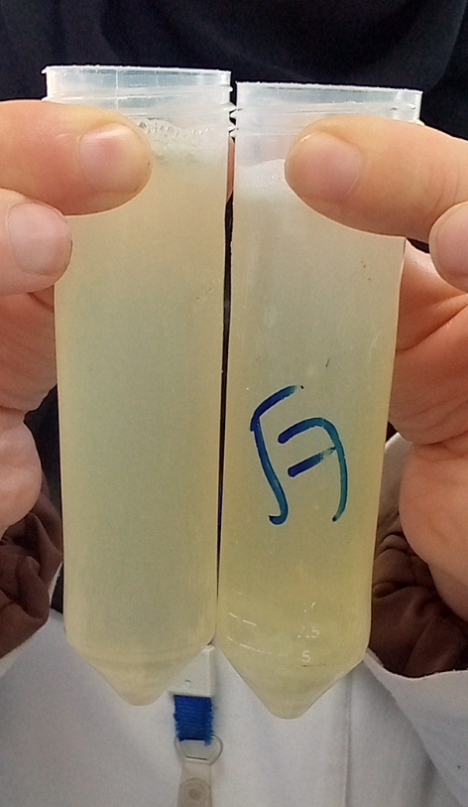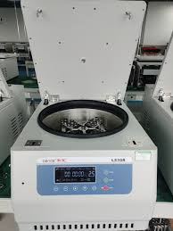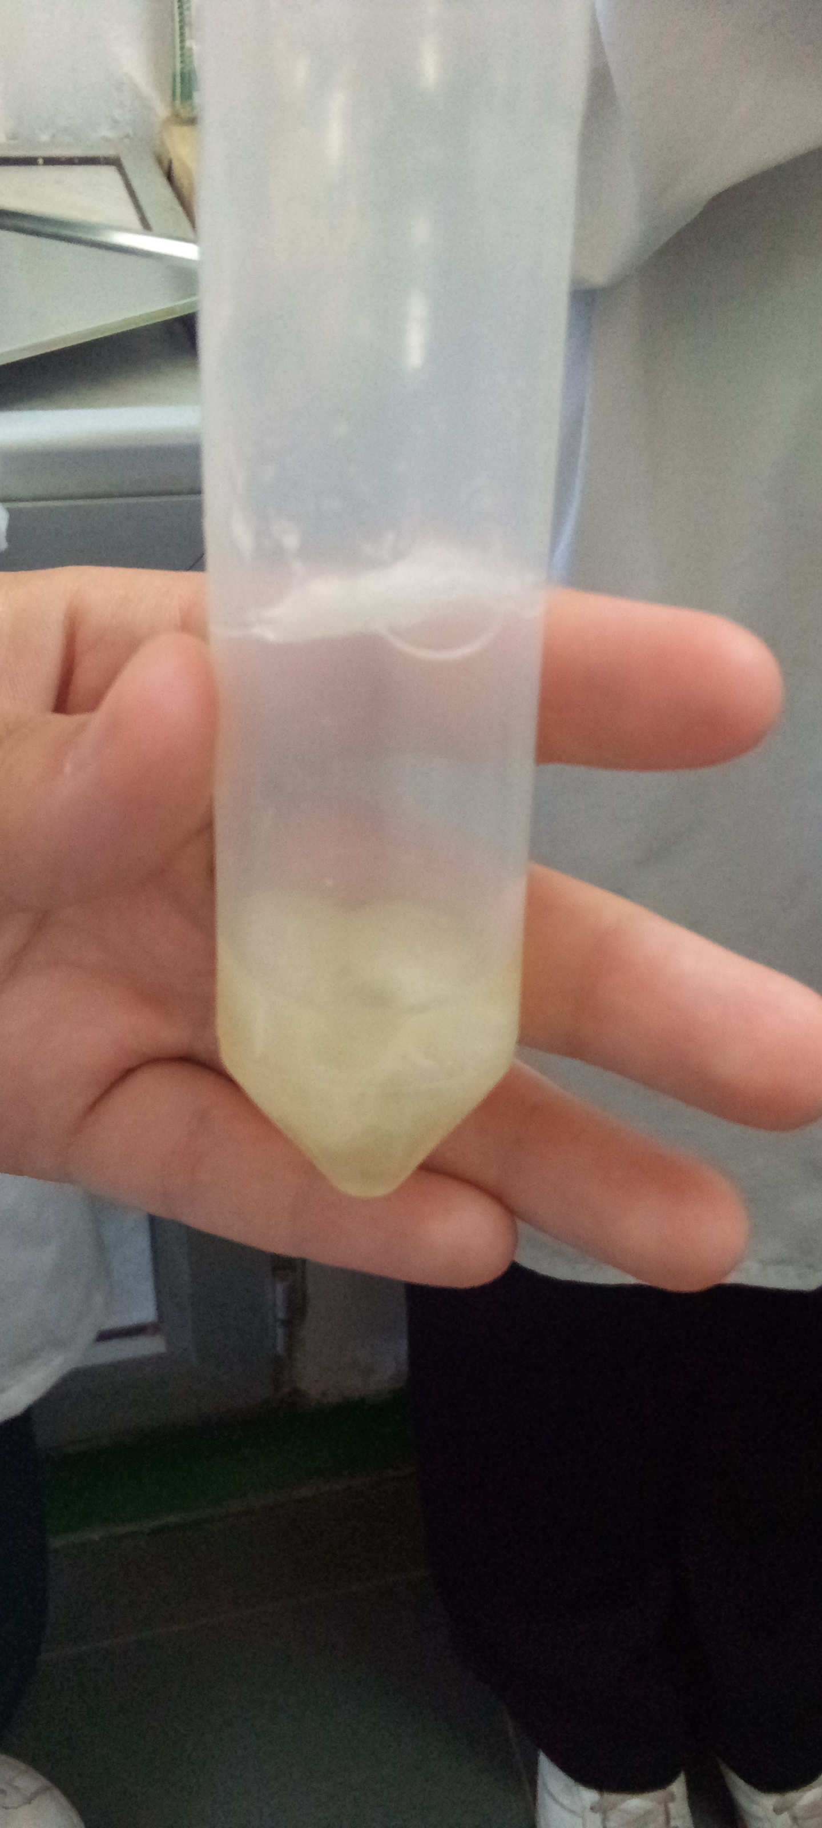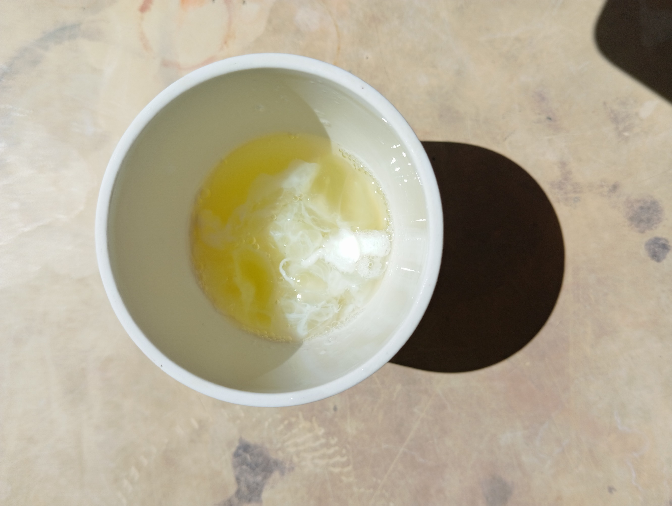

**Figure 23 :** Étapes photographiques de l’extraction de l’albumine à partir des blancs d’œuf

1. Preparation of the albumin 2%solution:

We weigh 2 g of albumin, which we then mix with 100 ml of distilled water.The mixture is agitated for 2 minutes using an agitator.

1. Preparation of reaction mixtures:

* **Preparation of tubes:**For each essential oil or extract, prepare the following tubes:
* 5 reaction tubes (named A to E for HE and 1 to 5 for extracts),,
* 1 witness tube only containing albumin,,
* 1 witness tube without HE or extract.
* **Preparation steps:**

Tube A: Add 2 ml of ethanol + 2 ml of the HE.→ Shake carefully.

Tube B: Take 2 ml of the A + 2 ml tube solution of ethanol.→ Shake.

Tube C: Take 2 ml of the tube solution B + 2 ml of ethanol.→ Shake.

Tube D: Take 2 ml of the C + 2 ml tube solution.→ Shake.

Tube E: Take 2 ml of the tube solution D + 2 ml of ethanol.→ Shake.

Then take 2 ml from this final solution and throw it away.(We're going to do the same steps for the extract).

* **Adding the buffer solution and albumin:**In each tube A to E (1 to 5), then add: 2.8 ml of buffer solution + 0.2 ml albumin solution

1. Induction of denaturation: Heat the tubes in a double boiler at 72 ° C for 5 minutes.
2. Cooling: Let the samples cool at room temperature.
3. Measure: measure the absorbance at 660 Nm using a spectrophotometerUV.

#### **Calculation of inhibition (%)****::**

#### **Inhibition (%) = $AContrôle−Aéchantillon∨\frac{}{AContrôle}$* 100**

#### 

* HASControl::absorbancenegative witness (without extract),,
* HASsample: absorbance of the tested extract.

**Remarks :**

* The higher the percentage of inhibition,**The more marked the anti-inflammatory effect.**
* It is recommended to do the tests in**triplicate**to ensure the reliability of the results.

**III.3.3 Antioxidant**

Antioxidant activity reflects the ability of a compound to neutralize free radicals, responsible for oxidative stress and various cellular disorders.The myrrh resin (C. Myrrhe), rich in phenolic and terpenic compounds, is traditionally used for its protective properties.In this study, its extracts were assessed for their antioxidant potential using an adapted in vitro test.

* **Principle of antioxidant activity (DPPH method)**

The DPPH test is based on the ability of antioxidants to give an electron or a hydrogen atom to the free radical DPPH • (2.2-diphenyl-1-picrylhydrazyl), thus resulting in its reduction.This reaction causes a change in color of dark purple to pale yellow, measurable by a decrease in absorbance at 517 nm.The greater the drop in absorbance, the higher the antioxidant power of the sample.

* **Procedure**

1. **Preparation of a DPPH solution**

The DPPH solutionwas prepared in a vial deemed by the solubilization of 4.1 mg of DPPH in 100 ml of ethanol.We cover the vial with aluminum for 30 min(Figure 24).

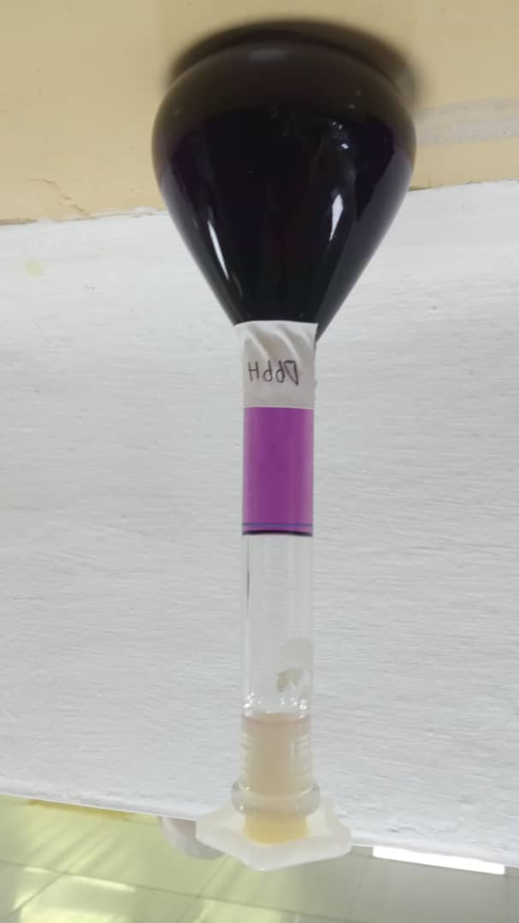

**Figure 24 :** La solution de DPPH

1. **Preparation of a mother solution from HE and extract**

To prepare the mother solution,**0.1 g of essential oil (HE)**And **0.1 g of extract**were weighed with precision, then dissolved in ethanol.The final volume was adjusted to**10 ml**Using a gauged vial.The final concentration obtained for each mother solution is to**10 mg/ml(Figure 25).**

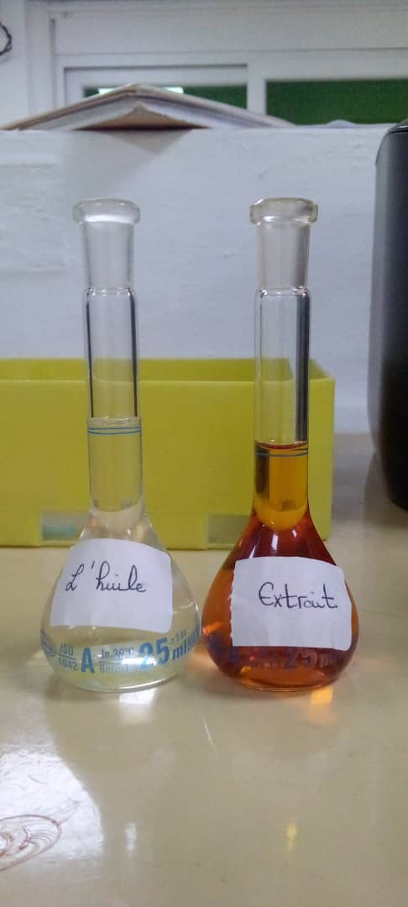

**Figure 25 :** Solutions diluées d’huile essentielle et d’extrait utilisées pour les tests

1. **Preparation of dilutions**

Dilutions of decreasing concentrations have been prepared from a mother solution of**10mg/ml**, in order to obtain the following concentrations intended for Activ testsiteAntioxidant: **5mg/ml, 1mg/ml, 0.5mg/ml, 0.1mg/ml, 0.05mg/ml, 0.01mg/ml, 0.005mg/ml, 0.001mg/mland 0.0001 mg/ml(Figure 26).**

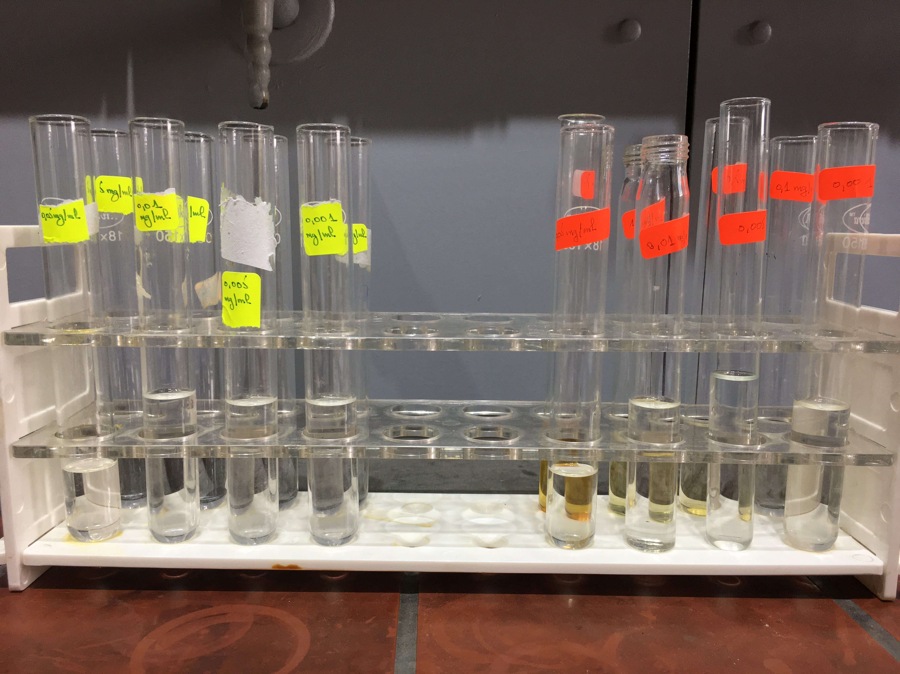

**Figure 26** : Différentes dilutionspréparer

* The percentage of inhibition is calculated according to the formula below:

**Pourcentage d`Inhibition (%) = $\frac{Ao\left(Contrôle\right)−Ao\left(échantillon\right)}{Ao\left(Contrôle\right)}$* 100**

1. **Reading antioxidant activity results**

At 517 nanometers in fact reading by using the visible UV spectrophotometer(Figure 27).

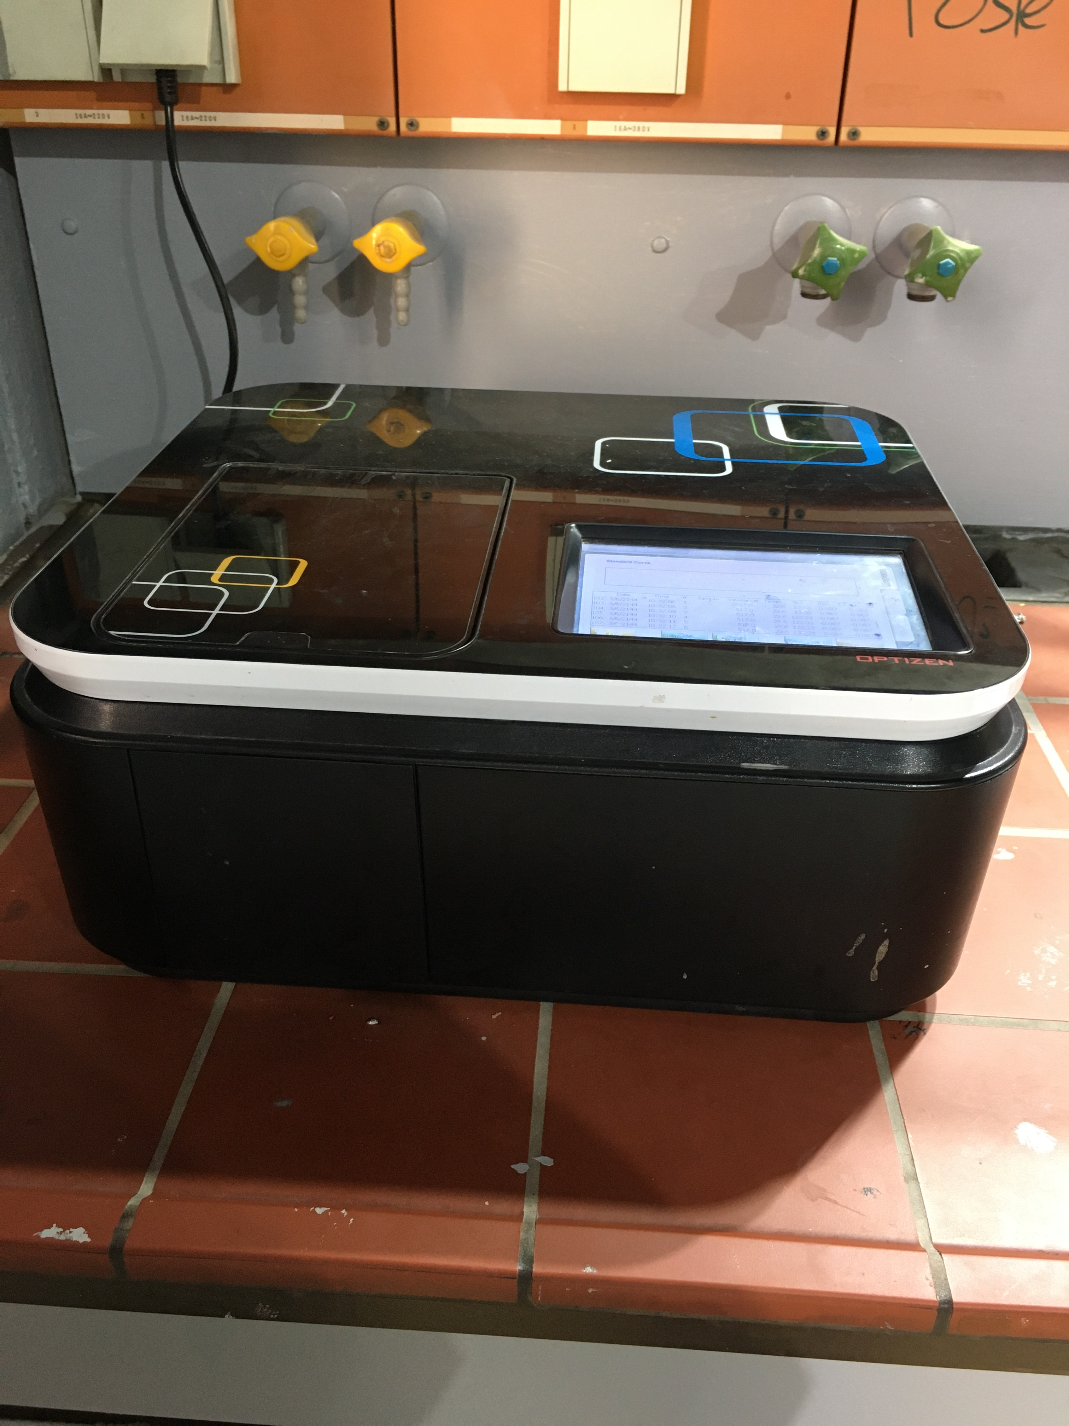

**Figure 27** : Appareil de spectrophotométrie UV utilisé pour les analyses

**III.4In vivo activities**

This in vivo study was carried out within the laboratories of the École normale supérieure (ENS) and focused on the evaluation of the analgesic activity of the experimental formulation.Three complementary tests have been implemented: the tail withdrawal test (Tail-Flick), the heating plate test (Hot Plate) and the torsion test (Writhingtest).

**III.4.1 Evaluation of the analgesic activity of the myrrhe extract**

The evaluation of the analgesic activity of the Myrrhe extract was carried out using**Murine behavioral models**recognized for their sensitivity to substances with analgesic potential.Three additional tests were used: the**tail removal test**(Tail-Flick Test) and the**test heating plate**(Hot Plate Test) and the torsion test (Writhingtest).These methods make it possible to measure the nociceptive response induced by a thermal stimulus, respectively at the level**spinal** (Medullary reflex) and **supraspinal**(central integration of pain).These models are commonly used in experimental pharmacology to characterize the analgesic effects of natural or synthetic compounds.

**has.Preparation of myrrh extract**

A quantity of 0.3 g of ethanolic extract of myrrh resin was taken, then incorporated in 0.7mlfrom Tween 20 to facilitate dispersion.The mixture was then completed with distilled water until reaching a final volume of 5ml.The solution was homogenized using a vortex for 10 minutes, until a stable and uniform suspension is obtained, suitable for intraperitoneal administration in mice.The prepared solution is then temporarily stored in an amber bottle, out of light, until it is used(Figure 28).

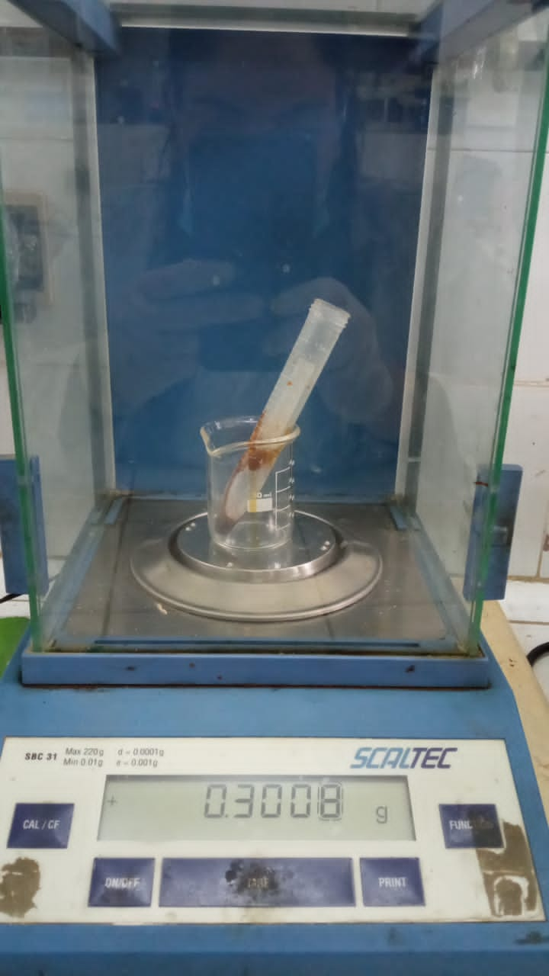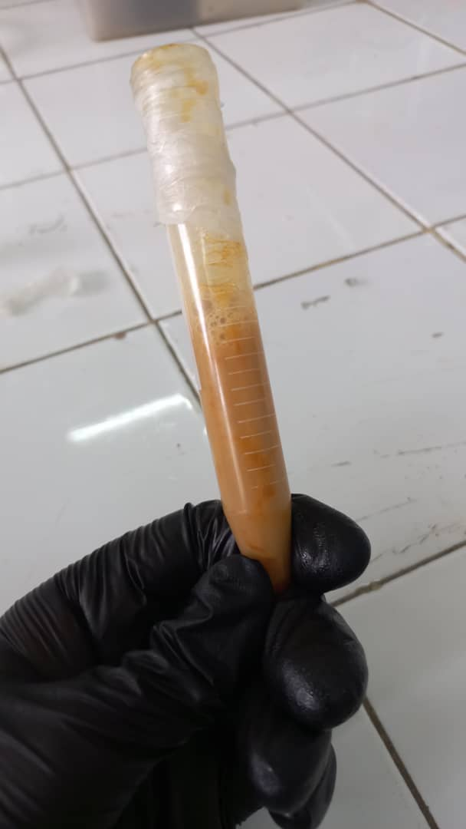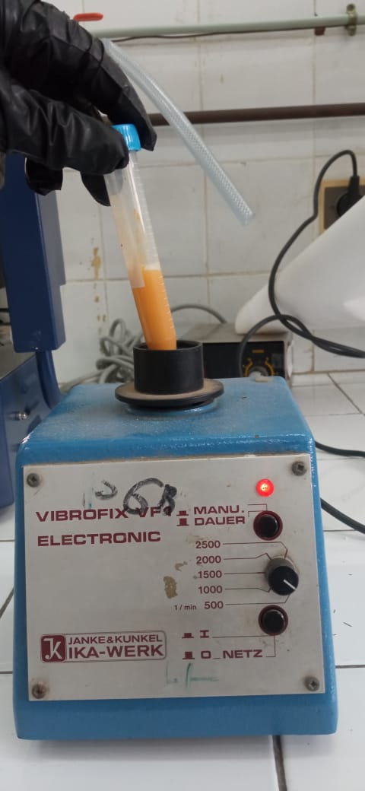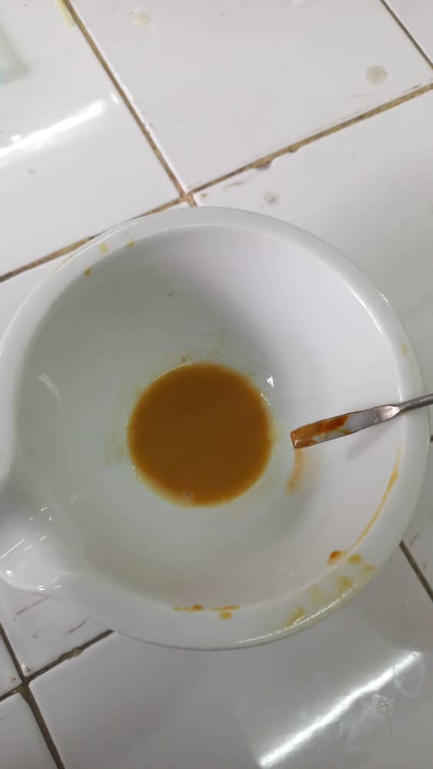

**Figure 28** : Préparation de la solution d’extrait avec Tween 20

**B.Adjustment of the dose per weighing of animals**

Before the cavage, each mouse was weighed individually using a precision electronic balance(Figure 29).The administered dose (mg/kg) was calculated according to the following formula:

***Volume injecté (ml) = $\frac{Dose\left({mg}/{kg}\right)×Poidsdel’animal\left(kg\right)}{Concentrationdel’extrait\left({mg}/{mL}\right)}$***

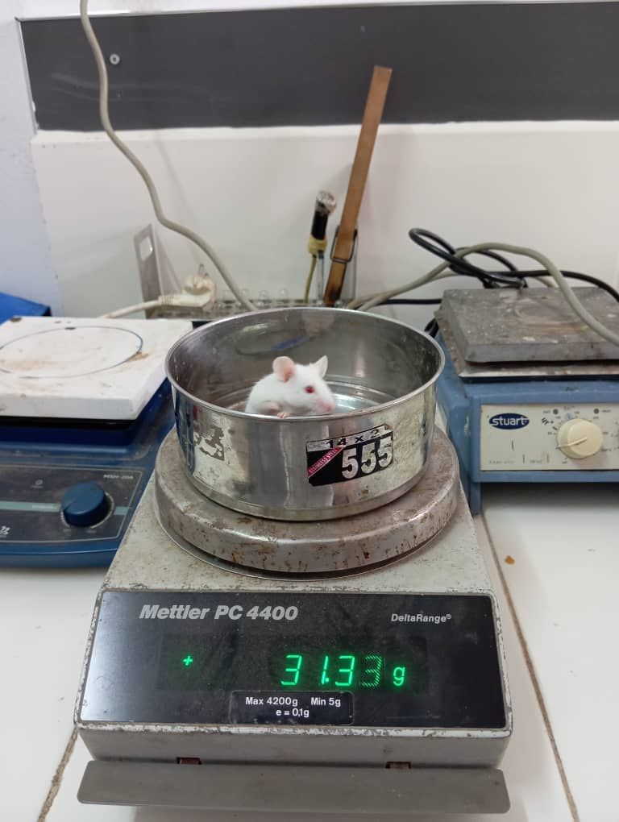

**Figure 29 :** Pesée d’une souris sur une balance électronique

**c.Administration by CAVAGE (oral route)**

The administration of the Myrrhe extract was carried out by**oral track**, using the technique of**gastric**, commonly used in preclinical pharmacology to reproduce the digestive absorption of natural substances.

* A**flexible gastric probe**, adapted to the size of the mice, was used to gently introduce the extract solution directly into the stomach(Figure 30).
* THE**ADMISTRATED VOLUME**was calculated according to the**Individual body weight**of each mouse, determined during the weighing phase (SeeSection B).
* **Each animal**received**A single administration**By cavage, made with caution to avoid stress, reflux or false road.
* All of the manipulations were carried out in compliance with the conditions of hygiene, sterility and animal welfare.

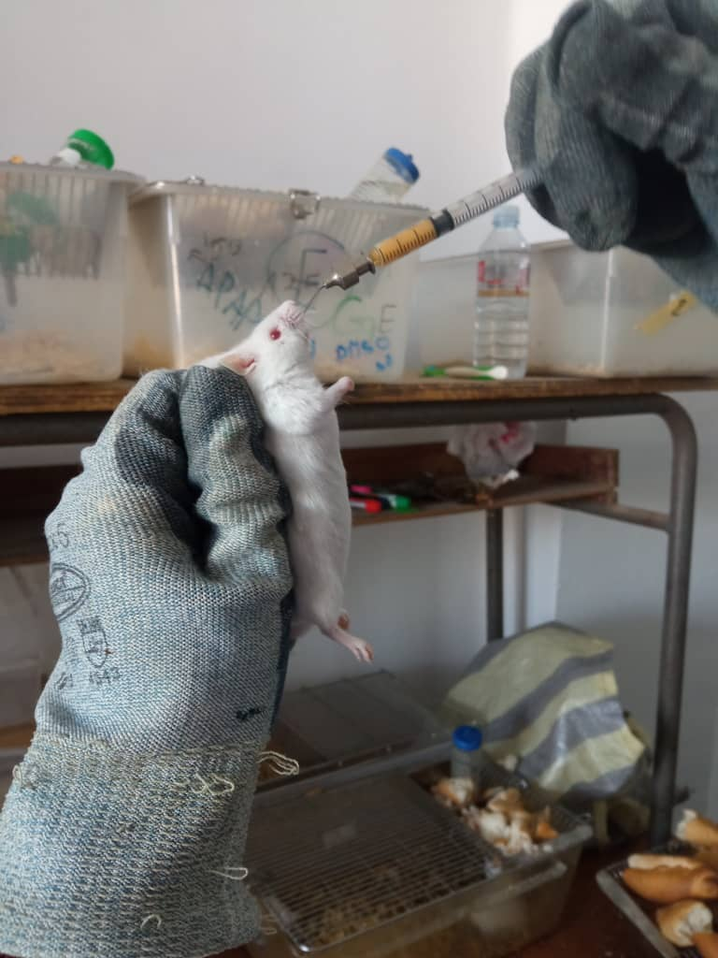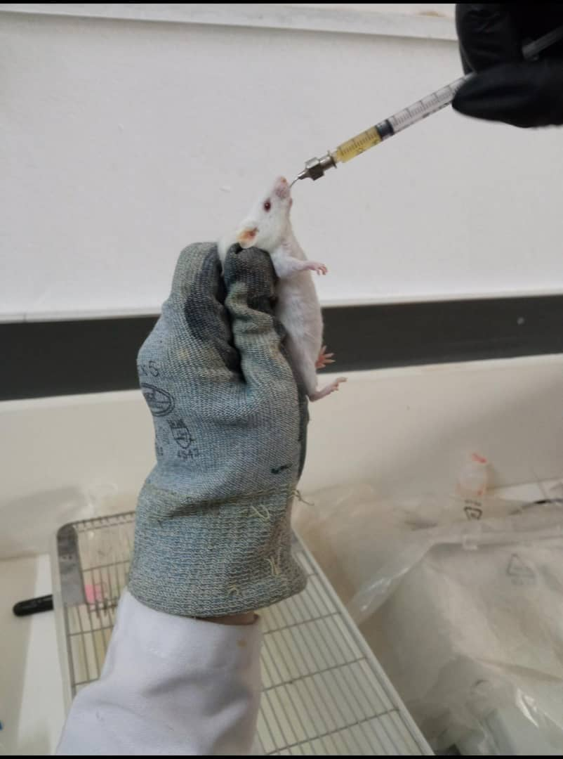

**Figure 30 :** cavage oral d’une souris avec sonde souple, en position verticale

ouce.

1. **Post-administration latency period**

After the cavage, animals are returned to their respective cages and observed for a period of 60 minutes, in order to allow the systemic absorption of myrrh extract before behavioral tests(Figure 31).

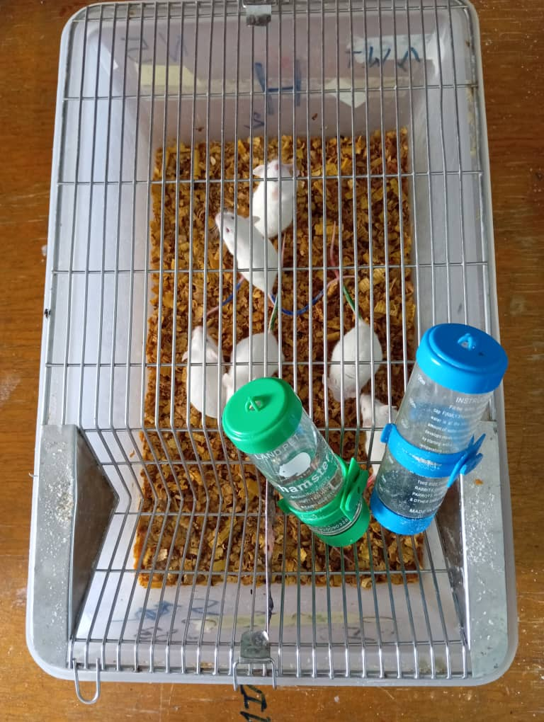

**Figure 31 :** Repos des souris dans leur cage après le cavage

1. **Tail withdrawal test (Tail-Flick Test)**

The purpose of this test is to assess the acute analgesic effect of myrrh resin by measuring the reflex time to withdraw tail in mice exposed to a harmful thermal stimulus.

* **Principle**

The tail removal test, or*Tail-Flick Test*, is a standardized experimental model used to assess the acute nociceptive response of spinal origin in rodent, generally mouse or rat.It is based on the principle according to which exposure of the caudal end to a harmful heat source induces a rapid withdrawal reflex, independent of the upper centers of the nervous system.This withdrawal period constitutes a quantifiable indicator of pain sensitivity and makes it possible to assess the antinocceptive effect of pharmacological substances, in particular these targeting the medullary mechanisms of the transmission of pain.

* **Procedure**
* Preparation of equipment: A bain-marie is preheated to a controlled temperature between 47 and 49 ° C, ensuring a harmful thermal stimulus without causing irreversible short-term tissue lesions.
* Habitization of the animal: Each mouse is placed individually in a transparent plexiglass tube, designed to restrict the animal's movements while minimizing stress.The device only allows the distal end of the tail to overtake outside the tube(Figure 32).
* Application of the thermal stimulus: Once the animal is properly positioned, the terminal portion of the tail (about 4-4.5 cm) is delicately submerged in the bain-marie.From the moment the tail comes into contact with hot water, a stopwatch is triggered to measure the time (second) put by the animal to remove its tail in response to the stimulusthermal (Figure 33).
* #error#
* Repetitions and controls: Each measure is carried out at adequate intervals in order to avoid thermal awareness or a conditioned response.Groups control (without treatment) and experimental (treated with the substance to be tested) allow a rigorous comparison of the antinocceptive effect.

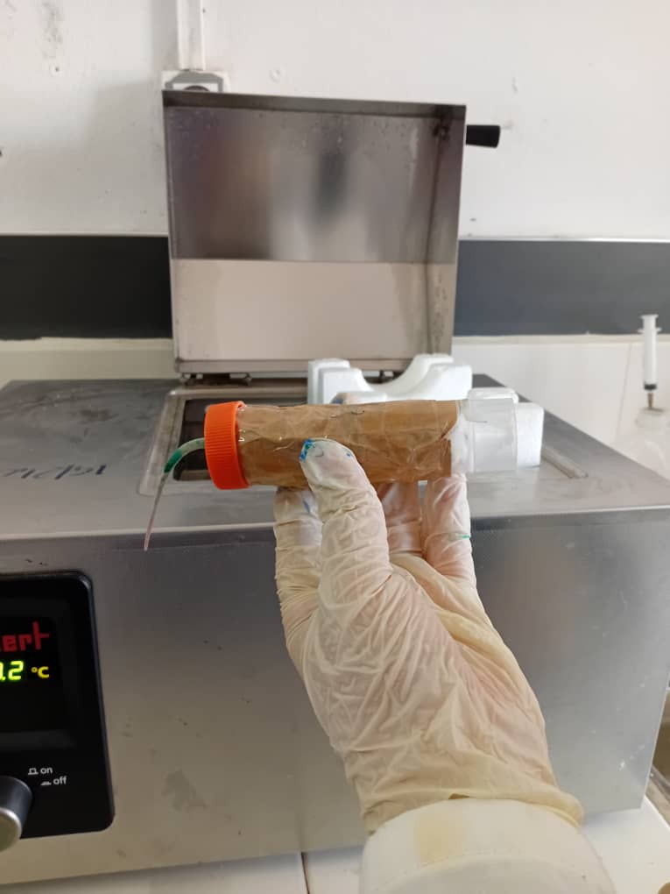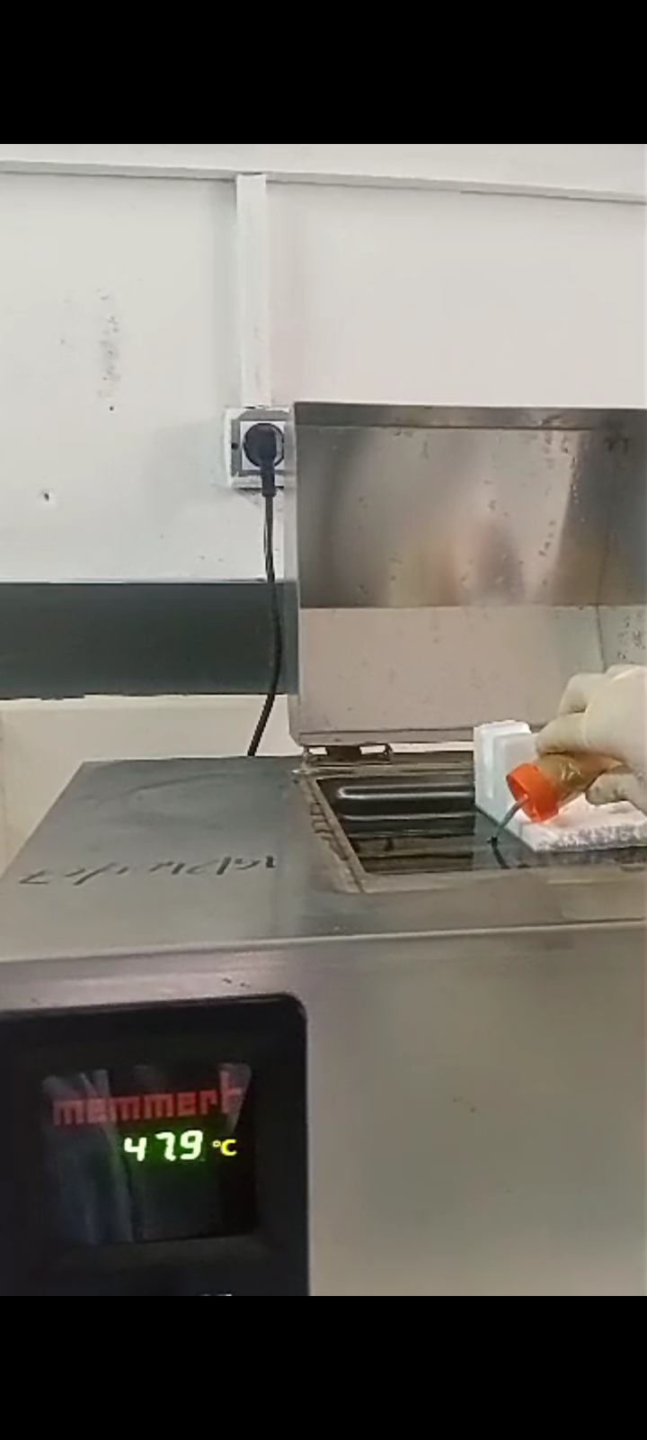

**Figure 32 :** Mise en place de la souris dans le tube de contention

**Figure 33 :** Immersion de la queue dans le bain-marie

1. **Heating plate test (Hot Plate Test)**

The aim of this test is to assess the central analgesic effect of the myrrh resin by measuring the time before the appearance of reflex behaviors in pain in mice exposed to a nociceptive thermal stimulus on a heating plate.

* **Principle**

The heating plate test is an experimental model used to assess the behavioral responsesupraspinalto a nociceptive thermal stimulus in mice.Unlike purely spinal reflexes, this test measures integrated reactions involving higher nerve centers, such as licking posterior legs, jumps or tremors, thus reflecting the central integration of pain.It is particularly relevant for the evaluation of analgesic compounds acting in the central nervous system.

The heating plate test is one of the most widespread nociception tests based on a high intensity stimulus.The pain induced by the thermal stimulus must go through thecentral nervous system(Snc))(Chahar et al., 2012).

* **Material and operating mode**
* Preparation of the device: The heating plate is set to a constant temperature between 54 and 56 ° C, verified and stabilized before each experimental session using a precision thermostat.
* Animal positioning:Each mouse is placed individually in the center of the heating plate, inside a transparent plexiglass beaker which limits its movements and prevents any leak through the duration of the test(Figure 34).
* Behavioral observation: Pain indicative reactions are observed carefully: mainly licking the hind legs, jumps and tremors.These behaviors reflect activationNociceptive wayssupraspinaland are indicators of painful perception.
* Latence time measurement: A digital stopwatch is triggered as soon as the mouse is placed on the plate.The time elapsed before the appearance of a first pain behavior is precision.
* Safety and experimental limits: in order to prevent any risk of prolonged burns or suffering, maximum latency time of 30 seconds is imposed.If no nociceptive behavior is observed at the end of this period, the animal is immediately removed from the plate.
* Repetition and control: The test is repeated several times at regular intervals according to the protocol, with control groups (without treatment) and treated groups to allow a comparative evaluation of the analgesic effect**.**

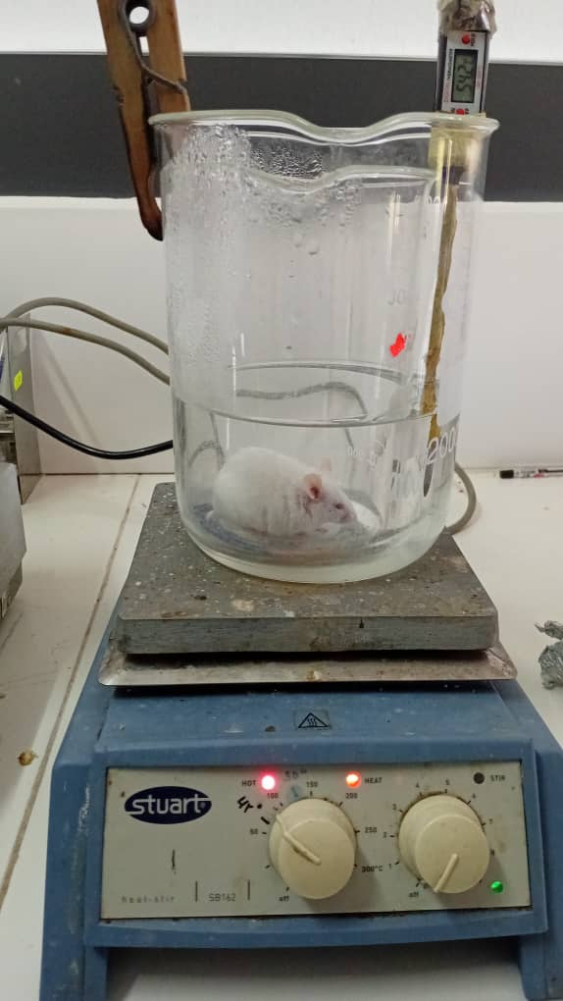

**Figure 34 :** Placement de la souris sur la plaque dans le cylindre transparent

1. **THEAbdominal torsion test (Writhingtest)**

The purpose of this test is to assess the peripheral analgesic effect of myrrh resin, quantifying painful responses induced by visceral chemical irritation in mice, in the form of characteristic abdominal contortions.

* **Principle**

The abdominal torsion test, known asWrithingTest, is a sensitive model of nociception used for the evaluation of substances with analgesic potential for peripheral action.It is based on the intraperitoneal injection of a diluted acetic acid solution, which induces pain of visceral origin by local release of inflammatory mediators such as prostaglandins and bradykinins.These mediators stimulate peripheral nerve endings, causing a series of involuntary contractions of the abdomen, generally accompanied by a stretch of the legs hindquarters.

This test is widely used to detect analgesic activity of natural extracts or synthetic compounds acting on the peripheral path of pain (Vogel,H. G.2008;Necklace, H. O. J.et al.1968).

* **Material and operating mode**
* Preparation of the solution:An acetic acid solution is 0.6 % prepared (V/V) in sterile physiological serum, just before use in order to guarantee its stability and effectiveness.
* Administration: Each mouse receives an intraperitoneal injection of the acetic acid solution at a dose of 10ml/kg of body weight, using a sterile with fine needle syringe(Figure 35).

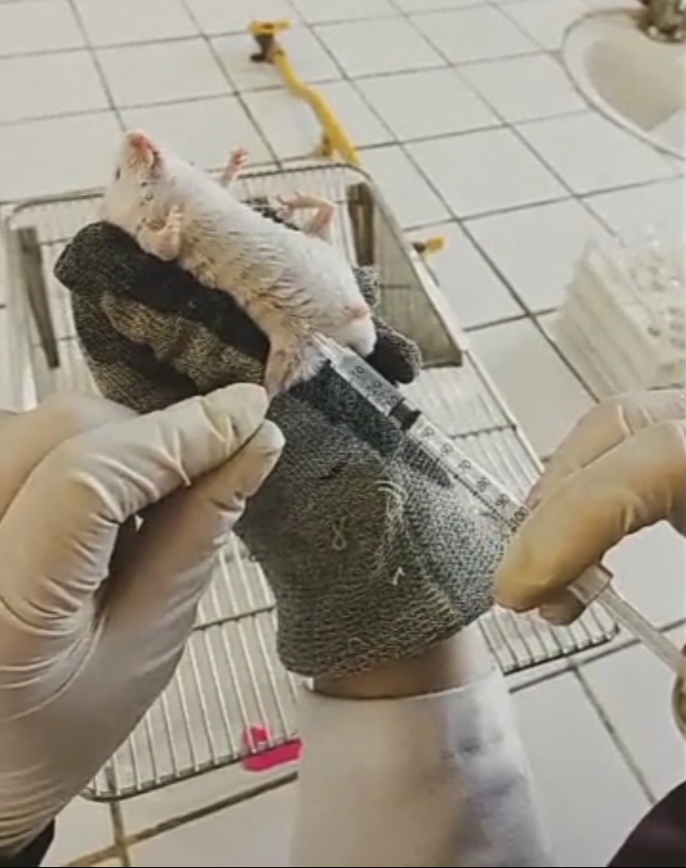

**Figure 35 :** Injection intrapéritonéale de la solution d’acide acétique chez la souris

* Observation: Immediately after injection, each mouse is placed in an individual transparent observation cage.After a 5 -minute induction period, abdominal contortions are counted for a period of 20 minutes(Figure 36).
* Pain criteria: the characteristic movements to record include the withdrawal of the abdomen, the stretching of the posterior legs, the elevation of the basin or the repeated abdominal contractions(Figure 37).

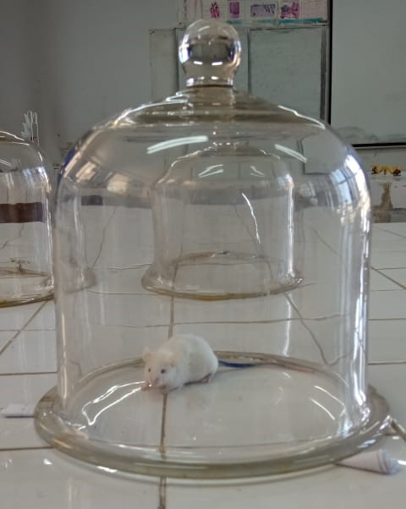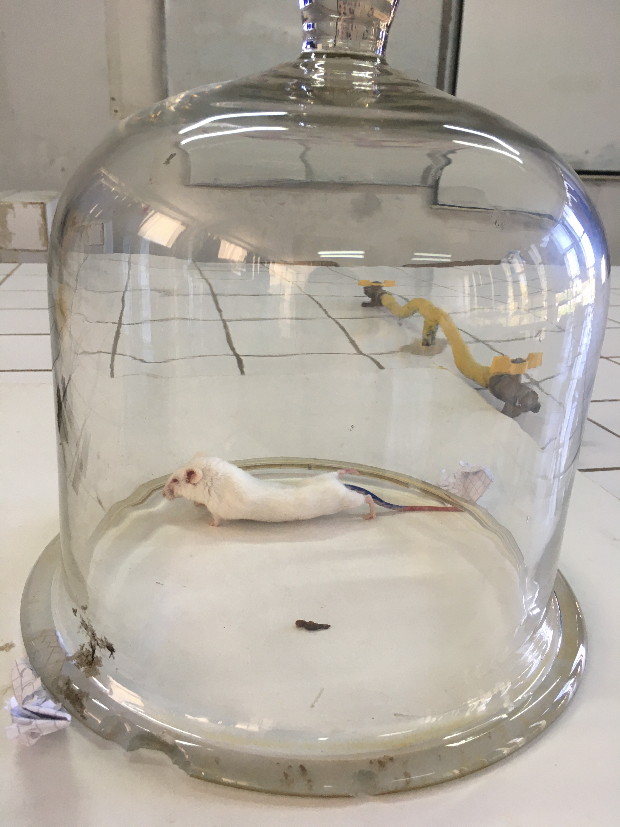

**Figure 37 :** Torsions abdominales après l’injection acide acétique

Figure 16: L’injection

Chapitre IV Matériels et méthodes

activité analgésique

L’effet analgésique des extraits a été évalué suivant le nombre de torsions abdominales

induites par l’injection intrapéritonéale (Figure 16) d’une solution de (10ml/Kg)

de l’acide acétique (0,6 %)suivant la méthode décrite par Kosteret al., (1959).

Torsions abdominales après l’injection acide acétique.

**Figure 36 :** Souris placée en cage d’observation individuelle après injection d’acide acétique

1. **Experimental remarks and ethical conditions**

* Animals have been manipulated in accordance with animal welfare standards.
* A rigorous cleaning of equipment (double boiler, plate) was carried out.
* No abnormal injury or behavior was observed during the post-test period.

**Chapter IV**

**Results and discussion**

In this chapter, we present the results obtained through all the experimental steps carried out.These include extraction yields, the chemical composition of the extracts analyzed by GC/MS and HPLC, as well as the various biological activities evaluated.These results make it possible to appreciate the quality of extracts and to better understand their pharmacological potential.

**IV.1 Study of the extraction of the volatile fraction**

## **IV.1 Study of the extraction yield of the essential oil of myrrh**

According to AFNOR standard, the yield of essential oil is defined as the ratio between the mass of essential oil obtained after extraction and the mass of the dry plant material used.It is expressed as a percentage and calculated(Table 4)By the following formula:

$$R\text{\%}=\left(\frac{Massedel'HE}{Massedematiérevégétalesèche}\right)×100$$

**Table 4:**Operating conditions for different methods of extraction of essential oils of Commiphora Myrrha

|  |  |  |
| --- | --- | --- |
|  | HD (BS) | HD-MO (BS) |
| Power (W) | 800 | 800 |
| Weight ofthe sample (g)) | 150 | 150 |
| Volume of distilled water (ml)) | 800 | 750 |
| Extraction time (min)) | 102 | 48 |
| Yield (%) | 2.36 | 1.90 |

### **IV.1.1 Influence of extraction techniques used on yields**

**The influence of the yield extraction technique has been evaluated by comparing two methods: classic hydrodistillation (HD) and hydrodistillation assisted by microwave (HD-MO), under the same conditions (figure38).**

**The yield obtained by the HD method (2.36 %) turned out to be slightly higher than that obtained by the HD-MO method (1.90 %), despite a shorter extraction time for the latter (48 min against 102 min for HD).This difference can be explained according to different reasons, such as the phenomenon of solute transfer (HE)hasThrough the different stages of extraction and in places in both cases HD and HD-MO.Indeed, in the case of HD the time dedicated to extraction from endogenous sites (pores,**mesopore**and micropore) is slower than that of HD-MO technique.**

**Figure 38 :** Variation du rendement d’extraction de l'huile essentielle de la myrrhe en fonction des techniques utilisées avec broyage simple

## **IV.1.2 Energy and environmental appearance**

In order to assess the energetic aspect of extraction techniques, the energy consumed (expressed in kWh/g) was calculated according to the formula:

$E=\frac{\left(\frac{P.t}{3600.1000}\right)}{mi}$**= $\frac{P.t}{3600.1000.mi}$**

With :**E :**electrical energy in kilowatt hour (kWh) per gram of HE.

**P:**#error#

**t#error#**Total time of heating in second.

**MI#error#**The mass of essential oil (G).

With regard to environmental impact, carbon dioxide rejected in the atmosphere has been calculated according to the fact that 1 kWh generated by the combustion of coal or another fossil fuel, rejects 800 g of co2in the atmosphere, using the below:

$$m{CO}_{2}=E×800$$

With :***M co2::***The amount of carbon dioxide released in gram (G).

***E :***L'electrical energy consumed in kilowatt hour (kWh).

According to**figure39-has,** We note that the HD technique is more consumer of energy than HD-MO, indeed microwaves allows intense heating which is carried out from interior to the outside unlike conventional hydrodistillation, where heating is carried out from outside to interior.This peculiarity of microwaves considerably promotes the diffusion of HES of internal medium to the external part (chemat, F.et al., 2017;Benkaci-Ali, F.2015).

This difference is also reflected in terms of environmental impact, measured through CO emissions2Associates.The release of**CO2**reached**179.64g**For technique**HD-MO (BS 800W)**, against**307.34g**For**HD (BS 800W) (figure39-b)**, which confirms a direct correlation between the energy consumed and the emissions of greenhouse gases.This link is consistent with the principles established by the energy conversion equation into carbon equivalent (Co2))demonstrating that any increase in electricity consumption in a process results in a proportional increase in the CO2released in the atmosphere (Chemat et al., 2017;Benkaci-Ali, F.2007).

**Figure 39-a :** Energie consommé en fonction des techniques utilisées

**Figure 39-b :** Dégagement du CO2 par rapport aux techniques utilisées

## **IV.1.3 Study of the extraction kinetics of the essential oil of myrrh**

### **IV.1.3.1Differential yield**

The differential yield corresponds to the amount of essential oil extracted at a given moment.In this section, the study focused on the variation in differential yield according to the extraction time (Figure 40))**,,**For two techniques (HD and HD-MO).The curvesobtained present different kinetic profiles (Table 5).The first phase, corresponding to the rapid liberation of HES from exogenous sites, is between 0 and 10 minutes for both methods.The HD-MO 800W technique shows an extraction to accelerate with higher yields from the first minutes, unlike HD which reaches its maximum efficiency more slowly.The second phase, marked by a gradual slowdown in extraction dominates by the extraction of the HE from endogenous internal sites (pores,mesopore, micropores).The third step of depletion is observed after 45 minutes of extraction, indicating the end of the extraction process.

**Figure 40:**Differential yield of the essential oil of myrrh extracted by different extraction methods

**Table 5:**Steps intervals of different extraction techniques (BS).

|  |  |  |  |
| --- | --- | --- | --- |
|  | **Step 1** | **Step 2** | **Step 3** |
| **T (Min) HD-MO 800W** | 0 - 10 | 10 - 45 | After 45 |
| **T (min) HD 800W** | 0 - 10 | 10 - 45 | After 45 |

### **IV.1.3.2 Cumulative yield**

To better exploit the results of the extraction kinetics we have drawn the cumulative yield according to the heating time (Figure 41).The curves obtained highlight distinct profiles between the two methods, reflecting a different extraction kinetics influenced mainly by the thermal transfer mode and the intensity of applied energy.

The HD-MO 800W technique is distinguished by a rapid start of the extraction process, with significant progression from the first minutes.Indeed, a cumulative yield of**0.87 %**has already been reached after 15 minutes, to peak in**1.81 %**at the end of the extraction (50 min).This performance is explained by the intense and targeted thermal effect of microwaves, which promotes a faster rupture of plant structures, facilitating the release of volatile compounds from exogenous and endogenous sites.

Unlike the HD 800W technique presents a slower extraction dominated by the second stage of extraction.The 50 -minute cumulative yield reaches only**0.85 %**, less than half of that obtained with HD-MO.This result is explained by the nature of conventional heating, less effective in terms of thermal transfer, with slower penetration of heat in the plant matrix.Thus, the extraction is done slowerly due to the distribution of the He of internal pore sites,mesoporetowards the exterior.

The analysis of optimal extraction times makes it possible to quantify the energy and temporal efficiency of the two techniques.Thus, the**time required to reach 80 % of the maximum yield (T80)**is**22 minutes**For HD-MO, against**48 minutes** For HD.Likewise, the**Optimal time to reach 90 % yield (T90)**is respectively of**35 minutes**For HD-MO and**56 minutes**for HD(Table 6).Generally, it is recommended to sacrifice 10 to 20% yield for a significant reduction in heating time Table 6 for a saving of time, energy, CO2Release and above all a high quality of extracted oil (reduction of chemical degradation reaction).

**Figure 41** : Rendement cumulées de l’huile essentielle de de la myrrhe extraite par différentes méthodes d’extraction

**Table 6**: Optimistic times for different extraction techniques

|  |  |  |  |
| --- | --- | --- | --- |
|  | **Optimal time 80%** | **Optimal time 90%** | **T total** |
| **T (Min) HD-MO 800W** | 22 | 35 | 43 |
| **T (min) HD 800W** | 48 | 56 | 65 |

### **IV.1.3.3 Energy and environmental aspect**

According to the results obtained(Figure 42 and 43), HD-MO turns out to be the most economical method in energy, with a consumption of 0.163Wh/g, compared to 0.210 kWh/g for HD at the same power.This trend is also reflected at the environmental level, where CO emissions2are lower for the classic technique (150 g against 187 g for the microwave method).Thus, despite the kinetic advantages of microwave assisted extraction, simple hydristillation remains more favorable in terms of energy and environmental sustainability.

**Figure 42-a :** Energie consommé en fonction des techniques utilisées avec le temps optimale 80%

**Figure 42-b :** Energie consommé en fonction des techniques utilisées avec le temps optimale 90%

**Figure 43-a :** Dégagement du CO2 par rapport aux techniques utilisées avec le temps optimale 80%

**Figure 43-b :** Dégagement du CO2 par rapport aux techniques utilisées avec le temps optimale 90%

## 

## **IV.1.4 Studies of extraction kinetics according to time by GC-MS**

The study of the extraction kinetics of the essential oil of myrrh (Commiphora Myrrha) by HD-MO at 800W makes it possible to better understand the dynamics of appearance, accumulation and disappearance of aromatic compounds during the process.Two types of resin prior treatment were compared: simple grinding (BS) and cryogenic grinding (BC), in order to assess the impact of the latter.

The analysis of the volatile compounds was carried out by gaseous chromatography coupled with mass spectrometry (GC-MS), allowing the identification of nearly 100 constituents: 90 volatile compounds in sample BC and 98 in the BS sample (Tables 7 and 8).

In the HD-MO 800W process, the type of grinding influences the extraction kinetic profile.Especially at the end of the extraction process.Overall, the quantity extracted with BC (n2-196c°) is relatively less important with that obtained by BS has the exception of the interval of time 22 to 37min.

The study of 800 W HD-MO extraction kinetics shows that the type of grinding strongly influences yield.Simple grinding (BS) allows more effective extraction than cryogenic grinding (BC), with optimal release of the compounds followed by slower progression until reaching stability around 45 minutes, with a maximum yield of around 4.5 %.On the other hand, the BC with liquid nitrogen (-196c °) presents aSlower extraction, reaching earlier stability (around 30 minutes) with lower yield (2.7 %).The decrease in yield with the BC probably due to the clutch phenomenon of the solid particles which prevents the good liquid solid contact, which reduce the surface (Figure 44).

**Figure 44::**Differential and cumulative yield of essential oilofThe extracted myrrh By HD-MO 800 W with different types of grinding

**IV.1.4.1 HD-MO P = 800W BS technique case**

* From Figure 46, we note that the profile of each compound is different for each constituent.In some cases, the highest yields are obtained either during the first step or the second step, and even during the third step.This confirms the fact that the composition of isolated (differential) oil is very dependent on heating time, which considerably affects the quality of isolated oil, as well as its physico-chemical properties and biological activities.

During the second step, limited to 45 minutes, compounds such as Furanoeudesma-1,3-Diene (29.48 % to T1) and β-elemn (6.83 % at1) show rapid release comparing to the first step, reaching 42.03 % and 4.52 % at T3 respectively.This intensive initial extraction is characteristic of an exogenous transfer, facilitated by the disorganization of surface structures under the targeted thermal effect of microwaves.Curzerene has a remarkable ascending profile, from 13.47 % to T1 to a maximum of 20.98 % to T4, reflecting progressive endogenous diffusion.This phenomenonis explained by the late rupture of the deep structures resistant, such as the thickened walls of the oleiferous cells, which slow down access to hydrophobic compounds.The 2-Epi-α-Cèdrene-3-One, detected solely at T1 (14.73 %), shows a typical behavior of thermosensible compounds: its subsequent absence is probably resulting from a degradation by rearrangement or oxidation under the thermal effect, as reportedBera, S.et al.(2020) In their analysis of sesquiterpenes extracted from myrrh.THECurzérénoneAnd elemol acetate, whose concentrations increased slowly to T5 (2.23 % and 2.22 % respectively), also testify to a deep release conditioned by thermal accumulation.This evolution combines with the results (he, z.et al.2014),,which have shown that the prolonged thermal action induced by microwaves causes a selective rupture of internal structures.

Other profiles such as those of elemol and γ-elemn remain more stable, but their slight increase over time indicates a compromise between structural accessibility and resistance to degradation.Compounds likeGermany and thenootkatolhave delayed extraction profiles, reaching their maximum concentrations to TEMmore advanced PS, while theMUUrolène(<γ->) decreases after a maximum.

The influence of the size of the crushed particles, the internal pressure induced by the selective absorption of microwaves, as well as the progressive destabilization of plant tissues make it possible to explain the differences observed between the compounds extracted in the initial phase and those released later.This behavior is in accordance with the mechanisms described by Chemat, F.et al.(2011), which underline the fundamental role of the thermal gradient and the structural properties of the matrix in the effectiveness of the microwave of natural substances.

* The yield study shows rapid extraction during the first 10 minutes, where more than 80% of total compounds, such as Furanoeudesma-1,3-Diene and Curzene, are released thanks to the grinding and microwave heating.Then, a slow phase continues beyond 20 minutes, with a weak gain (less than 10%), corresponding to the extraction of intracellular compounds like the elemol.A level is reached between 30 and 40 minutes, reflecting the saturation of the extractive process.

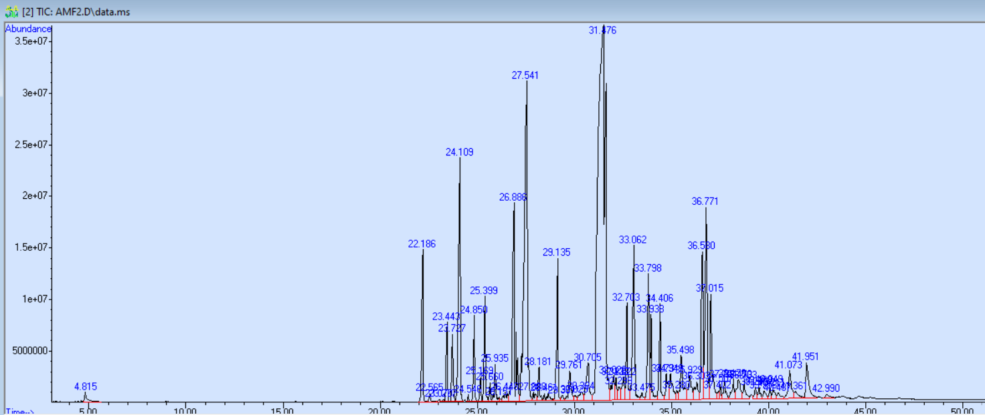

**Figure 45:**GC/MS chromatogram of assisted hydrodistillation p800W power microwaveBs(T2))

**Table 7:**Kinetics of extraction of the essential oil of the myrrh extracted by HD-MO P = 800W BS followed by GC-MS

|  |  |  |  |  |  |  |  |
| --- | --- | --- | --- | --- | --- | --- | --- |
| **KI reference** | **Compound name** | **MF** | **T1(%))** | **T2(%)** | **T3(%)** | **T4(%)** | **T5(%)** |
| **939** | α-Pinene | C10H16 | 0.92 | 0.30 | 0.24 | / | 0.12 |
| **1338** | Δ-Elemène | C15H24 | **3.03** | **2.04** | **2.00** | **1.32** | 0.90 |
| **1351** | α-Cubebena | C15H24 | / | 0.13 | 0.10 | / | / |
| **1360** | Silphirefol -4,7 (14) -Diene | C15H24 | / | 0.05 | / | / | / |
| **1375** | α-Ylangena | C15H24 | / | 0.03 | / | / | / |
| **1376** | α-Copaène | C15H24 | 1.42 | 1.04 | 0.78 | 0.56 | 0.35 |
| **1388** | β-Bourbonène | C15H24 | 1.36 | 1.08 | 0.88 | 0.64 | 0.41 |
| **1390** | β-Elemène | C15H24 | **6.83** | **4.99** | **4.52** | **4.23** | **2.41** |
| **1409** | α-Gurjunène | C15H24 | / | 0.07 | 0.06 | / |  |
| **1419** | (E)-Karyophyllene | C15H24 | 1.47 | 1.04 | / | / |  |
| 1420 | β-Ylangena | C15H24 | / | / | 0.96 | 0.78 | 0.45 |
| **1432** | β-Copaène | C15H24 | 0.36 | 0.31 | 0.31 | / | 0.17 |
| **1436** | γ-Elemène | C15H24 | **1.67** | 1.44 | **1.80** | **1.62** | **1.27** |
| **1439** | α-Guainene | C15H24 | 0.24 | 0.22 | 0.20 | / | 0.10 |
| **1454** | α-Humulène | C15H24 | 0.65 | 0.60 | 0.58 | / | 0.27 |
| **1460** | Hello-Aromadendrene | C15H24 | / | 0.07 | / | / | / |
| **1466** | Ishwarane | C15H24 | / | 0.32 | / | / | 0.10 |
| **1475** | 10-EPI-β-Acoradiene | C15H24 | / | / | / | / | **2.12** |
| **1476** | Cadina-1 (6), 4-Diene | C15H24 | **5.14** | / | / | / | / |
| **#error#** | γ-Gurjunène | C15H24 | 0.71 | / | / | / | 0.34 |
| **1479** | γ-Muurolène | C15H24 | / | **5.09** | **4.41** | **2.17** | / |
| **1481** | German germacrene | C15H24 | 0.63 | / | **1.08** | 0.46 | 0.27 |
| **1499** | Curzérene | C15H20O | **13.47** | **11.13** | **14.81** | **20.98** | **14.27** |
| **1498** | α-Sélinène | C15H24 | **1.01** | / | / | / | / |
| **1502** | γ-Patchoulene | C15H24 | **/** | / | #error# | / | 0.27 |
| **1513** | γ-Cadinène | C15H24 | / | 0.26 | 0.11 | / | 0.10 |
| **1523** | Δ-Cadinène | C15H24 | 0.60 | 0.49 | 0.80 | / | 0.45 |
| **1529** | Zonaren | C15H24 | / | 0.34 | 0.13 | / | 0.09 |
| **1546** | Sélina-3,7 (11)-dine | C15H24 | / | / | 0.31 | / | 0.21 |
| **1548** | Epoxidad 'Italicène | C15H24O | / | / | 0.19 | / | 0.15 |
| **1549** | Elemol | C15H26O | **1.74** | **2.13** | **2.13** | **1.14** | **1.25** |
| **1559** | Silphiperfol-5-Éné-3-Ol A | C15H24O | **/** | 0.14 | / | / | / |
| 1569 | Long | C15H26O | **/** |  | 0.18 | / | / |
| **1572** | Furanoudesma-1,4-Diene | C15H18O | 0.48 | 0.79 | **1.00** | / | 0.67 |
| **1578** | Spathulanol | C15H24O | / | **#error#** | **#error#** | #error# | 0.15 |
| **1583** | Oxide ofkaryophyllene | C15H24O | **/** | 0.13 |  | / | / |
| **1602** | Trans-β-Elemenone | C15H22O | **/** | 0.38 | 0.41 | / | 0.33 |
| **1606** | Curzérénone | C15H18O | / | **1.32** | **1.62** | / | **2.23** |
| **1619** | Junnol | C15H26O | / | / | / | **36.66** | / |
| **1633** | Furanoudesma-1,3-Diene | C15H18O | **29.48** | **31.04** | **42.03** | **22.44** | **39.32** |
| **1627** | 2-Epi-α-Cèdrene-3-One | C15H22O | **14.73** | / | / | / | / |
| **1646** | Cubenol | C15H26O | **/** | / | #error# | / | 0.32 |
| **1651** | CEDR-8 (15)-ène-9-α-ol | C15H24O | **/** | 0.79 | **1.07** | / | **1.30** |
| **1658** | Atractylone | C15H20O | **/** | 0.38 | 0.55 | / | / |
| 1660 | Gymnomitrol | C15H24O | **/** | 0.38 | 0.40 | / | 0.39 |
| **1669** | Methylhinokiéate | C16H24O2 | **/** | 0.63 | 0.50 | / | 0.58 |
| **1680** | Elemol acetate | C17H28O2 | **/** | **1.56** | **1.88** | / | **2.22** |
| **1681** | Ishwarone | C15H22O | **4.19** | **/** | / | / | / |
| **1693** | Germacrone | C15H22O | **/** | **3.69** | **4.32** | **4.08** | 0.13 |
| 1697 | AcorononeB | C15H24O | **/** | **/** | **/** | **/** | **3.76** |
| **1709** | cis-Thujopsenal | C15H22O | **/** | **0.18** | / | / | 0.26 |
| **1715** | NOOTKATOL | C15H24O | **/** | **1.87** | **3.17** | / | **5.86** |
| **1718** | (Z) -α-Atlant | C15H22O |  |  |  | **2.92** | / |
| **1725** | (Z)-Nuciferol | C15H22O | **1.54** | **/** | / | / | / |
| **#error#** | (E)-Nuciferous | C15H20O | **/** | **1.19** | / | / | **1.45** |
| **1736** | Eremophilone | C15H22O | **/** | **1.58** | 0.70 | / | / |
| **1752** | 1-acetyl-4,6,8-Triméthylazulnene | C15H16O | **/** | **0.64** | / | / | / |
| **1761** | (Z)-Lanceol | C15H24O | **/** | 0.86 | 0.60 | / | **1.25** |
| **1767** | Dimenol | C15H26O | **/** | **/** | 0.35 | / | / |
| **1774** | α-Costol | C15H24O | **/** | 0.18 | / | / | 0.20 |
| **1776** | Amorpha-4,7 (11)-dine | C15H24 | **/** | **/** | **/** | **/** | 0.17 |
| **1784** | Acetate ofHinesol | C17H28O2 | **/** | **1.27** | 0.56 | / | 0.75 |
| **1792** | Dimenone | C15H24O | **/** | **/** | **/** | **/** | 0.17 |
| **1797** | (2.5-Dimethoxyphenyl)-Phenyl-methanol | C15H16O3 | **/** | **0.80** | / | / | 0.72 |
| **1803** | 14-Hydroxy -δ-Cadinène | C15H24O | **/** | **/** | 0.46 | / | / |
| **1811** | iso-Acoron | C15H24O2 | **/** | **/** | **/** | **/** | 0.27 |
| **1811** | Acidvetivènic | C15H22O2 | **/** | 0.68 | 0.32 | / | 0.31 |
| **1820** | Acoron | C15H24O2 | **/** | **/** | **2.98** | / | **1.46** |
| **1823** | β-Vetivone | C15H22O | **/** | **2.98** | 0.50 | / | / |
| **1831** | (Z) -Cetetate ofnuciferol | C17H24O2 | **/** | **4.57** | / | / | **2.40** |
| **1841** | o-Methyl-α-Pipsole | C16H22O3 | **/** | **2.04** | 0.23 | / | 0.85 |
| **1843** | α-Vetivone | C15H22O | **/** | **/** | **/** | **/** | 0.37 |
| **1856** | α-Chénopodiol | C15H26O2 | **/** | 0.13 | / | / | 0.26 |
| **1862** | Amorpha-4,7-Dièn-2-α-Acouxoxy-11-Methoxy | C18H28O3 | **/** | 0.24 | / | / | / |
| **1864** | cis-Acidthujopsenic | C15H22O2 | **/** | 0.47 | 0.37 | / | / |
| **1870** | Fuzziol | C15H26O2 | **/** | **/** | **/** | **/** | 0.47 |
| **1875** | α-Hexadecanol | C16H34O | **/** | **/** | **/** | **/** | 0.29 |
| **1887** | Acetate ofoplopanonyl | C17H28O2 | **/** | 0.51 | 0.42 | / | 0.69 |
| **1897** | 8S, 13-Cédranédiol | C15H26O2 | **/** | 0.82 | / | / | / |
| **1905** | Isopimara-9 (11), 15-Diene | C20#error#32 | **/** | **#error#** | **/** | **/** | **1.10** |
| **1912** | Kuddiol | C15H26O | **/** | 0.47 | 0.65 | / | / |
| **1922** | Total | C20H32 | **/** | **/** | **/** | **/** | 0.20 |
| **1931** | Beyerene | C20H32 | **/** | 0.24 | 0.13 | / | 0.19 |
| **1938** | Hint | C20H32 | **/** | 0.27 | / | / | 0.33 |
| **1949** | Pimaradiene | C20H32 | **/** | 0.26 | / | / | / |
| **1953** | Columellarine | C15H20O2 | **/** | **/** | **/** | **/** | 0.17 |
| **1961** | Laughed(tetrahydro)) | C20H32 | **/** | 0.19 | / | / | 0.29 |
| **1974** | Dolabradian | C20H32 | **/** | 0.30 | / | / | 0.17 |
| **1978** | Biflorer | C20H32 | **/** | 0.21 | / | / | 0.16 |
| **1997** | Kaur-15-ath | C20H32 | **/** | **/** | **/** | **/** | 0.09 |
| **2000** | 13-Epimethyl-coat | C20H32 | **/** | 0.98 | / | / | / |
| **2017** | Phyllocladene | C20H32 | **/** | 0.34 | / | / | / |
| **2024** | Warburgenal | C15H22O3 | **/** | **/** | **/** | **/** | 0.87 |
| **2024** | Cataponol | C15H18O2 | **/** | **/** | 0.50 | / | / |
| **2043** | Kaurène | C20H32 | **/** | **1.22** | 0.12 | / | / |
| **2057** | Manoeol | C20H34O | **/** | **/** | **/** | **/** | 0.80 |
| **2060** | 13-Epimanool | C20H34O | **/** | **/** | 0.37 | / | / |
| **2087** | Abiétadiene | C20H32 | **/** | 0.15 | / | / | / |

**F****Figure 46::**Variation of the different percentageentineMajority compounds of the essential oil of myrrh as a function of HD-MO 800W-BS time

**Figure 47** : Pourcentages cumulés des composés majoritaires de l’huile essentielle de la myrrhe extraite par la technique HD-MO 800W-BS



**A**

**m\z**

**Intensite%**

**Intensite%**



**B**



**Figure 48 :** Spectres de fragmentations des composés majoritaires identifiés dans le cas de HD-MO 800W BS. **A** : Furanoeudesma-1,3-diene. **B** : Elémène<β->. **C** : Curzérène

**C**

**m\z**

**m\z**

**Intensite%**

Analysis of variation profiles of differential chemical families depending on time (Figure 49)highlights profiless gooddifferentFor each family depending on the chemical nature and the location of compounds in different internal sites.Hydrocarbon sesquiterpenes have a decrease in their percentage during their heating process probably linked to the physical dissemination phenomenon through location sites, as well as any stable degradation reactions.

In the case of oxygenated sesquiterpenes a strong increase in percentage is observed between 18 and 28 min inthe second stepExtension followed by a rapid decrease up to 43 min.This fluctuation phenomenon is probably linked to a matrix transfer phenomenon that a phenomenon of thermal degradation. The increase in this compound is isolated during the second of extraction, this means that this compound family requires a relatively high heating time for this freed from the phase of plant particles.In the case of furanose composites, some are better extracted at the start of extraction, while the other is free only after a long heating.This is probably linked simultaneously to molecular mass, polarity and their coefficient of diffusesolid-liquid ion.For the diTerpenes and the rest of the compounds, similar gaits are observed in the observed phenomena are identical to the cases of furanic compoundss.

The profileCumulative chemical classes shows two groups of chemical families, the 1ergroup50-hasOr we observe horizontal curve profiles for sesquiteHydrocarbon rpenes, a profilecourtyardBe growing and another profiledecreasing for oxygenated sesquiterpenes.In the case of the figure50-bA strong fluctuation of percentage of the diterpenes and the rest of the compounds is observed due to several complex parameters involved such as molecular mass, thepolarityand their location in internal pore sites,Mesoporesand micropores.

**Figure 49 :** Variation du pourcentage des classes chimiques d’huile essentielle en fonction du temps par la technique HD-MO 800W-BS

**Figure 50-b :** Pourcentage cumulé des classes chimiques d’huile essentielle de la myrrhe extrait par la technique HD-MO 800W -BS

**Figure 50-a :** Pourcentage cumulé des classes chimiques d’huile essentielle de la myrrhe extrait par la technique HD-MO 800W-BS

## **IV.1.4.2HD-MO P = 800W BC technique case**

* In the case of cryogenic grinding we see a considerable influence on the qualitative and quantitative aspect as well as on the profile of variation of the main composes identifies according to the time in the differential case (figure52)).The low particles obtained by BC have considerably impacted the quantitative and qualitative aspect of the HES extracted(Koba, K. H.et al., 2016),,So for theFuranoeudesma-1,3-Diene The largest quantity was exhausted during the first 20 minutes, while a very low quantity obtained at the end of the extraction process (Verzera, HAS.et al., 2025), this can be explained by the dominance of exogenous sites (partial solubilization phenomenon) and in places during the early days of heating**(Cvitković, D.et al., 2022).**For curzerne and β-éLémène A moderate composition fluctuation is observed.Furthermore, we note that the curve profile of β-eLémène BC remains the samehasthat obtained in BS.

For the rest of the compounds (NOOTKATol, germacrone,CurzérénonesummerLemol), we observe increasing gaits depending on time, this suggests that the transfer of materials from exogenous (dominant) sites is embarrassed by the phenomenon of clogging of fine plant particles, which requires significant heating time for their release (diffusion)**(Chemat, F.et al., 2017;Cravotto, G.et al., 2008).**Note that BC has contributed to the appearance of new compounds such as bulnesol and β-Vetil(appeared in all time in BC and only in T2 and T3 in BS)**.**

Differential kinetic study is the only technique capable of monitoring qualitatively and quantitativelythe presencea compose as a function of time, unlikehasCumulative kinetics which is used only to determine the chemical composition of real HE has a time T.

In Figure 53relating to the cumulative percentage, we note that the percentage fluctuations are verystable hasThe exception of Furanoeudesma-1,3-Diene where a strong variation is observed during the first 20 minutes of extraction and which stabilizes at the end of the process, for the other composes The same remark was noted.

Taking into account that the optimal time of 80% corresponding to 18 min of extraction, according to figures 47and 53relating to the BS and BC, somematters such asNOOTKATOL, germacrone,Curzérénone, β-vetivone, Élémol, BUlnesol, will be extracted in low percentage while others likeTHEFuranoeudESMA-1,3-Diene, Curzenene and β-éLémène will be obtained in high percentage.Hence an optimal time of extraction must be chosen in a quantitative and qualitative way (compositionchemical).Indeed, the profile Aromatic of the He is very dependent on heating time, which significantly influencing their biological activities.

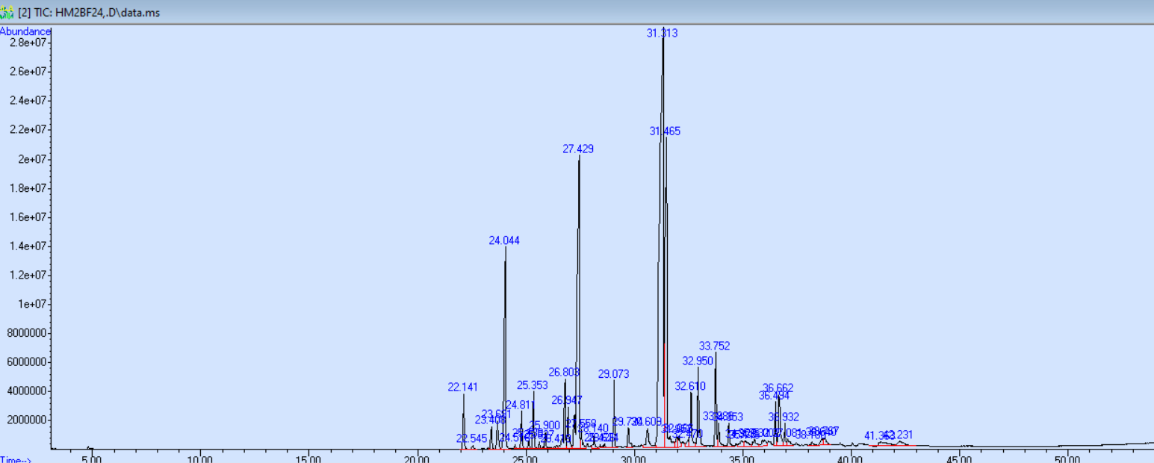

**Figure 51::**GC/MS chromatogram of assisted hydrodistillation p800W power microwaveBc(T2)

**Table 8:**Kinetics of extraction of the essential oil of the myrrh extracted by HD-MO P = 800W BC followed by GC-MS

|  |  |  |  |  |  |  |  |
| --- | --- | --- | --- | --- | --- | --- | --- |
| Ki reference | Compose name | MF | T1(%)) | T2(%) | T3(%) | T4(%) | T5(%) |
| 939 | α-Pinene | C10H16 | **2.91** | / | 0.14 | **2.41** | **6.86** |
| 1338 | Δ-Elemène | C15H24 | **1.79** | **1.420** | **1.09** | 0.80 | **1.28** |
| 1351 | α-Cubebena | C15H24 | 0.13 | 0.11 | 0.08 | / | / |
| 1375 | α-Ylangena | C15H24 | 0.04 | / | / | / | / |
| 1376 | α-Copaène | C15H24 | 0.71 | 0.57 | 0.44 | 0.30 | 0.32 |
| 1388 | β-Bourbonène | C15H24 | **1.11** | 0.94 | 0.70 | 0.44 | 0.41 |
| 1390 | β-Elemène | C15H24 | **6.44** | **#error#** | **#error#** | **3.05** | **2.98** |
| 1409 | #error#-Gurjunène | C15H24 | 0.14 | 0.11 | 0.09 | 0.06 | / |
| 1411 | α-Cededian | C15H24 | / | / | / | / | / |
| 1419 | Karyophyllene(E) | C15H24 | **1.01** | 0.92 | 0.72 | 0.43 | 0.35 |
| 1432 | β-Copaène | C15H24 | 0.27 | 0.24 | 0.21 | 0.12 | / |
| 1436 | γ-Elemène | C15H24 | **1.27** | **1.41** | **1.48** | 0.81 | 0.59 |
| 1439 | α-Guainene | C15H24 | 0.18 | 0.17 | 0.14 | 0.09 | / |
| 1454 | α-Humulène | C15H24 | 0.62 | 0.54 | 0.42 | 0.34 | / |
| 1463 | Cadina-1 (6), 4-Diene (CIS) | C15H24 | 0.20 | 0.14 | 0.14 | 0.22 | / |
| 1466 | Muurola-4 (14), 5-Diene (CIS) | C15H24 | / | / | / | / | / |
| 1472 | DAUCA-5.8-Diene | C15H24 | / | / | / | 0.29 | / |
| **1476** | Cadina-1 (6), 4-Diene (trans) | C15H24 | **2.04** | **2.25** | **1.82** | 0.66 | / |
| 1481 | German germacrene | C15H24 | **1.28** | **1.21** | **1.03** | 0.83 | **1.08** |
| 1498 | α-Sélinène | C15H24 | / | 0.68 | / | / | / |
| 1499 | Curzérene | C15H20O | **9.88** | **12.95** | **12.96** | **9.70** | **9.42** |
| 1513 | γ-Cadinène | C15H24 | 0.38 | / | 0.23 | 0.20 | 0.43 |
| 1523 | Δ-Cadinène | C15H24 | 0.37 | 0.41 | 0.41 | 0.41 | 0.32 |
| 1529 | Zonaren | C15H24 | 0.14 | 0.09 | 0.16 | 0.14 | / |
| 1546 | Sélina-3,7 (11)-dine | C15H24 | 0.21 | 0.19 | 0.20 | 0.16 | / |
| **1549** | Elemol | C₁₅h₂₆o | **1.42** | **1.64** | **1.30** | **1.08** | 0.65 |
| 1557 | DAUCA-4 (11), 7-Diene (trans) | C₁₅H₂₄ | / | / | 0.13 | / | / |
| 1572 | Furanoeudesma-1,4-Diene | C₁₅h₁₈o | 0.46 | 0.72 | 0.83 | 0.63 | / |
| 1575 | Zierone | C₁₅h₂₂o | 0.18 | / | / | / | / |
| 1585 | Presilphirefolan-8-Ol | C₁₅h₂₆o | / | / | / | 0.12 | / |
| 1589 | cis-β-Elemenone | C₁₅h₂₂o | 0.22 | / | / | / | / |
| 1602 | β-Elemenone(trans) | C₁₅h₂₂o | / | / | 0.33 | 0.19 | / |
| 1606 | Curzérénone | C₁₅h₁₈o | 0.91 | **1.11** | **1.26** | **1.35** | **2.37** |
| 1612 | Isolated(cis) | C₁₅h₂₄o | / | / | / | / | 0.54 |
| 1619 | Cedrol(epimère) | C₁₅h₂₆o | / | / | / | / | **15.48** |
| **1627** | Cedren-3-One (2-Epimer-α) | C₁₅h₂₂o | / | / | / | **23.54** | **/** |
| 1633 | Furanoeudesma-1,3-Diene | C₁₅h₁₈o | **22.68** | **35.10** | **33.18** | **8.62** | **11.39** |
| 1636 | Cadin-4-en-7-ol (CIS) | C₁₅h₂₆o | **6.77** | **11.69** | **7.93** | / | / |
| 1644 | Isobornyl isobutanoate(6-hydroxy) | C₁₄h₂₄o | 0.38 | 0.50 | / | **1.45** | / |
| **1651** | CEDR-8 (15)-EN-9-α-ol | C₁₅h₂₄o | 0.36 | 0.51 | 0.79 | / | / |
| 1658 | Atractylone | C₁₅h₂₂o | 0.23 | / | 0.42 | 0.36 | / |
| **1669** | Methylhinokiate | C₁₆h₂₄o₂ | 0.45 | 0.37 | 0.45 | 0.53 | / |
| 1671 | Bulnesol | C₁₅h₂₆o | **1.40** | **1.70** | **1.84** | **2.11** | **3.84** |
| 1693 | Germacrone | C₁₅h₂₂o | **2.12** | **3.15** | **2.83** | **2.93** | **3.26** |
| 1709 | Thujopsenal | C₁₅h₂₂o | 0.16 | / | 0.22 | 0.25 | / |
| **1715** | NOOTKATOL | C₁₅h₂₄o | **1.76** | **2.51** | **3.35** | **3.35** | **5.25** |
| **1728** | Nuciferous(Z) | C₁₅h₂₀o | **1.42** | 0.81 | 0.80 | **1.28** | **2.49** |
| **1736** | Eremophilone | C₁₅h₂₂o | **1.88** | 0.76 | 0.97 | **1.82** | **2.54** |
| **1752** | 1-acetyl-4,6,8-Triméthylazulnene | C₁₅h₁₆o | 0.47 | / | / | / | / |
| **1756** | Nuciferous(E) | C₁₅h₂₂o | / | / | 0.51 | 0.60 | 0.72 |
| 1760 | Cyclocolorenone | C₁₅h₂₂o | 0.21 | 0.48 | 0.77 | 0.95 | / |
| 1767 | Dimenol | C₁₅h₂₆o | / | 0.44 | / | / | **1.15** |
| 1774 | α-Costol | C₁₅h₂₄o | / | / | 0.25 | 0.36 | / |
| **1784** | Acetate ofhinesol | C₁₇h₂₈o₂ | 0.53 | 0.46 | 0.86 | 0.91 | **1.03** |
| **1797** | (2.5-Dimethoxyphenyl)-Phenyl-methanol | C₁₅h₁₆o₃ | **1.06** | / | 0.40 | 0.68 | **1.49** |
| 1803 | Δ-Cadinène (14-hydroxy) | C₁₅h₂₄o | / | 0.58 | / | / | / |
| 1806 | NOOTKATONE | C₁₅h₂₂o | / | / | 0.27 | 0.30 | / |
| **1811** | Acidvetivènic | C₁₅h₂₂o₂ | 0.49 | / | / | 0.51 | / |
| 1820 | Acoron | C₁₅h₂₄o₂ | / | **1.24** | **1.51** | **3.38** | **3.78** |
| **1823** | β-Vetivone | C₁₅h₂₂o | **3.68** | **2.21** | **2.47** | **5.73** | **7.54** |
| **1831** | Acetate ofnuciferol(Z) | C₁₇h₂₄o₂ | **6.10** | 0.69 | **1.43** | **2.65** | **4.00** |
| **1841** | Pipitzol(o-methyl, α) | C₁₆h₂₂o₃ | / | / | / | / | / |
| 1847 | Eremophilone(8-hydroxy) | C₁₅h₂₂o₂ | / | 0.40 | / | / | / |
| **1856** | α-Chénopodiol | C₁₅h₂₆o₂ | 0.35 | / | 0.30 | / | 0.60 |
| **1864** | Acidthujopsenic(cis) | C₁₅h₂₂o₂ | / | / | / | / | / |
| 1870 | Fuzziol | C₁₅h₂₆o₂ | 0.19 | / | / | / | / |
| 1878 | Cubiten | C₂₀H₃₂ | / | / | / | 0.56 | 0.87 |
| **1889** | Cedédranediol(8s, 14) | C₁₅h₂₆o₂ | 0.48 | 0.19 | 0.57 | 0.75 | / |
| **1897** | Cedranediol(8s, 13) | C₁₅h₂₆o₂ | 0.89 | / | **1.04** | **1.38** | / |
| 1905 | Isopimara-9 (11), 15-Diene | C₂₀H₃₂ | / | / | / | / | **1.46** |
| **1912** | Kuddiol | C₂₀H₃₂ | 0.61 | 0.49 | 0.70 | 0.94 | **1.67** |
| 1931 | Beyerene | C₂₀H₃₂ | / | / | 0.23 | 0.28 | **1.19** |
| **1938** | Cembrene | C₂₀H₃₂ | 0.37 | / | 0.21 | / | / |
| **1949** | Pimaradiene | C₂₀H₃₂ | 0.31 | / | / | 0.45 | / |
| **1961** | Laughed(tetrahydro)) | C₂₀H₃₂ | 0.30 | / | 0.20 | #error# | **1.14** |
| **1974** | Dolabradian | C₁₃h₁₂n₂o | 0.41 | / | 0.42 | 0.70 | / |
| **1978** | Biflorer | C₂₀H₃₂ | 0.38 | / | 0.29 | 0.43 | / |
| **1980** | Banisterine | C₂₀H₃₂ | / | / | / | / | / |
| 1997 | Kaur-15-ath | C₂₀h₃₄o | / | / | / | 0.69 | / |
| **2000** | Dolabradian(13-epimer) | C₂₀H₃₂ | **1.22** | / | **1.62** | **1.03** | / |
| 2013 | Oxide ofmanoeol(13-epimer) | C₂₀H₃₂ | / | / | / | / | 0.41 |
| **2017** | Phyllocladene | C₁₅h₂₂o₃ | 0.28 | / | **1.11** | 0.88 | / |
| **2043** | Kaurène | C₂₀H₃₂ | **1.44** | / | / | **1.33** | / |
| 2088 | Nootkatinol | C₂₁H₄₄ | / | / | 0.16 | / | / |
| **2087** | Abiétadiene | C₁₅h₁₆o₃ | 0.27 | / | / | 0.40 | / |
| 2100 | Henaicosan | C₁₅h₂₆o | / | / | / | 0.66 | / |
| 2141 | Osthole | C₁₅H₂₄ | / | / | / | 0.33 | / |
| 2116 | Laurenan-2-One | C20H32O | / | 0.66 | / | / | / |
| 2159 | Incensola | C20H34O2 | 0.37 | 0.70 | / | 0.29 | / |

**Figure 52 :** Variation du pourcentagedes composés majoritaires de l’huile essentielle de la myrrhe en fonction du temps HD-MO 800W-BC

**Figure 53:**Pourcentage cumulé des composés majoritaires de l’huile essentielle de la myrrhe extraite par la technique HD MO 800W-BC

**Figure:**Pourcentage cumulé des composés majoritaires de l’huile essentielle de la myrrhe extraite par la technique MO 800-BC.

**Figure:**Pourcentage cumulé des composés majoritaires de l’huile essentielle de la myrrhe extraite par la technique MO 800-BC.

In the case of differential chemical classes, the BC led toprofilesDifferent variation in a chemical class has another with a significant fluctuation during this extraction of the He, as it is already cited, some compounds are better extracted at the beginning (furanosequiterpene and sesquiterpenes), while others are better isolated at the end of the extraction,Parameters like polarityand molecular mass.

**Figure 54::**Variation in the differential percentage of chemical classes De l’Essential oil depending on time by HD-MO 800 techniqueW-Bc

The profiless cumulativees chemical classespresentLess important fluctuations than the differential case, but with slightly different variation profiles.Of Figure 55, the optimal time will not significantly carry out the percentage of different chemical classes, however the chemical composition of each class is strongly modified as shown in Figure 54relating to the differential case.

**Figure 55 :** Pourcentage cumulé des classes chimiques d’huile essentielle de la myrrhe extrait par la technique HD-MO 800W BC

## **IV.2Study of the chemical composition of the polyphenolic fraction by HPLC-DAD HPLC**

The ethanolic extracts of Myrrhe were analyzed by HPLC in order to identify the compounds more precisely.The table9presents the compounds identified from the isolated fraction.The structure of flavonoids was determined using the same standards as those used for HPLC analysis.Thirteen components have been identified (Figure 56) thanks to the retention times of targeted reference substances (standards).The results of HPLC-Dad confirm the presence of phenolic compounds such as catechin, thekkaempferol, anthrone, 4-hydroxybenzoic acid, vanillin, quercetin, protocatechic acid and isovanilic acid.All these compounds, as well as salicylic acid and acidsyringe, were identified in the present works.

It is interesting to note that the compounds of hydroxycinnic acid present in all the samples studied, such as caféic acid, vanillin, acidsyringe, quercetin and catechin, have already been identified by other authors (Abbas,R.and al.2020).Certain polyphenols such as acidcoumaric, ninguenine,pyrocatecholand rutin have also been reported in previous studies (Abbas,R.et al 2020), but were not detected in our samples.

Although Propyl Gallate and Acidelagichave not been detected in our extracts, 4-hydroxybenzoic acid has been identified in all the samples studied.

In addition, someflavonolssuch as the Gallate d 'epigallocatechineAnd hydrated catechin was not reported in previous work on this plant.

Other significant compounds have also been exclusively discovered in the context of this work, such as salicylic acid, anthrone, protocatechic acid, 4-hydroxybenzoic acid, trans-2,4-deméthoxycinnomic acid,

Overall, the total phenolic yields (Table 9) of My1 (12.45 %), My2 (14.03 %) and My4 (18.02 %) were relatively higher than those of My3 (10.02 %).In addition, a significant difference in the composition was observed according to the regions studied, in particular for the main phenolic compounds such as catechin (my1: 0.68 %, my2: 0 %, my3: 0.21 %, my4: 0 %), thekkaempferol(My1: 0 %, My2: 0 %, My3: 0, 043 %, My4: 0.06 %), Anthrone (My1: 0.166 %, My3: 0.0282 %, my4: 0.0378 %), 4-hydroxybenzoic acid (My1: 0.113 %, my1: 3.0375 %, my3: 0.28 %My4: 0.7209 %), vanillin (R1: 0.166 %, R2: 0 %, R3: 0.028 %, R4: 0.037 %).It should be noted that myrrh from My2 is clearly distinguished from other regions, because catechin, vanillin and anthrone have not been detected, while a significant content ofkkaempferol(0.06 %), salicylic acid (0.68 %) and 4-hydroxybenzoic acid (3.038 %) was isolated in high percentage.

Thus, compounds such as trans-2,4-methoxycinnic acid, hydrates ofquercetin, flavone, gallic acid and coffee acid have not been detected in our samples, while certain phenolic compounds are common to all the regions studied (with the exception of My2), such as vanillin, kaempferol, catechin and anthrone.

In addition, some samples presented notable differences in their composition compared to other regions such as My1, My2 and My3, where compounds such as Kaempferol and Quercetine have not been detected.Due to its high content of biologically active polyphenols, myrrh resin could present many bioactive properties against painful rules, digestive problems, gingivitis and pharyngitis.It is well known to be useful in the treatment of various diseases, including obesity, lipid anomalies, cardiovascular problems, arthritis and fractures.

On the other hand, theflavanonedetected as the main polyphenolic compound in all the samples studied is also an additional advantage in thebioactivityresin as a powerful antioxidant and radical tramp (lee, J.-H.2015), reducing the risk of certain chronic diseases and presenting anti -cancer activities (Murti,,Y. andMishra, P.*,,*2014)), antivirals (Park, HAS.and al*,,*2003**))**,,and anti-inflammatory (Frattarolo, L.and al,2019)).In addition, the My1 and My3 samples presented an important catechin content, with antioxidant, antimicrobial (antimicrobial (antimicrobialABDEl-Raouf, O. M.and al,2015),,Neuroprotectors, anti-inflammatory and antidiabetics(Wang, R.and al,2019)).Kaempferol, salicylic acid and 4-hydroxybenzoic acid, mainly present in most of our extracts, can help strengthen antibacterial and antifungal activities as well as antiviral and anti-inflammatory effects, making it promising treatment against COVVI-CVI-19 (Tutunchi, H.and al,2020).

In addition, gallic acid was detected in the state of traces in the samples studied only with λ = 275.4.It is interesting to note that these significant differences in phenolic compounds are closely linked to geographic conditions (regions), in particular My2 of Pakistan, which is clearly distinguished from other samples.Regarding the effect of the power of microwaves, we have also found a significant difference in the composition between My2 and My4 from Yemen.In addition to the crushed surface difference, the heating intensity resulting from the high power of microwaves accentuates the difference in composition caused by the thermal degradation of polyphenols according to different chemical reactions.

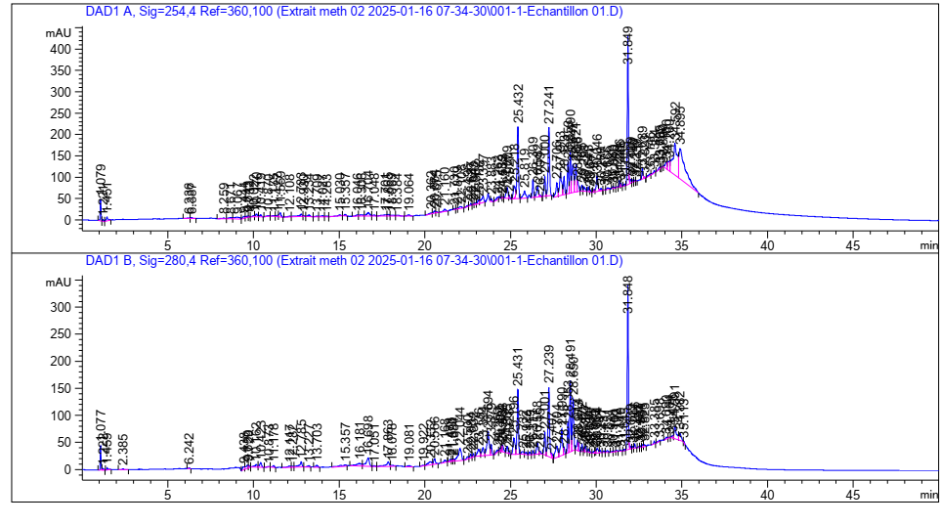

**My1 Region 1**

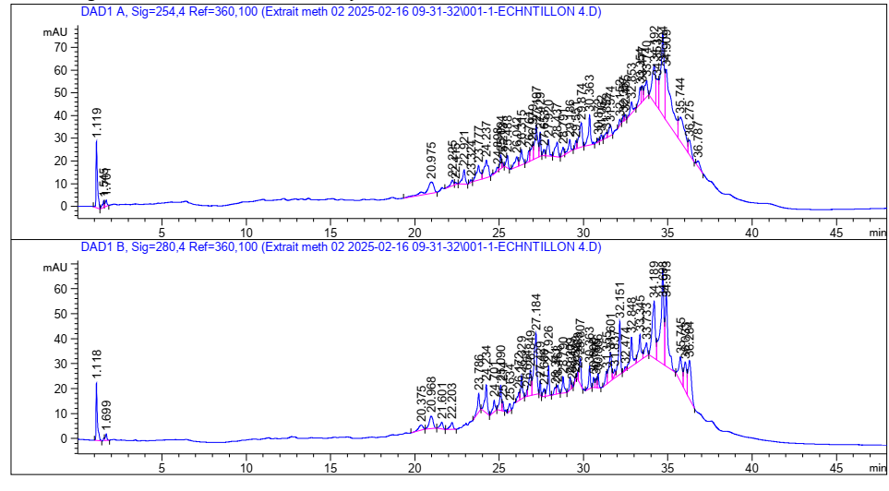

**My2 Region 2**

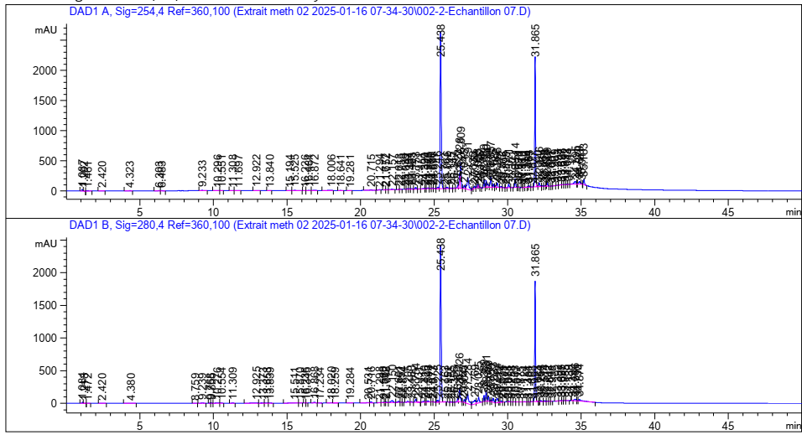

**My3 Region**3

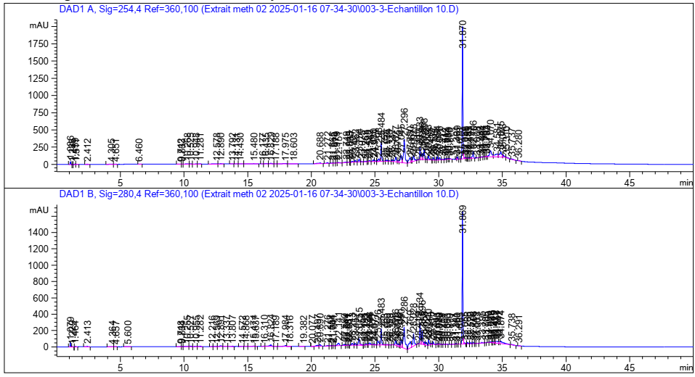

**Figure 56 ::**HPLC chromatogram of myrrhe extract according to the region and the microwave power studied, region 1: Saudi Arabia HD-MOP = 800 W, Region 2: Pakistan HD-MO P = 800 W, Region 3: Yemen HD-MO P = 800 W, Region 4: Arabia Saudi HD-MO P = 600 W

|  |  |  |  |  |  |  |  |  |  |  |  |  |  |  |  |  |
| --- | --- | --- | --- | --- | --- | --- | --- | --- | --- | --- | --- | --- | --- | --- | --- | --- |
|  | **My1 (Region**1) | | | | **My2 (Region**2) | | | | **My3 (Region**3) | | | | **My4 (Region**4) | | | |
| Wavelength ʎ (nm) | 280.4 | | 254.4 | | 280.4 | | 254.4 | | 280.4 | | 254.4 | | 280.4 | | 254.4 | |
|  | TR (min) | % | TR (min) | % | TR (min) | % | TR (min) | % | TR (min) | % | TR (min) | % | TR (min) | % | TR (min) | % |
| 2.5-Dimethoxy cinnamic acid | 2.385 | 0.0893 | / | / | / | / | / | / | / | / | / | / | / | / | / | / |
| Acidparahydroxybenzoic | / | / | 20.675 | 0.1135 | 1,118 | 3,0375 | 1,119 | 4.01 | / | / | / | / | 20.690 | 0.7209 | 20.688 | 0.6308 |
| Caffeine | / | / | / | / | / | / | / | / | / | / | / | / | / | / | / | / |
| Gallic acid | Traces (For Wavelength ʎ = 275.4) | | | | | | | | | | | | | | | |
| Protocatechic acid | / | / | / | / | / | / | / | / | 4.380 | 0.0720 | 4.323 | 0.0432 | 4.364 | 0.0599 | 4.305 | 0.1244 |
| Anthrone | 1,222 | 0.1665 | 1,221 | 0.1145 | / | / | / | / | 1,213 | 0.0282 | 1.202 | 0.0237 | 1,229 | 0.0378 | 1.235 | 0.0287 |
| Catechin | 1.077 | 1,3920 | 1.079 | 1,1747 | / | / | / | / | 1.084 | 0.1475 | 1.087 | 0.2264 | 1.079 | 0.6813 | 1.086 | 0.56733 |
| Flavone | / | / | / | / | / | / | / | / | / | / | / | / | / | / | / | / |
| Acidisophanilic | / | / | / | / | / | / | / | / | 4.380 | 0.0720 | / | / | 4.364 | 0.0599 | / | / |
| Kaempferol | / | / | / | / | / | / | / | / | / | / | 4.471 | 0.043 | / | / | 4.471 | 0.06 |
| Quercetin | / | / | / | / | / | / | / | / | / | / | / | / | 4.657 | 0.0654 | / | / |
| Hydrate | / | / | / | / | / | / | / | / | / | / | / | / | / | / | / | / |
| Salicylic acid | / | / | 9.067 | 0.6824 | / | / | 1,119 | 4.11 | / | / | / | / | / | / | / | / |
| Acidsyringe | / | / | / | / | 1,118 | 3,0375 | / | / | / | / | / | / | / | / | / | / |
| Trans-4-Methoxycinnamic acid | / | / | / | / | / | / | / | / | / | / | / | / | / | / | / | / |
| Vanillin | / | / | 1,284 | 0.1665 | / | / | / | / | / | / | 1,284 | 0.028 | / | / | 1,284 | 0.037 |

**Tableau 9 :** Résultats de l’analyse HPLC des composés phénoliques de la résine de myrrhe

**IV.3 Study of antimicrobial activity of myrrh resin on bacterial and fungal pathogenic strains**

The evaluation of the anti -microbial activity of oil and myrrhe extract was carried out by measuring the inhibition zones formed around the tested samples (Figure 57).

**Table 10:**Results of antimicrobial activities

|  |  |  |  |
| --- | --- | --- | --- |
| Lots  Bacteria | Extract + DMSO  (mm)) | Oil + DMSO  (mm)) | Oil  (mm)) |
| Pseudomonas aeruginosa | 8.88 | R | 7.7 |
| ESCherichia COOLIS | R | R | 7.66 |
| Candida albicans | 7.7 | 9.61 | 10 |
| Staphylococcus aureus | 15.31 | 11.1 | 12.01 |
| Bacillus subtilis | R | R | R |

**Noticed**#error#

Examination of inhibition zones(Table 10)reveals that the extractt ethanolic of myrrh diluted toDMSO is particularly active countestaphylococcusaurus (15.3mm) and shows a notable inhibition of pseudomonasaeruginosa (8.88mm), while pure essential oil, effectively inhibits the Application (10mm) and Escherichiacoli (7.66mm) strains but loses its effectiveness when diluted in DMSO.On the contrary, the bacillussubtilis remains resistant to all the formulations tested.

The absence of an inhibition zone for some of them is mainly explained by their natural resistance, but can also result from the degradation of extracts and essential oils under the heating effect.

The results show thatTHEStaphylococcus aureus is the most sensitive strain of myrrh extracts, whatever the form used (essential oil, ethanolic extract, etc.), while other microorganisms have variable levels of resistance depending on the strains and types of extracts.The DMSO, recognized for its properties of solubilization and facilitation of the penetration of molecules (Balouiri, M.et al., 2016), slightly improves the dissemination of the active ingredients from the extract or the oil to significantly increase global activity.Consequently, the extract of myrrh in the presence of DMSO, appears as aPartial natural alternative against certain gram pathogens-Posiatives such as S. Aureus, while its effectiveness remains reduced vis-has-Vis of Gram bacteria-Negatives.

**IV.4 Study of anti-inflammatory activity of essential oils and myrrh extracts**

The results presented in Figures 58and 59have revealed that the extract of the myrrh exerts a notable inhibitory activity, reaching a maximum percentage of inhibition of**95.98% at UDo not concentration of 0.1875mg/ml**.However, a gradual decrease in this activity has been observed at higher concentrations, which can be explained by an effect of saturation of the reaction environment or an interference linked to the turbidity of the mixture.L'**Ic50extract**was estimated at**0.724mg/ml**, reflecting moderate but significant efficiency.

L'**essential oil**has also demonstrated a marked anti-inflammatory activity.IC50obtained (**0.636mg/ml**) is slightly lower than that of the extract, which suggests an inhibitory efficiency greater than lower concentration.This performance could be attributed to the richness of essential oil in volatile bioactive compounds, including sesquiterpenes and monoterpenes, widely recognized for their anti-inflammatory properties.

As a comparison, the**sodium diclofenac**, used as a reference anti-inflammatory, presents an IC50of**0.314mg/ml**, according to a study carried out with the same method of denaturing protein (Thunbergia grandiflora, 2022).Although IC50Natural myrrh extracts are superior, indicating lower inhibitory power, the results obtained remain significant.They support the interest of these extracts in the development of**Alternative natural formulations**, potentially better tolerated and without major side effects linked to synthesis NSAIDs.

These observations are part of the continuity of previous work, like that of Ahmed et al.(2022), which has shown that the methanolic extract of Myrrhe effectively inhibits the thermal denaturation of albumin, with a dose-dependent response.Other studies have also highlighted the anti-inflammatory activity of certain specific compounds of myrrh, in particular the**Myrthanol A**, whose efficiency sometimes exceeds that of hydrocortisone (Dolara, P. et al., 2000).

Thus, the two forms extracted from the myrrh resin -**raw extract and essential oil**-Manifest a significant anti-inflammatory activity, confirming the traditional uses of this medicinal plant.Essential oil, in particular, could offer a promising natural therapeutic option in**Sweet anti-inflammatory anti-inflammatory**Well tolerated.

**Figure 58 :** graphes représentant le **% d’inhibition de la dénaturation de l’albumine** en fonction de la concentration des extraits et des huiles essentielles

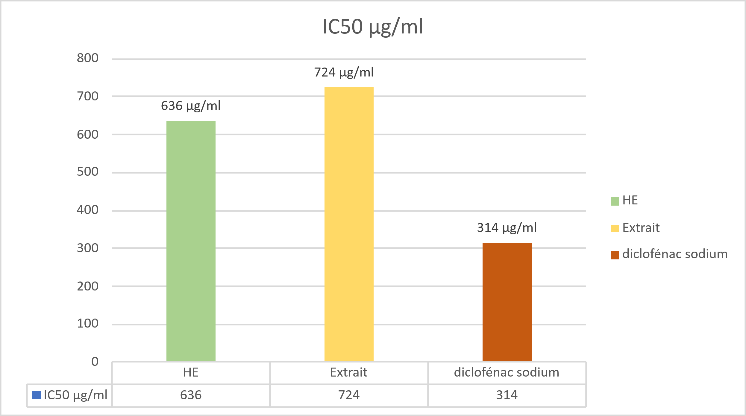

**Figure 59** : Histogramme des valeurs IC50 (µg/ml) des huiles essentielles et des extraits de Myrrhe obtenus par la méthode de broyage simple et diclofénac sodium

## **IV.5 Study of the antioxidant activity of essential oils and myrrh extracts by the trapping method at DPPH**

The antioxidant activity of essential oils was evaluated by the method at the DPPH, by measuring the reduction of the free radical DPPH •, accompanied by a change in purple to yellow color, detected at 517 nm per spectrophotometry.The percentage of inhibition (% I) was calculated for each extract, with analyzes carried out in triplicate to guarantee the reliability of the results (figure60).

**Figure60::**Antioxidant activity as a function of the concentration of essential oils and extracts from myrrh

IC values ​​analysis₅₀reveals that the extract studied presents a remarkable antioxidant activity, with an IC₅₀0.7 µg/ml, surpassing that of essential oil (3.5 µg/ml) as well as reference antioxidants such as BHA (2.3 µg/ml) and the BHT (4.63 µg/ml)) (Table 11).

This notable efficiency could be attributed to the richness of the extract in phenolic and flavonoid compounds, known for their capacity to neutralize free radicals by transfer of electrons or protons (Ouahab, HAS.et al., 2023).In comparison, the more moderate activity of essential oil could be explained by the predominance of terpene compounds, often less effective in the DPPH test because of their lipophilic character (Ghaliaoui, N.et al., 2020).TheseResults (Figure 61)Underline the potential of extract as a natural source of antioxidants, with interesting application prospects in the pharmaceutical and agrifood fields.

These observations are consistent with the data reported in the Ben Abdallah study, M.(2018) which showed that a notable antioxidant activity of an alcoholic extract of myrrh,with an IC50 close to that obtained here (0.0012 mg/ml), although the solvent used is different (methanol).Likewise, el-Kamali, H. H.et al.(2010) observed moderate antioxidant activity in myrrh essential oil.These variations between the results can be explained by several influential factors, including the nature of the solvent, the extraction method, the chemical composition of the sample, as well as the phenomena of synergy or antagonism between the different antioxidant molecules present.

Myrrh extract has proven more efficient than essential oil in the trapping of free radicals, making it a promising candidate for antioxidant applications in the pharmaceutical, cosmetics or nutraceutical fields.These results confirm that the choice of the type of extract plays a key role in the antioxidant efficiency of myrrh.

**Painting11::**Antioxidant activity result by DPPH

**Samples IC50 µg/ml**

He 3.5

Extract 0.7

BHT4.63

Bha 2.3

**Figure61**: Histogram of IC50 values ​​(µg/ml) essential oils and extracts from the myrrh obtained by the simple grinding method

**IV.6** **Evaluation of the analgesic activity of the ethanolic extract of Myrrhe**

The experimental study presented aims to assess the analgesic effect of a treatment on mice through three classic pain models: the Caudal removal test (Tail Flick), the heating plate test (Hot Plate) and the chemical irritation test (Writhing Test).These models are commonly used in pharmacology to detect antinocceptive effects of natural or synthetic agents, targeting either the central nervous system or the peripheral pains of pain.

* The Tail Flick test, which measures the reaction time of an animal in the face of an applied thermal source, has shown a significant difference between the treated groups and witness (Figure 62).The P value obtained is 0.0056 (p <0.05), with an average increase of 10.11 seconds of latency.This increase indicates a marked central analgesic effect, comparable to that induced by opioid agonists in similar models, as shown by bars work, D. et al.(2001).The determination coefficient (R² = 0.6893) confirms a good correlation between treatment and physiological response.
* The heating plate test (Figure 63), which measures the animal's behavioral response (licking, jump, withdrawal) in reaction to thermal pain applied to legs, has also shown statistically significant results with a value of 0.0036.The average difference observed is 10.78 seconds between the two groups.This suggests an increase in the thermal pain tolerance threshold, once again reflecting central analgesic activity.This result is consistent with the effects observed in plant extracts with analgesic properties such as turmeric or ginger (Ribeiro, R. A. et al., 2018), and reinforces the hypothesis of an action on the receptors involved in the modulation of central pain.
* The Writhing Test (Figure 64) Measures the visceral pain induced by the intraperitoneal administration of acetic acid, a validated model to assess peripheral analgesic effects.A significant decrease in the number of contortions has been observed in micetreated, with a value P of 0.0384.The average difference is 46.33 contortions, indicating a marked reduction in the pain caused.This result suggests an inhibition of the peripheral pains of pain, probably via anti-inflammatory action or inhibition of prostaglandin biosynthesis, mechanism comparable to that of non-steroidal anti-inflammatory drugs (necklace, H. O. J. et al., 1968;ZarghiAndArfaei, 2011).

These results justify a real therapeutic interest of myrrh as a natural analgesic agent with double mechanism of action, and pave the way for in -depth research on the identification of active compounds responsible for this double activity.

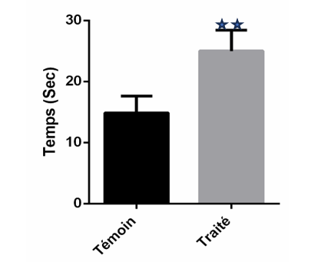

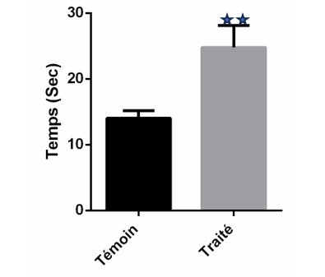

**Figure 62 :** Effet du traitement sur le temps de latence au test Tail Flick chez les animaux

**Figure 63 :** Effet du traitement sur la latence de réaction au test de la plaque chauffante chez les animaux

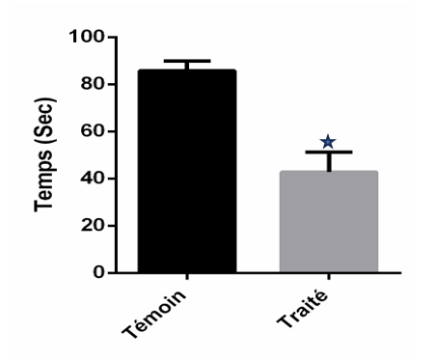

**Figure 64 :** Pourcentages d’inhibition de l’extrait 300mg/Kg sur le nombre de torsions induites par l’acide acétique

**Chapter V**

**The formulation**

As part of our valuation project, we have developed three innovative formulations based on myrrhe resin: a roll-on, a balm and preparation for skin use.These products have been designed to exploit the therapeutic properties of myrrh, recognized since Antiquity,While being part of an applied research approach aimed at offering innovative natural solutions, suitable for targeted and efficient use.

**V.1Innovative Roll-on-on-based on targeted application**

### **V.1.1 Manufacturing process**

The process is based on a soft maceration of the resin in an oily base of vegetable origin, followed by careful filtration.A natural antioxidant agent has been added to improve product stability.This practical format(Figure 65)Allows targeted application, especially for muscle and joint pain, while ensuring good skin penetration of active compounds.

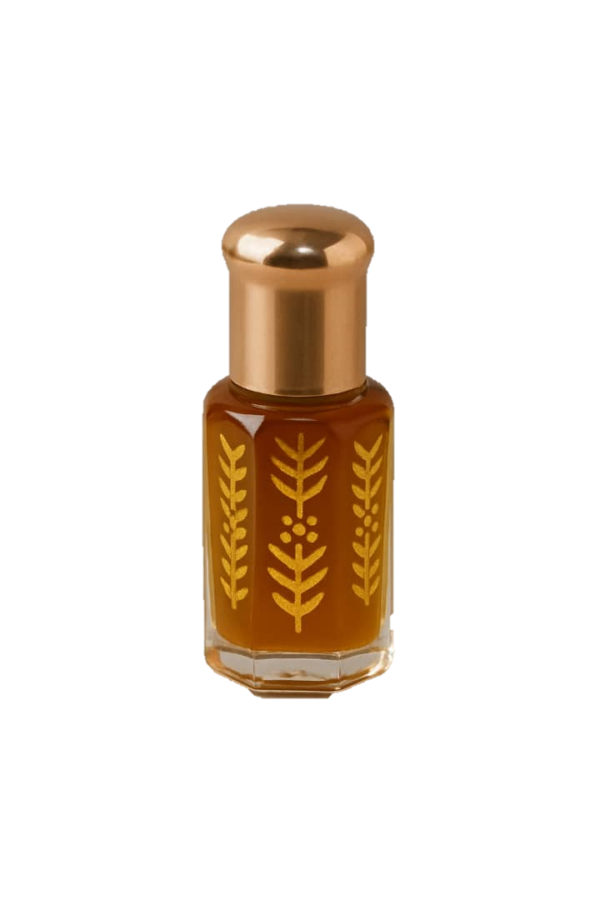

**Figure 65 :** Formulation finale du roll-on thérapeutique à base de myrrhe

**V.1.2 Therapeutic effect of the Roll-on formulated from myrrh**

The Roll-On product developed as part of this work has an interesting therapeutic potential for the relief of localized pain and skin inflammation.Thanks to the synergy between the volatile fraction of myrrh (rich in bioactive compounds) and the oily base chosen, this formulation acts on several levels.It first has an anti-inflammatory effect by inhibiting inflammation mediators, confirmed by protein denaturation tests.Then its anti -microbial properties make it possible to limit theDevelopment of microorganisms in the applied area, thus helping to prevent secondary infections.Antioxidant activity, for its part, strengthens the protection of tissues against oxidative stress, participating in cellular regeneration.

Finally, the results of the analgesic test in vivo suggest a significant soothing effect, which makes this formulation particularly suitable for topical use in the treatment of muscle or joint pain of light to moderate intensity.

**V.2 MYRRHE BALAGE for optimal skin protection and regeneration**

**V.2.1 Manufacturing process**

The formulation started with prolonged contact with the raw material with a quality vegetable oil, enriched as a coordinate for its thickening natural properties.This association promotes the extraction and stabilization of the active compounds of myrrh, while contributing to the texture of the balm.The oily phase obtained was then heated gently to incorporate waxes and plant butters, guaranteeing a homogeneous and stable consistency.To preserve the heat -sensitive active ingredients, in particular the natural vitamin E added at the end of preparation for its antioxidant properties, the temperature has been rigorously controlled.Finally, the balm(Figure 66)has been conditioned in hermetic containers, ensuring its conservation and safety.

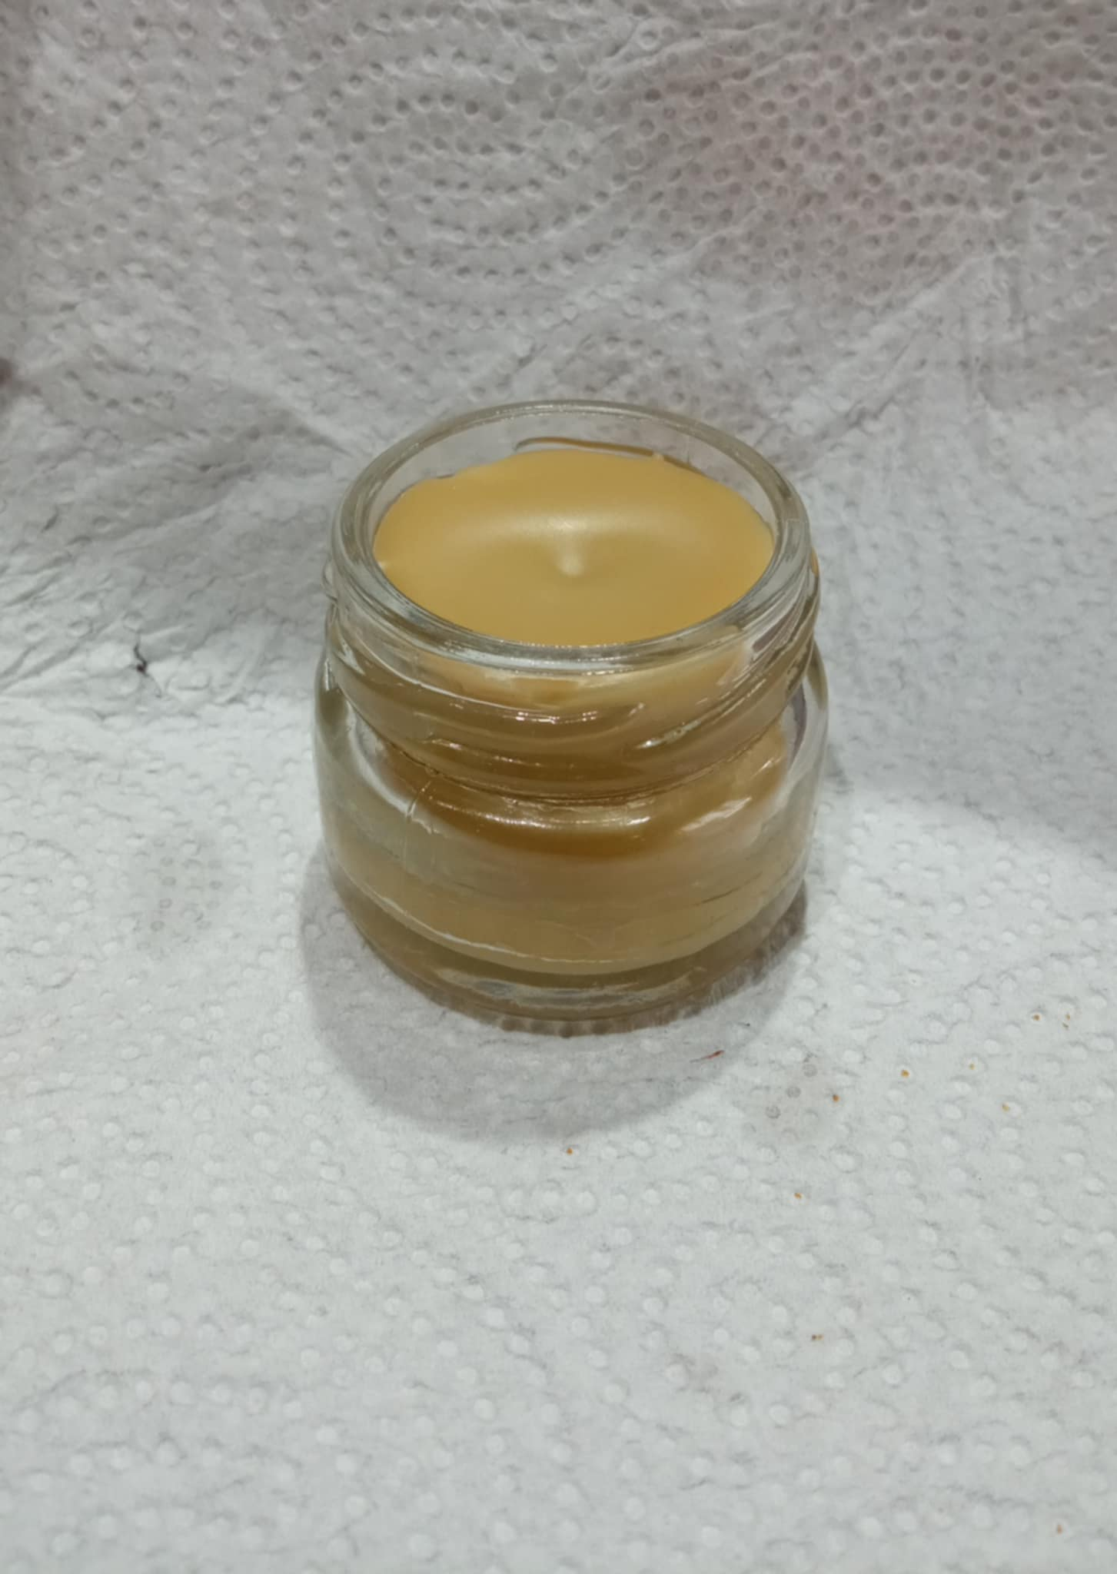

**Figure 66 :** Formulation finale de baume thérapeutique à base de résine de myrrhe

**V.2.1 Therapeutic effect of myrrh Balm**

Thanks to the richness of its natural components, this balm has multiple properties:**soothing,,anti-inflammatory,,antimicrobials**And**regenerating**.It is particularly suitable for sensitive skin or subject to irritation.Its protective and repairing effect makes it useful in localized skin care, in particular to calm redness, promote healing and strengthen the skin barrier.The presence of plant active ingredients with antioxidant properties also helps to fight against oxidative stress and premature aging of the skin.

**V.3Petroleum jellybased on myrrh extract**

**V.3.1 Manufacturing process**

The preparation was carried out by progressive incorporation of an active plant extract in a neutral base previously softened(67).The mixture was made at controlled temperature in order to preserve the integrity of sensitive compounds, while ensuring a homogeneous dispersion of the assets in the matrix.The final texture obtained is stable, easy to apply and well tolerated by the skin.The packaging was carried out in hermetic pots for dermal use.

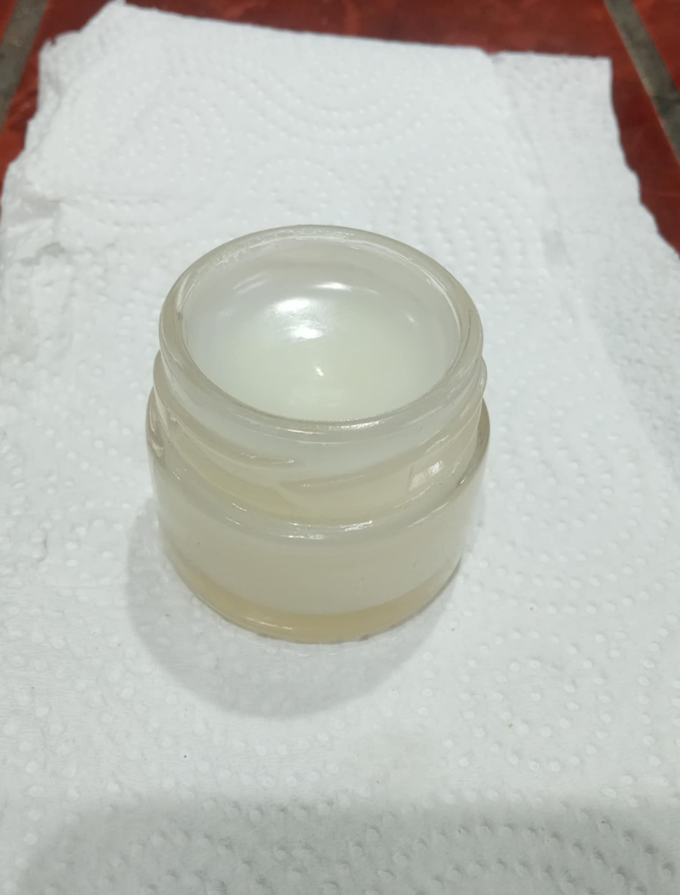

**Figure 67 :** Formulation finale de vaseline à base d’extrait de myrrhe

**V.3.1 Therapeutic effect ofpetroleum jellybased on myrrh**

Thanks to its high concentrated myrrh extract content, thispetroleum jellypresents a multiple therapeutic potential, particularly suitable for intensive skin care.Its action is based on a synergy of effects**deep anti-inflammatory drugs**,,**Large spectrum antimicrobials**, And**local pain relievers**, which make it an ally of choice for attacked skin or in the repair phase.Its fatty phase, enriched with liposoluble active ingredients, allows a**gradual penetration**bioactive components in the superficial layers of the skin, offering a**prolonged action**and targeted.It contributes to**relieve localized pain**, has**reduce redness** inflammatory**Limit microbial proliferation**, and at**promote repair tissue**, in particular in the event of chappers, crevices, or minor post-traumatic inflammation.This treatmentdermato-active can also be applied in**soothing massage on tense areas or painful**, in particular tired muscles or sensitive joints, where it provides a**natural relaxing effect**Without known side effects.

**Conclusion**

The study we conducted around myrrh (CommiphoraSPP.) Speed ​​in an innovative approach to enhance an ancestral medicinal plant through an integrated approach, combining extraction, analysis and application.This project allowed us to better understand the chemical complexity and the biological richness of this resin, while laying the first foundations for modern exploitation, with therapeutic and entrepreneurial purposes.

Chromatographic analyzes have been an essential step for the characterization of extracts.The use of gaseous phase chromatography coupled with mass spectrometry (GC-MS) has made it possible to identify the volatile constituents of essential oils with precision, including sesquiterpenes and furanoses, compounds recognized for their anti-inflammatory and antimicrobial properties (Shen et al., 2020; Riaz et al., 2017).

At the same time, high performance liquid chromatography (HPLC) has made it possible to detect and quantify phenolic compounds in ethanolic extracts, such as ferulic acid and flavonoids, thus reinforcing understanding of the antioxidant profile of myrrh (ElAshryet al., 2019).

The biological results obtained have highlighted antioxidant, antimicrobial, anti-inflammatory and analgesic properties.These observations corroborate data from the literature and strengthen the positioning of myrrh as a potential functional ingredient in skin care (Dolara et al., 2000).

Beyond the experimental aspect, we have translated these scientific achievements into concrete actions by the development of three natural dermal formulations, thoughts to combine efficiency, safety and accessibility.This passage from the laboratory to the pre-commercial formulation is fully part of an applied research dynamic and entrepreneurial innovation.

For lack of time, certain complementary avenues, such as evaluation of the stability of formulations, dermatological tests on volunteers, or toxicity tests, as well asComparison with other species of Commiphora could not be explored.However, they represent promising prospects as part of a future product research or maturation project.

In short, this work highlights the richness of myrrh as a natural resource with high therapeutic and socio-economic potential.It is part of a broader desire to reconcile modern science with ancestral medicinal heritage, by valuing local resources according to sustainable, responsible and scientifically founded approaches.

**“All well -conducted research always leaves more open doors behind than closed answers.»»**- A perspective that encourages us to continue this path with rigor, passion and innovation.

# 

# **Bibliographies references**

***HAS***

* Abbas, R., Al-Mushin, HAS.,Elsharbasy, F., &Ashiry, K. (2020).*[Title of the missing article]*.**[Title of the missing journal]**.Openaccessunder the Creative Commons License Assign 4.0.
* Abd el-Raouf, O. M., El-SOYED, E. S. M., & Mani, M. F. (2015).*[Title of the missing article]*.*Journal ofBIOCHEMICALandMolecularToxicology, 29*(8), 426–431.https://doi.org/10.1002/jbt.21729
* Abdel-Hay, M. H., Saleh, A., El Ashry, E., Rashed, N., & Salama, O. (2002).Colorimetric determination of gross powdered myrrh, purified myrrh extract, oily fraction and its different galenic forms.*Spectroscopy Letters, 35*(2), 183–197.<https://doi.org/10.1081/SL-120003009>
* Abdul-Ghani, R. A.,Loutfy, N., & Hassan, A. (2009).Myrrh andtremotodosisIn Egypt: overview of safety, efficiency and efficiency profiles.*ParasitologyInternational, 58*(2), 210–214.<https://doi.org/10.1016/j.parint.2009.01.002>
* Adams, R. P. (2007).*Identification of Essential Oil Components by Gas Chromatography/Mass Spectrometry*(4th ed.).Alltred PublishingCorporation.
* .(2000).Standard NF T75-006: essential oil-Definition and specifications.Paris: French normalization association.
* French Health Products Health Safety Agency (Afssaps).(2010).*French pharmacopoeia*(10th ed.).Ministry of Health
* Al-Harrasse, A., Khan, A. L., Asaf, S., & al-Rawahi, A. (2019).*BiologyofgenusBoswellia*.<https://public.ebookcentral.proquest.com/choice/publicfullrecord.aspx?p=5771071>(Accessed May 12, 2020).
* Alsharif, K. (2020).Potential effect of anti-inflammatory properties of myrrh.*Letters in AppliedNanobioscience, 9*, 1687–1694Akbar, S. (2020).*Commiphora Myrrha*(Nees) Engl.(Burseraceae).In S. Akbar (ed.),*Manual of 200 medicinal plants: a complete review of their traditional medical uses and their scientific justifications*(pp. 701–706).Springer InternationalPublishing.
* Azwanida, N. N. (2015).A review on the extraction methods used in medicinal plants, principle, strength, and limitation.*Medicinal&AromaticPlants*, 4 (3), 196.<https://doi.org/10.4172/2167-0412.1000196>.

***B***

* Bakkali, F., Averbeck, S., Averbeck, D., & Idaomar, M. (2008).Biological Effects of Essential Oils - A Review.*Food and Chemical Toxicology, 46*(2), 446–475.<https://doi.org/10.1016/j.fct.2007.09.106>
* Balouiri, M., Sadiki, M., &Ibnsouda, S. K. (2016).Methods for in vitro Evaluating Antimicrobial Activity: A review https://doi.org/10.1016/j.jpha.2015.11.005
* Bars, D.,Gozariu, M., & Cadden, S. W. (2001).*Animal Models of Nociception*.Pharmacological Reviews, 53 (4), 597–652.https://doi.org/10.1124/pr.53.4.597
* Başer, K.,Halfci, B.,Dekebo, HAS., &Dagne, E. (2003).Essential oils of certain species of*Boswellia*, of Myrrhe and Opecanax.*Flavourand fragrance newspaper, 18*(2), 153–156.<https://doi.org/10.1002/ffj.1150>
* Belkou, H.,Beyoud, F., & Taleb, B. Z. (2005).*Approach to the biochemical composition of green mint (Mentha spicataL.) In the Ouargla region*[Master's thesis].University of Ouargla.
* Ben Abdallah, M. (2018).*Study of the anti-inflammatory activity of natural extracts: case of myrrh (Commiphora Molmol)*[Master's thesis, University of Tunis El Manar].
* Benaissa, O. (2011).*Study of terpenic metabolisms andflavonicof the compound family species, genresChrysanthemumAndRhantherium.Biological activity*[Doctoral thesis, UniversityRagersConstantine, Algeria].
* Benayad, N. (2008).*Essential oils extracted from Moroccan medicinal plants: effective means of fighting pests of food stored food*[Doctoral thesis, Mohammed V University - Faculty of Sciences of Rabat, Department of Chemistry].
* Bendif, H. (2017).Phytochemical characterization and determination of biological activities in vitro of active extracts of someLamiaceae::*AjugaIVA*(L.)Schreb.,*Teurcrum polium*L.,*ThymusMunbyanus* subsp.*coloratus*(Bave.&Reut.)Greet&BardetAnd*Rosmarinus Eriocalyx*Jord &Fur.Doctoral thesis in biological sciences, the National School of Kouba-Alger.
* Benkaci-Ali, F. (2007).*Study of the chemical composition of Nigella Sativa from Algeria*[Doctoral thesis, University of Sciences and Technology Houari Boumediene].
* Bera, S., de, S., & de, B. (2020).Essential Oils and Their Chemical Composition With Relivance to Myrrh.*Natural Product Research*, 34 (9), 1264–1275.<https://doi.org/10.1080/14786419.2018.1515145>
* Besombes, C. (2008).Contribution to the study of hydro-thermomicanic extraction phenomena of aromatic herbs: generalized applications.University of La Rochelle.
* Bézanger-Beautiful, L., Pinkas, M., &Torck, M. (1986).*Plants in modern therapy*(2nd revised ed.).Maloine editions.
* Bimakr, M., Rahman, R. A.,Ganjloo, A., Taip, F. S., &Zaidul, I. S. M.(2011).Comparison of Different Extraction Methods for the Extraction of Major Bioactive Flavonoid Compounds from Spearmint (*Mentha spicata*L.) Leaves.*Food andBioproducts Processing*, 89 (1), 67–72.<https://doi.org/10.1016/j.fbp.2010.03.002>
* Bisset, N. G., & Wichtl, M. (1994).*Plant -based drugs and phytopharmaceutical products*.Scientific publishersMedPharm GmbH;CRCPress.
* Bone, K., & Mills, S. (2013).*Principles and Practice ofPhytotherapy:Modern Herbal Medicine*(2nded.).ElsevierHealthSciences.
* Boukhobza, F., & Goetz, P. (2014).*Phytotherapy in dedemn: clinical guide*.EditionsCdp.ISBN 978-2-84361-244-2.
* Boyraz, N., & Özcan, M. (2005).Antifungal Effect of Some Spice Hydrosols.*Fitoterapia*, 76, 661-665.
* Brand-Williams, W., Cuvelier, M. E., & Berset, C. (1995).Use of A Free Radical Method to Evaluate Antioxidant Activity.*LWT - Food Science andTechnology, 28*(1), 25–30.<https://doi.org/10.1016/S0023-6438(95)80008-5>
* Bruneton, J. (2009).*Pharmacognosia: phytochemistry, medicinal plants*(4th ed.).Lavoisier editions.
* Burt, S. (2004).Essential Oils: Their Antibacterial Properties and Potential Applications In Foods - A Review.*International Journal of Food Microbiology, 94*(3), 223–253.<https://doi.org/10.1016/j.ijfoodmicro.2004.03.022>

***C***

* Chagra, K. (2019).Study of physico-chemical and biological properties of cloves (*Syzygiumaromaticum*L.).Master in chemical engineering, Mohamed UniversityKhiderde Biskra (Algeria).
* Chahar, M. K., Sharma, N., Dobhal, M. P., & Joshi, Y. C. (2012).Flavonoid::A versatile source of anticancerdrugs.Pharmacognosy Reviews, 5 (9), 1–12.
* Chalchat, J. K., Carry, L. P., Menut, C.,Lamaty, G.,Malhuret, R., &Chopineau, J. (1997).Correlation between scalmComposition andantimicrobial Activity.VI.Activity of some African Essential Oils.*Journal of Essential Oil Research*, 9, 67-75.
* Chemat, F., Vian, M. A., &Cravotto, G.(2017).*Green Extraction of Natural Products: Concept and Principles*.International Journal ofMolecularSciences**,,**18 (7), 1584.<https://doi.org/10.3390/ijms18071584>
* Chemat, F., Zill-E-Huma, & Khan, M. K. (2011).Applications of Ultrasound in Food Technology: Processing, Preservation and Extraction.*Ultrasonic Sonochemistry*, 18 (4), 813–835.<https://doi.org/10.1016/j.ultsonch.2010.11.023>
* Chemat, S.,Lagha, A., Ait Amar, H., & Chemat, F. (2003).Ultrasound assisted microwavedigestion.*Ultrasonic Sonochemistry*, 11, 5-8.
* Collier, H. O. J., Dinneen, L. C., Johnson, C. A., & Schneider, C. (1968).The Abdominal Constriction Response and its Deletion by Analgesic Drugs in the Mouse.British Journal ofPharmacologyandChemotherapy, 32 (2), 295–310.
* Cravotto, G., & Cintas, P.(2008).*Power Ultrasound in Organic Synthesis: MovingcavitationalChemistry from Academia to Innovative and Large-Scale Applications*.Chemical SocietyReviews, 38 (2), 268–289.<https://doi.org/10.1039/B812169E>
* Cvitković, D., et al.(2022).*The Influence of Cryogrinding on Essential Oil, Phenolic Compounds and Pigments Extraction from myrtle (Myrtus Communis L.)Leaves*.Processes**,,**10 (12), 2716.<https://doi.org/10.3390/pr10122716>

***D***

* Decaux, I. (2002).*Phytotherapy: user manual*.Editions Le Bien Public.
* Dekebo, A., Lang, M.,Polborn, K., Dagne, E., & Steglich, W. (2002).FourlignanascommiphoraErlangeriana.Journal of NaturalProduct, 65 (9), 1252–1257.<https://doi.org/10.1021/np020070l>
* Demisew, S. (1993).Description of certain essential oil plants in Ethiopia and their native uses.*Journal of EssentialOilResearch*, 5, 465–479.<https://doi.org/10.1007/s00210022023250>.
* Do, Q. D.,Angkawijaya, A. E., Tran-Nguyen, P. L., Huynh, L. H.,Soetaredjo, F. E.,Ismadji, S., & Ju, Y. H.(2014).Effect of Extraction Solvent on Total Phenol Content, TotalFlavonoid content, and antioxidant Activity of*Limnophila aromatica*.*Journal of Food and Drug Analysis*, 22 (3), 296–302.<https://doi.org/10.1016/j.jfda.2013.11.001>
* Dolara, P., Corte, B.,Ghelardini, C.,Pugliese, A. M.,Cerbai, E.,Menhetti, S., & Lo Nostro, A. (2000).**Localanaesthetic, antibacterial and antifungal properies of sesquiterpenes from myrrh**.*Planta Medica*, 66 (4), 356–358.<https://doi.org/10.1055/s-2000-8536>
* Dolara, P.,Luceri, C.,Ghelardini, C., et al.(1996).Analgesic effects of myrrh.*Nature*, 379, 29.
* Durvelle, J.-P. (1930).*Manufacture of essences and perfumes*.

***E***

* El-Ashram, S., & Suo, X. (2017).The Effect of Myrrh (Commiphora Molmol) Against Fasciolagigantica: Antiparasitic Activity and Potential Therapeutic Uses.*ParasitologyResearch*,,*116*(2), 741–749.<https://doi.org/10.1007/s00436-016-5332-2>
* El Ashry, E. S., Rashed, A. N., Salama, O. M., & Saleh, A. K. (2019).Phenolic Constituents and Antioxidant Activity of Myrrh (Commiphora Molmol) Ethanolic Extract.Journal of NaturalProductResearch, 33 (9), 1203–1210.
* El-Kamali, H. H., Mahjoub, S. A., & Hamad, S. A. (2010).Antibacterial Activity of Essential Oils of*Commiphora Molmol*(Myrrh) Against Some Pathogenic Bacteria.*Journal ofMedicinalResearch plants*,,*4*(4), 354–357.
* Above, S., Hua, Y., Wang, Y.,Gu, W., Zhou, W., Duan, J.-A., Jiang, H., Chen, T., & Tang, Y. (2012).Evaluation of anti-inflammatory and analgesic properties of individual and combined extracts of*Commiphora Myrrha*and*Boswellia cardrii*.*Journal ofEthnopharmacology, 139*(3), 649–656.<https://doi.org/10.1016/j.jep.2011.11.009>

***F***

* Frattarolo, L.,Carullo, G., Brindisi, M.,Mazzotta, S.,Bellissimo, L.,Rago, V.,Curcio, R., Dolce, V.,Aiello, F., &Cappello, A. R. (2019).*[Title of the missing article]*.*Antioxidants, 8*(6), 186. Https://doi.org/10.3390/antiox8060186

***G***

* Ghaliaoui, N.,Hazzit, M., Hadjadj, M., & Mokrane, H. (2020).*Impact of Freezing and Drying Preprocessing on Pigments Extraction from the Brown SeaweedPhyllaria reniformisCollection in Algerian Coast*.

***H***

* H.Tutunchi, F.Naeini, HAS.Ostadrahimi, M. J.Hosseinzadeh-Attar, Phytotherapy Research 2020, 34, 3137-3147.
* He, Z., CHAPITAL, D. C., Cheng, H. N., Thomas Klasson, K., OLANYA, O. M., &Uknal, J. (2014).Application of Tung Oil to Improve Adhesion Strength and Water Resistance of Cottoneed Meal and Protein Adhesives on Maple Veneer).
* Hessas, T., & Simoud, S. (2018).Contribution to the study of chemical composition and the evaluation of the antimicrobial activity of essential oil of*Thymus* SP.Doctoral thesis in pharmacy, Mouloud Mammeri University (Algeria).
* HANUS, L. O.,Rezanka, T.,Dembitsky, V. M., & Moussaieff, A. (2005).Myrrh—*Commiphora*Chemistry.*Biomedical Papers, 149*(1), 3–28.htts: //doi.org/10.5507/bp.2005.001

***I***

* Iserin, P. (2001).*Encyclopedia of medicinal plants*.Larousse Bourdasse editions
* Izzo, A. A., & Ernst, E. (2009).Interactions between herbal medicines and prescribed drugs: at Systematic Review.*Phytotherapy Research*,,*23*(5), 583–595.<https://doi.org/10.1002/ptr.2626>

***J***

* J.-H.Lee, Food Bioscience 2015, 11, 1-7.

***K***

* Koba, K. H., et al.(2016).*Effect of cryogenic grinding on volatile and fatty oil constituents*.**Journal of EssentialOilResearch**, 28 (2), 132–139.
* Koster, R., Anderson, M., de Beer, E.J. (1959).Actic Acid for Analgesic Screening.*Federation Proceedings*, 18, 412.

***L***

* L.Frattarolo, G.Carullo, Mr. Brindisi, S.Mazzotta, L.Bellissimo, V.Rago, R.Curcio, V. Dolce, F.Aiello, A. R.Cappello,,Antioxidants2019, 8, 186.
* Lagunez Rivera, L. (2006).Study of the extraction of secondary metabolites from different vegetable materials in reactor heated by direct thermomagnetic induction.Doctoral thesis, National Polytechnic Institute of Toulouse, France.
* Lahlou, M. (2004).Methods to Study Phytochemistry and BioActivity of Essential Oils.*Phytotherapy Research*, 18, 435-448.
* Lee, J.-H.(2015).*[Title of the missing article]*.*Food Bioscience, 11*, 1–7.https://doi.org/10.1016/j.fbio.2015.03.001
* Lemenih, M., &TEketay, D. (2004).Reviewarticle:Frankincense and Myrrh Resources ofEthiopian:I Distribution, production, Opportunities for Dryland Development and Research Needs.*Sinet: Ethiop.J.SCI.*, 26, 63–72.<https://doi.org/10.4314/sinet.v26i1.18201>.
* Leung, A. Y. (1980).*Encyclopedia of current natural ingredients used in food, drugs and cosmetics*.JohnWileyand sounds.
* Ljaljević Grbić, M.,Unković, N.,Dimkić, I.,Janaćković, P.,Gavrilović, M.,Stanojević, O., &Vukojević, J. (2018).Frankincense and Myrrh Essential Oils and Burn Incense Fume Against Micro-Inhabitants of Sacralambient::Wisdom of the ancients?*Journal ofEthnopharmacology*, 219, 1–14.<https://doi.org/10.1016/j.jep.2018.03.003>

***M***

* Mangena, T., &Muyima, N. Y. O. (1999).Comparative Evaluation of the Antimicrobial Activities of Essential Oils of*Artemisia afra*,,*Pteronia Incana*, and*Rosmarinus officinalis*We select Bacteria and Yeast Strains.*LettersinApplication Microbiology*, 28 (4), 291-296.
* Massoud, A., ElSisi, S., & Salama, O. (2001).Preliminary study of the therapeutic efficiency of a new drugfasciolicidederived from*Commiphora Molmol*(myrrh).*American Journal of TropicalMedicineandHygiene*, 65, 96–99.
* Mompon, B. (1994).What a commercial future for the products obtained by new extraction technologies: CO2, microwave, ultrasound, new solvents.In*4th International Nyons Meeting*(pp. 149-166).
* Murti, Y., & Mishra, P. (2014).*[Title of the missing article]*.*IndianJournal of Pharmaceutical Sciences, 76*(3), 163.

***N***

* Nomicos, E. Y. H. (2007).Myrrh: Medical Marvel or Myth of the Magi?*HolisticNursing Practice*, 21 (5), 308–323.<https://doi.org/10.1097/01.HNP.0000298616.32846.34>.
* Food, V. N.,Angelis, M., de Vita, D., Messore, A., de Leo, A.,Ialongo, D.,Tudino, V.,Saccolithi, F., de Clear, G., &Garzoli, S. (2021).Study of the antiviral activity of the essential oil of Commiphora Myrrha (Nees))Engine.And its main components.Pharmaceuticals, 14 (3), 243.<https://doi.org/10.3390/ph14030243>

***O***

* O. M. Abd El-Raouf, E. S. M. El-SOYED, M. F. Manie, Journal of Biochemical and Molecular Toxicology 2015, 29, 426-431.
* Orabi, S. H., Al-Sabbagh, E. S., Khalifa, H. K., Mohamed, M. A. E.-G.,Elhamouly, M., Gad-Allah, S. M., Abdel-Daim, M. M., &Eldaim, M. A. A. (2020).Commiphora Myrrha Resin Alcoholic Extract Extract Ameliorates High Fat Diet Induced Obesity via Regulation of UCP1 and Adiponectin Proteins Expression in rats.*Nutrients*, 12 (3), 803.<https://doi.org/10.3390/nu12030803>
* Ouahab, HAS.,Menaiaia, K., & Khaldi, F. (2023).*Phytochemical analysis, antioxidant, and acetylcholinesterase activities of propolis extracts from soukAhras, Algeria*.University of SoukAhras.<https://www.univ-soukahras.dz/wpuploads/eprints/2024-1948-a2796.pdf>

***P***

* Paredes, M.Alzuru, J. Mendez, M. Rodríguez-Terga, Biological and Pharmaceutical Bulletin 2003, 26, 108-109.
* Penchev, P. I. (2010).Study of the extraction and purification processes of bioactive products from plants by coupling of separative techniques with bass and high pressure.Doctoral thesis in processes of processes and the environment, University of Toulouse, France.
* Pibiri, M. C. (2006).Microbiological sanitation of air and ventilation systems using essential oils.Doctoral thesis, Lausanne, Canada.
* PIOCHON, M. (2008).Study of essential oils of plant species in Laurentian flora: chemical composition, pharmacological activities andhemi-synthesis.University of Quebec in Chicoutimi.

***R***

* R. Abbas, A. Al-Mushin, F.Elsharbasy, K.Ashiry, Open access.This article is distributed under the terms of the creative commons attribution 2020, 4.
* R. Wang, W. Yang, Y. Fan, W.Dehaen, Y. Li, H. Li, W. Wang, Q. Zheng, Q. Huai, Bioorganic Chemistry 2019, 88, 102951.
* Rahman, M. M., Garvey, M., Piddock, L. J. V., & Gibbons, S. (2008).Antibacterial Terpenes from the Oleo-Resin Of*Commiphora Molmol*(Engl.).*Phytotherapy Research*, 22 (10), 1356-1360.
* Rao, R. M., Khan, Z. A., & Shah, A. H. (2001).Toxicity studies in mice of theolécommeresin*Commiphora Molmol*.*Journal ofEthnopharmacology*, 76, 151–154.
* Rehman, M. E., Halim, S. A., Khan, A., Khan, M., Al-Hatmi, S., & al-Harrasse, A. (2022).CommikuanoidsAC: Newstriterpanoids cycloartaneWith exploration of the inhibition of carbon dioxide-II from the Commiphora resinskuaby molecular molecular molechers and in silico.Phytotherapy Research, 157, 105125.<https://doi.org/10.1016/j.phymed.2022.105125>
* RIAZ, M., Rahman, N. U., ZIA-UL-HAQ, M., & Jamil, M. I. (2017).Chemical Composition and Biological Activities of the Essential Oil from Commiphora Myrrha.Molecules, 22 (4), 632.
* Ribeiro, R. A., Vale, M. L.,Thomazzi, S. M., & Ferreira, S. H. (2018).*Analgesic Activity of Turmeric and Curcumin in Animal Models*.European Journal of Pharmacology, 833, 1–10.<https://doi.org/10.1016/j.ejphar.2018.05.045>
* Roussy, G., & Pearce, J. A. (1995).*Foundations and Industrial Applications of Microwaves and Radio Frequency Fields*.JohnWiley& Sounds ltd.

***S***

* Sagdiç, O. (2003).Sensitivity of Four Pathogenic Bacteria to Turkish Thyme and Oregano Hydrosols.*Lebensmittel-Wissenschaft& Technology*, 36, 467-473.
* Saha, S., & Ahmed, A. (2012).Antimicrobial Activity of Myrrh (Commiphora Myrrha) Against Various Human Pathogens.*Journal ofEthnopharmacology*,,*141*(1), 233-239.<https://doi.org/10.1016/j.jep.2012.02.019>
* Sahraoui, N., Vian, M. A.,Bornard, I.,Bottledjiret, C., & Chemat, F. (2008).Improved Microwave Steam Distillation Appartus for Insulation of Estastial Oils: Comparison with Conventional Steam Distillation.*Journal ofChromatographyHAS*, 1210, 229-233.
* SAMATE, A. D. (2002).Chemical composition of essential oils extracted from aromatic plants from the Sudanian area of ​​Burkina Faso: valuation.Doctoral thesis, University of Ouagadougou, Burkina Faso.
* Sasidharan, S., Chen, Y., Saravanan, D., Sundram, K. M., & Yoga Latha, L. (2011).Extraction, insulation and characterization of bioactive compounds from Plants ’extracts.*African Journal of Traditional, Complementary and Alternative Medicines*, 8 (1), 1–10.<https://doi.org/10.4314/ajtcam.v8i1.60483>
* Shalaby, M. A., & Hammouda, A. A. (2014).Analgesic, anti-inflammatory and antihyperlipidemic activities of*Commiphora Molmol*Extract (Myrrh).*Journal ofIntercultural Ethnopharmacology*, 3, 56–62.<https://doi.org/10.5455/jice.20140308074335>
* Shen, T., Li, G.-H., Wang, X.-N., & Lou, H.-X.(2012).The Genus*Commiphora*: A review of its traditional uses, phytochemistry, and pharmacology.*Journal ofEthnopharmacology*, 142, 319–330.<https://doi.org/10.1016/j.jep.2012.05.025>.
* Shen, T., Li, G. H., Wang, X. N., & Lou, H. X. (2020).The GenusCommiphora:A review of its traditional uses, phytochemistry and pharmacology.Journal ofEthnopharmacology, 247, 112255.
* Siddiqui, M. Z. (2016).The Medicinal Properties of Myrrh: An Ancient Plant With Modern Applications.*Journal of Traditional and Complementary Medicine*,,*6*(2), 163–168.<https://doi.org/10.1016/j.jtcme.2015.07.001>
* Singleton, V. L.,Orthofer, R., &Lamuela-RAventos, R. M. (1999).Analysis of Total Phenols and other oxidation substrates and antioxidants by means of folin-CiocalteuREAGE.In P. Lester (ed.),*Methods in Enzymology*(Vol. 299, pp. 152–178).Academic Press.https://doi.org/10.1016/S0076-6879(99999017-1
* Stashenko, E. E.,Jaramillo, B. E., &Martínez, J. R. (2004a).Comparison of Different Extraction Methods for the Analysis of Volatile Secondary Metabolites of*Lippiaalba*(Mill.) N.E. Brown, Grown in Colombia, and Evaluation of its in vitro antioxidant Activity.*Journal ofChromatographyHAS*, 1025, 93-103.
* Stashenko, E. E.,Jaramillo, B. E., &Martínez, J. R. (2004b).Analysis of Volatile Secondary Metabolites from Colombian*Xylopia aromatica*(Lamarck) by different extraction and headspace methods and gas chromatography.*Journal ofChromatographyHAS*, 1025, 105-113.
* SU, S., Wang, T., Duan, J.-A., Zhou, W., Hua, Y.-Q., Tang, Y.-P., & Qian, D.-W.(2011) b.Anti-inflammatory and analgesic activity of different extracts of*Commiphora Myrrha*.*Journal ofEthnopharmacology*, 134 (2), 251–258.<https://doi.org/10.1016/j.jep.2010.12.003>
* SU, S., Zhang, X., Li, Y., & Chen, J. (2011) a.Effects of Myrrh Essential Oil On Cancer Cell Proliferation.*Journal of Medicinal Plants Research*, 5 (14), 3101–3107.<https://doi.org/10.xxxx/jmpr.2011.3101>

***T***

* Teisseire, P. J. (1991).*Fragrant substances chemistry*.TEC & DOC.Lavoisier.
* Tipton, D., Lyle, B., Babich, H., & Dabbous, M. K. (2003).Cytotoxic and anti-inflammatory effects in vitro of myrrh essential oil on gingival fibroblasts and human epithelial cells.Toxicology in vitro, 17 (3), 301–310.<https://doi.org/10.1016/S0887-2333(03)00016-5>
* Tucker, A. O. (1986).Frankincense and Myrrh.*Economic Botany*, 40 (4), 425–433.<http://www.jstor.org/stable/4254901>.
* Tutunchi, H.,Naeini, F.,Ostadrahimi, HAS., &Hosseinzadeh-Attar, M. J. (2020).*[Title of the missing article]*.*Phytotherapy Research, 34*(12), 3137–3147.<https://doi.org/10.1002/ptr.6759>

**V**

* Verzera, A., et al.(2025).*Quantitative gc -analysisofSesquiterpenesinmyrrhessentialoil*.(Prepublication))
* Vogel, H. G. (2008).Drug Discovery andAssessment:Pharmacological Assays (3rd ed.).Springer.

**W**

* Wang, R., Yang, W., Fan, Y., Dehaen, W., Li, Y., Li, H., Wang, W., Zheng, Q., & Huai, Q. (2019).*[Title of the missing article]*.*BioorganicChemistry, 88*, 102951. Https://doi.org/10.1016/j.bioorg.2019.102951

Y

* Y.Murti, P. Mishra,IndianJournal of Pharmaceutical Sciences 2014, 76, 163
* Yahiaoui, N. (2005).Extraction, analysis and evaluation of the insecticide effect of essential oils of*Mentha spicata*(L.) On*Rhyzopertha dominica*(F) (Coleoptera,,Bostrychidae) And*#error# confusum*(DUV) (Coleoptera,,Tenebrionidae).Page 19, 24

**Z**

* Zambonelli, A.,D'Aurelio, A. Z., Severi, A., Benventi, E., Maggi, L., & Bianchi, A. (2011).Chemical Composition and Fungicidal Activity of Commercial Essential Oils of*Thymus vulgaris*L.*Journal of Essential Oil Research*, 16 (1), 69-74.
* Zarghi, HAS., &Arfaei, S. (2011).*Selective Cox-2Inhibitors:A Review of Their Structure-Activity Relationshipships*.Iranian Journal of Pharmaceutical Research, 10 (4), 655–683.<https://www.ncbi.nlm.nih.gov/pmc/articles/PMC3891238/>
* Zerfa, HAS., &Kouchache, K. E. (2015).Experimental study of the adsorption of a dye on agricultural waste (orange bark and date stems).Master's memory

***Webography***

1. <http://tpejbs2012.canalblog.com/archives/2012/02/13/23515308.html. Site consulté le 19/02/2024>.
2. <http://www.aromimport.com/proprietes.htm>.
3. [www.albanmuller.com](http://www.albanmuller.com/)
4. <http://www.phytonpathos.com/regroupement/chimie/proprietesbiochimiques/LesHuilses sentiellesouHE.htm>

# 

# **Annexed**

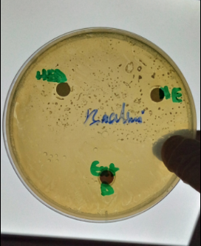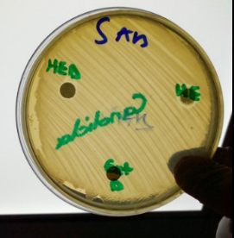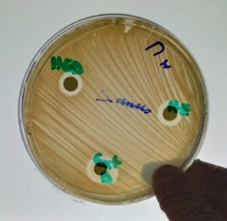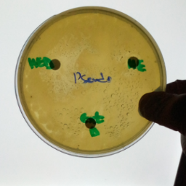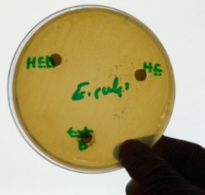

**Figure 57 :** Zones d’inhibition de l’huile essentielle et de l’extrait de myrrhe contre les micro-organismes testés